1 What is the domain of the relation shown below?
1)
2)
3)
4)

2 Let f be a function such that is defined on the domain . The range of this function is
1)
2)
3)
4)

3 If the function has the domain , what is its range?
1)
2)
3)
4)

4 If the domain of the function is , then the range is
1)
2)
3)
4)

5 The function has a domain consisting of the integers from to 1, inclusive. Which set represents the corresponding range values for ?
1)
2)
3)
4)

6 If 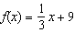, which statement is always true?
1)
2)
3) | If , then
4) | If , then

7 The range of the function is
1)
2)
3)
4)

8 If , which interval describes the range of this function?
1)
2)
3)
4)

9 What is the range of the function ?
1)
2)
3)
4)

10 The domain of the function is
1)
2)
3)
4)

11 The range of is the set of all real numbers
1) | less than or equal to
2) | greater than or equal to
3) | less than or equal to
4) | greater than or equal to

12 The range of the function is all real numbers
1) | less than or equal to
2) | greater than or equal to
3) | less than or equal to
4) | greater than or equal to

13 Which interval represents the range of the function ?
1)
2)
3)
4)

14 The range of the function defined as is
1)
2)
3)
4)

15 Which function has a domain of all real numbers and a range greater than or equal to three?
1)
2)
3)
4)

16 Bryan said that the piecewise function graphed below has a domain of all real numbers.

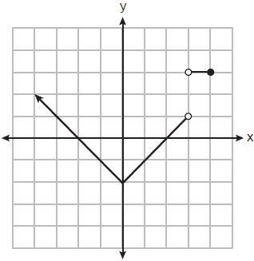

State two reasons why Bryan is incorrect.
1 ANS: 1 REF: 081710ai

2 ANS: 1
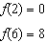

REF: 081411ai

3 ANS: 2 REF: 081806ai

4 ANS: 3
, ,

REF: 011812ai

5 ANS: 2
, ,

REF: 011914ai

6 ANS: 4
of a positive number is a positive number.

REF: 061417ai

7 ANS: 1 REF: 012018ai

8 ANS: 3 REF: 061816ai

9 ANS: 4
Vertex

REF: 012424ai

10 ANS: 2 REF: 062320ai

11 ANS: 2
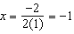;

REF: 082316ai

12 ANS: 2
REF: 061611ai

13 ANS: 4
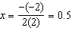
REF: 081923ai

14 ANS: 2 REF: 011619ai

15 ANS: 2
All four functions have a real domain. f has a real range. h has a positive real range. m has a nonnegative real range.
REF: 062424ai

16 ANS:
The function is not defined at or .
REF: 082327ai

