1 The accompanying graph shows the curves of best fit for data points comparing temperature to altitude in four different regions, represented by the relations A, B, C, and D.

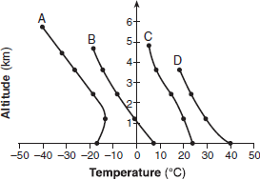

Which relation is not a function?
1) | A | 3) | C
2) | B | 4) | D

2 Which diagram represents a relation in which each member of the domain corresponds to only one member of its range?
1) | 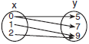 | 3) | 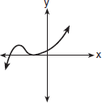
2) | 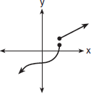 | 4) | 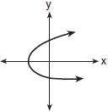

3 Which graph does not represent a function of x?
1) | 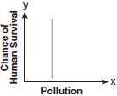 | 3) | 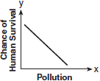
2) | 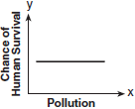 | 4) | 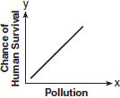

4 Which graph is not a function?
1) | 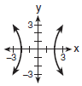 | 3) | 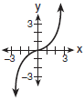
2) | 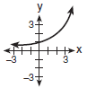 | 4) | 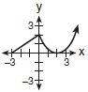

5 Each graph below represents a possible relationship between temperature and pressure. Which graph does not represent a function?
1) | 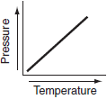 | 3) | 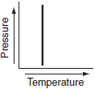
2) | 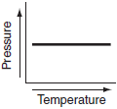 | 4) | 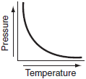

6 Which graph does not represent a function?
1) | 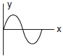 | 3) | 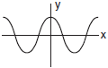
2) | 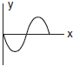 | 4) | 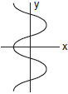

7 Which graph represents a function?
1) | 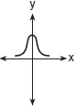 | 3) | 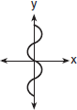
2) | 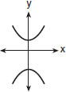 | 4) | 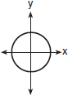

8 Which set of ordered pairs is not a function?
1) |  | 3)
2) |  | 4)

9 Which set of ordered pairs does not represent a function?
1) |  | 3)
2) |  | 4)

10 The relation defined by the set of ordered pairs is not a function. Which of the ordered pairs listed below, if omitted from this relation, will make the resulting set a function?
1) |  | 3)
2) |  | 4)

11 Given the relation . Which replacement for a makes this relation a function?
1) | 1 | 3) | 0
2) |  | 4) | 4

12 On the accompanying diagram, draw a mapping of a relation from set A to set B that is not a function. Explain why the relationship you drew is not a function.

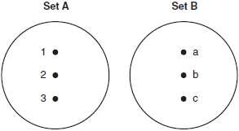
1 ANS: 1 REF: 060902b

2 ANS: 3 REF: 060310b

3 ANS: 1 REF: 080301b

4 ANS: 1 REF: 010511b

5 ANS: 3 REF: 060601b

6 ANS: 4 REF: 010213siii

7 ANS: 1 REF: 060320siii

8 ANS: 1 REF: 080403b

9 ANS: 2 REF: 060715b

10 ANS: 4 REF: 018530siii

11 ANS: 4 REF: 068634siii

12 ANS:
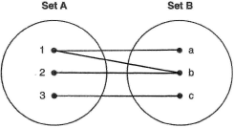 The relationship is not a function because an element in Set A maps to two different elements in Set B.

REF: 010622b

