1 Which graph does not represent a function?
1) | 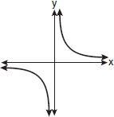 | 3) | 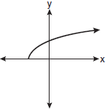
2) | 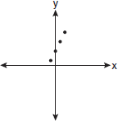 | 4) | 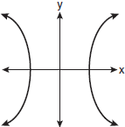

2 Which graph does not represent a function?
1) | 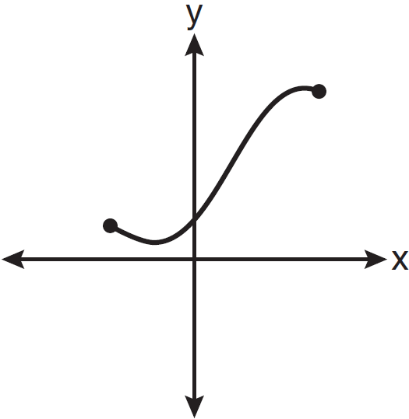 | 3) | 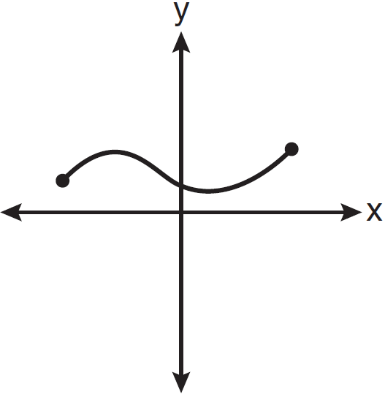
2) | 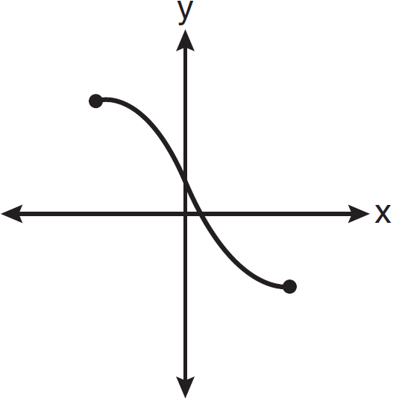 | 4) | 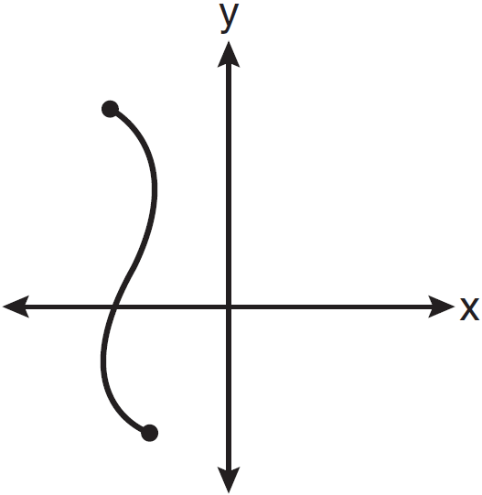

3 Which graph represents a relation that is not a function?
1) | 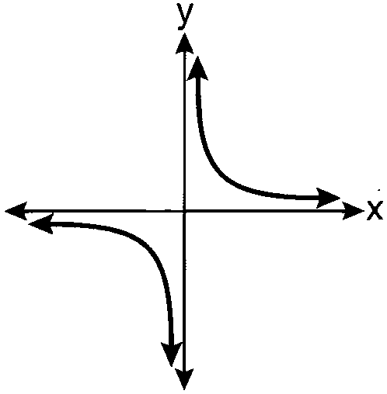 | 3) | 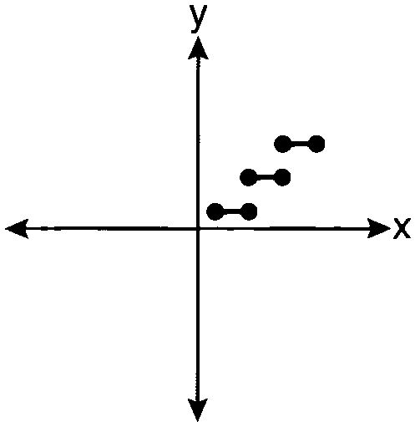
2) | 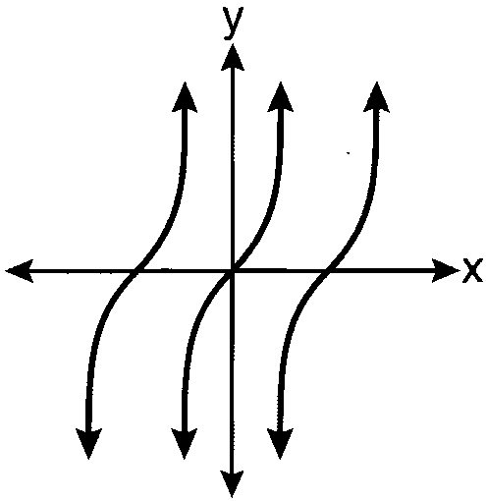 | 4) | 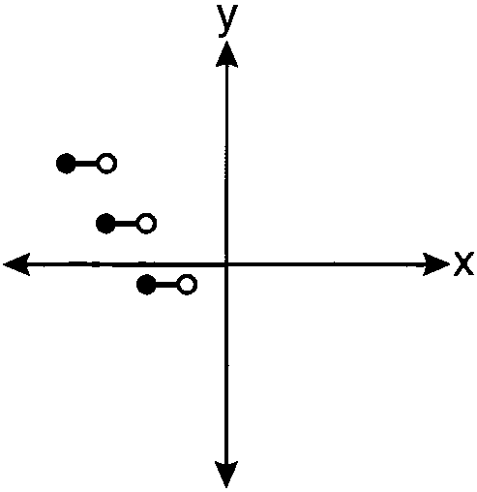

4 Which graph represents a function?
1) | 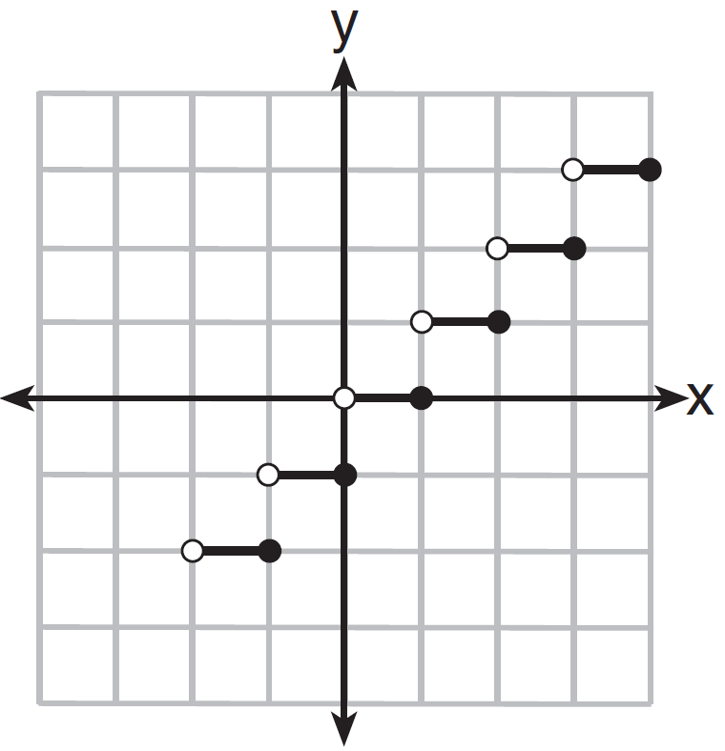 | 3) | 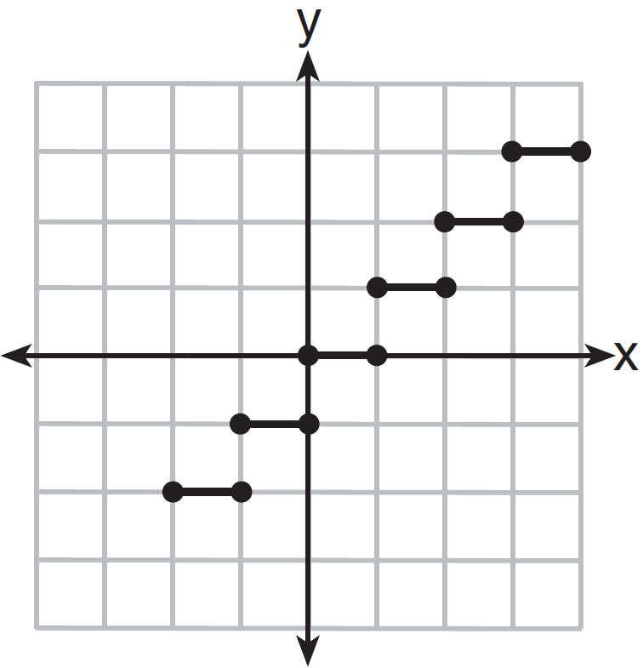
2) | 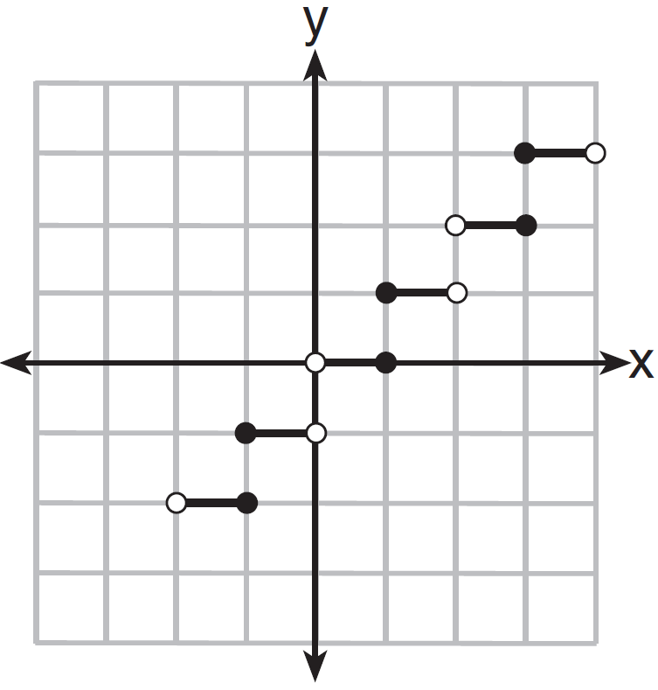 | 4) | 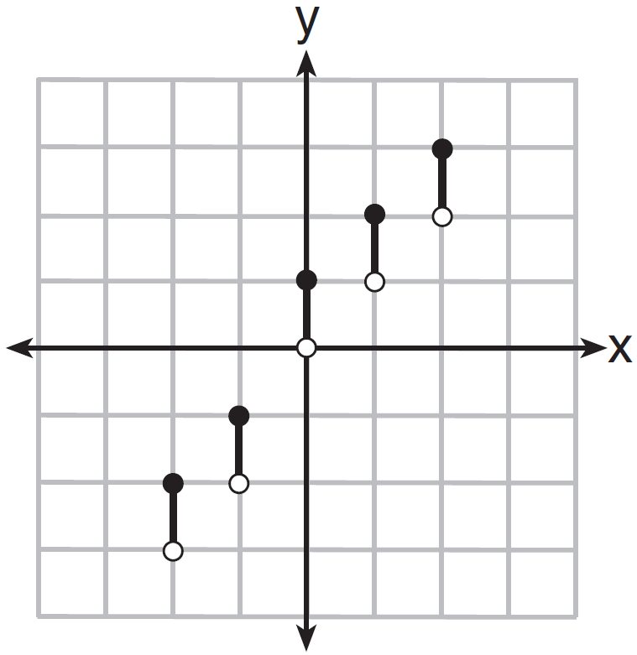

5 Which graph represents a function?
1) | 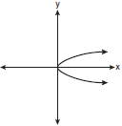 | 3) | 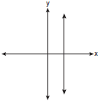
2) | 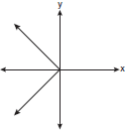 | 4) | 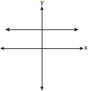

6 Which graph represents a function?
1) | 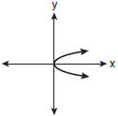 | 3) | 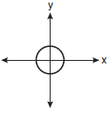
2) | 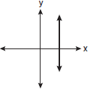 | 4) | 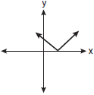

7 Which graph represents a function?
1) | 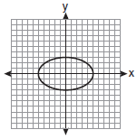 | 3) | 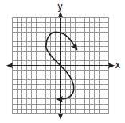
2) | 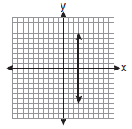 | 4) | 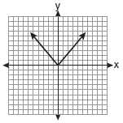

8 Which graph does not represent a function?
1) | 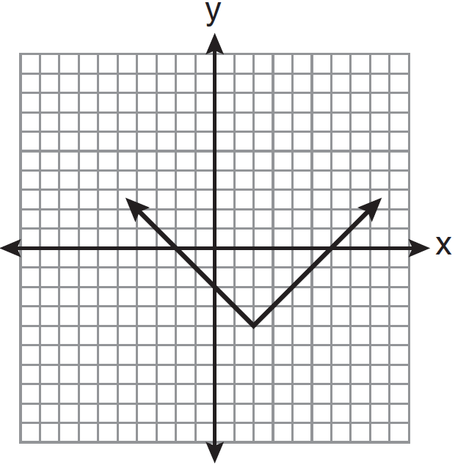 | 3) | 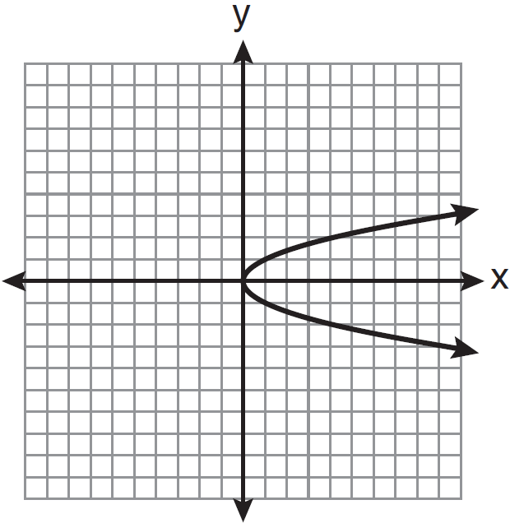
2) | 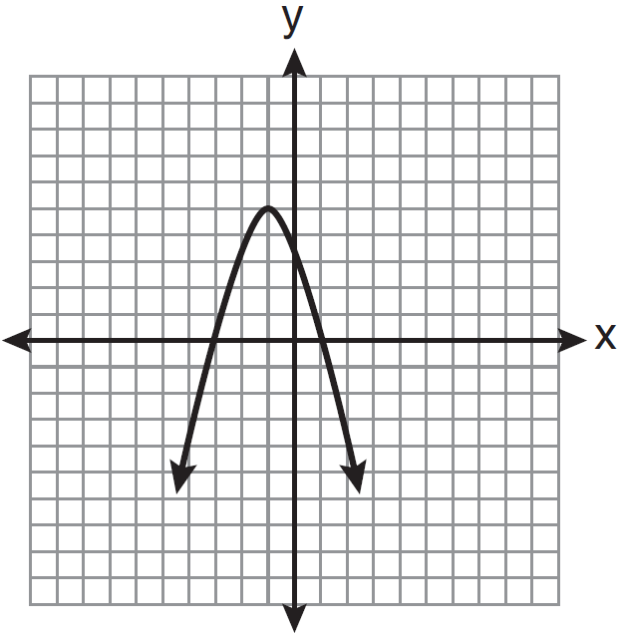 | 4) | 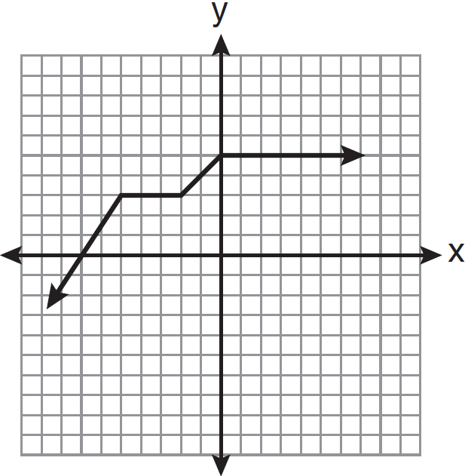

9 Which graph represents a function?
1) | 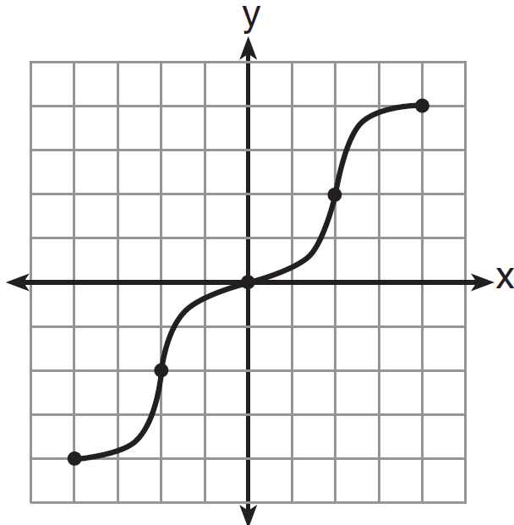 | 3) | 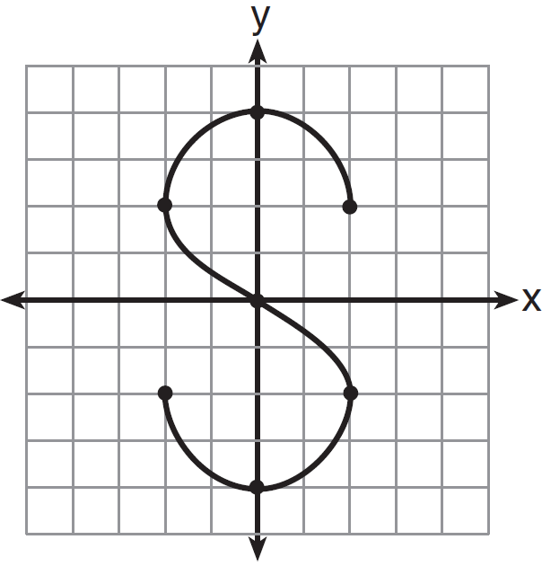
2) | 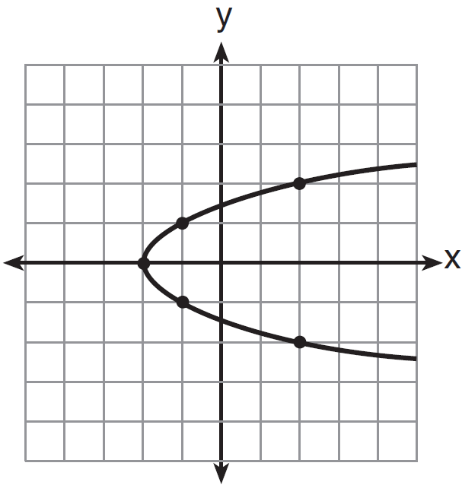 | 4) | 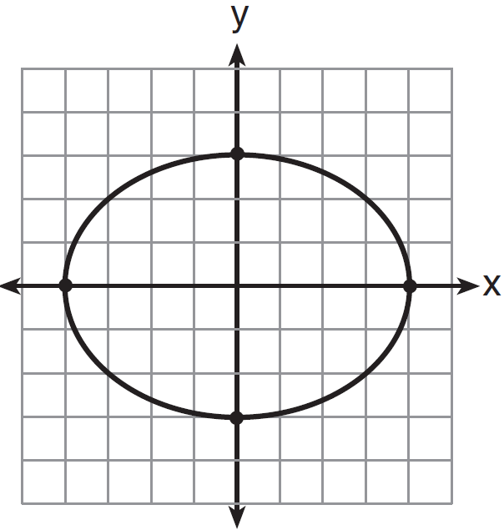

10 Which graph represents a function?
1) | 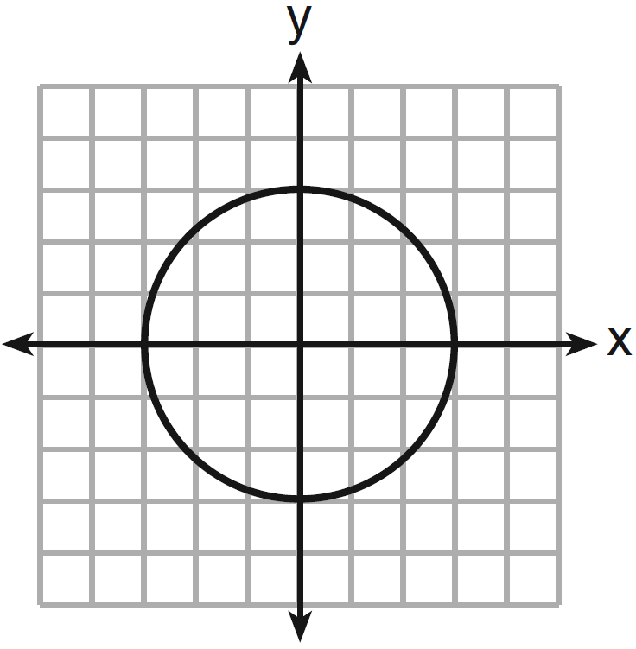 | 3) | 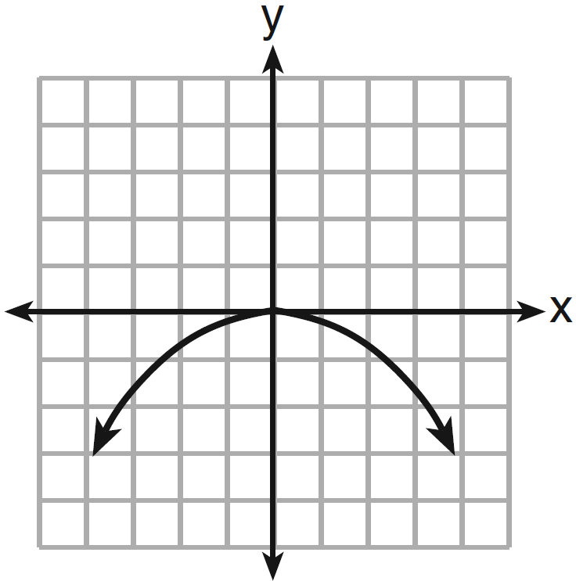
2) | 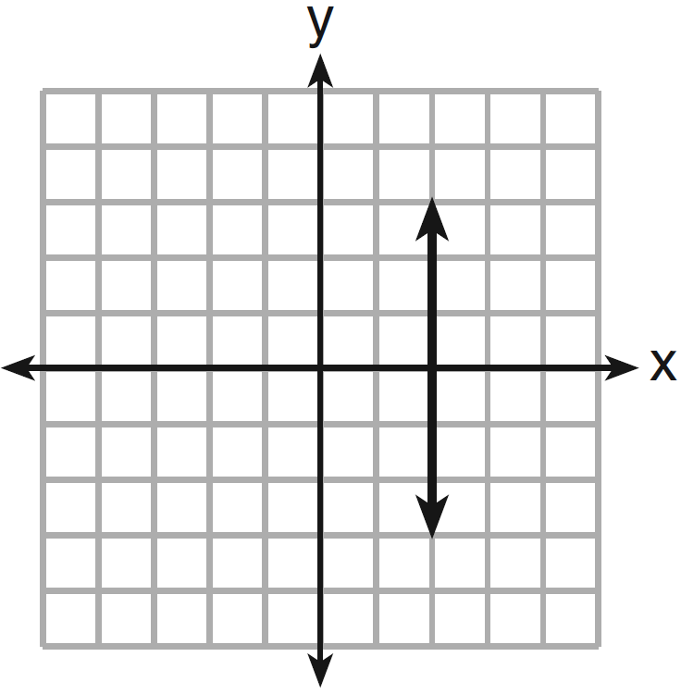 | 4) | 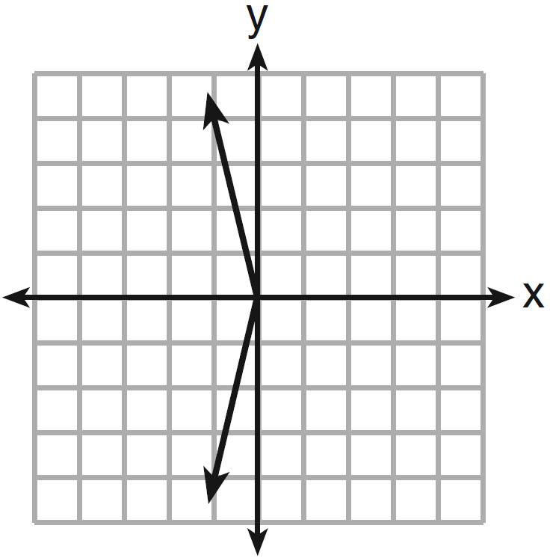

11 Which graph does not represent the graph of a function?
1) | 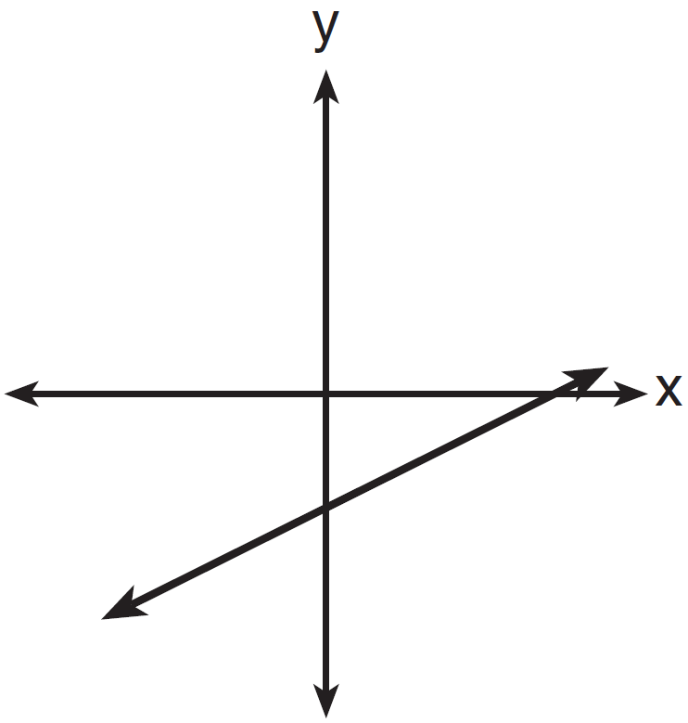 | 3) | 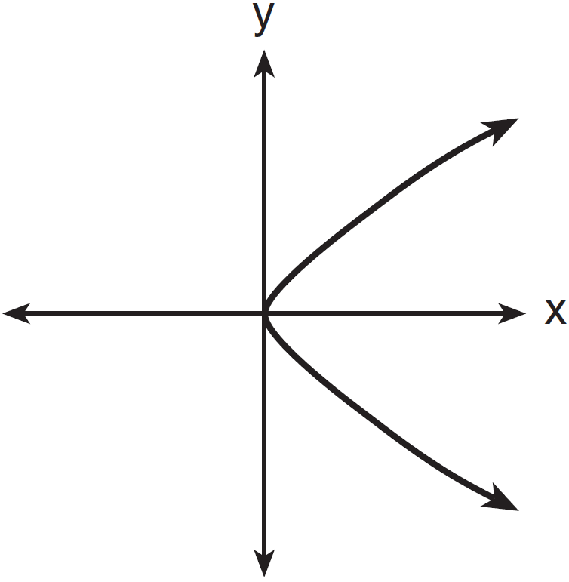
2) | 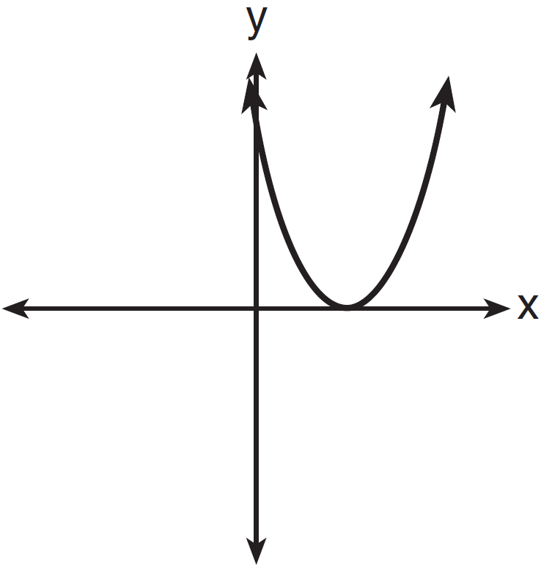 | 4) | 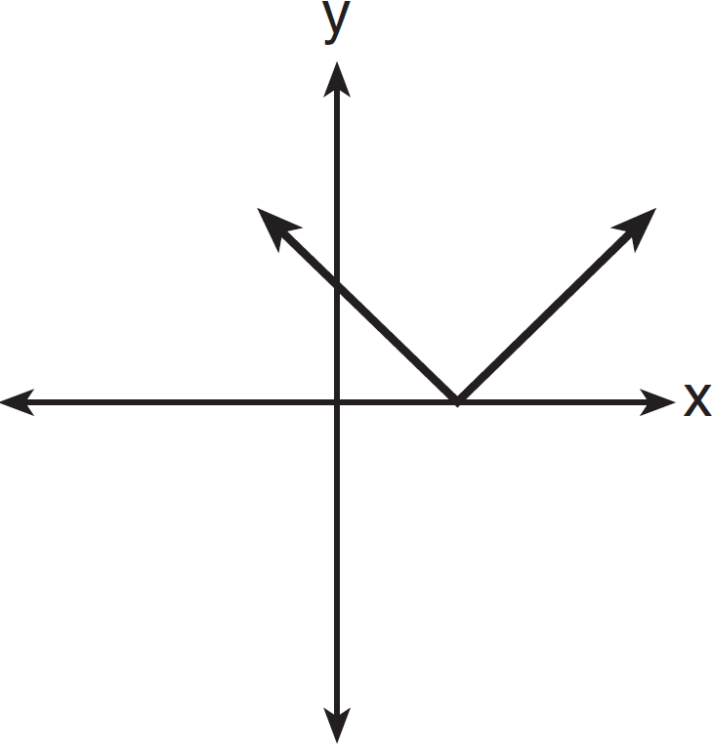

12 Which statement is true about the graphs of f and g shown below?

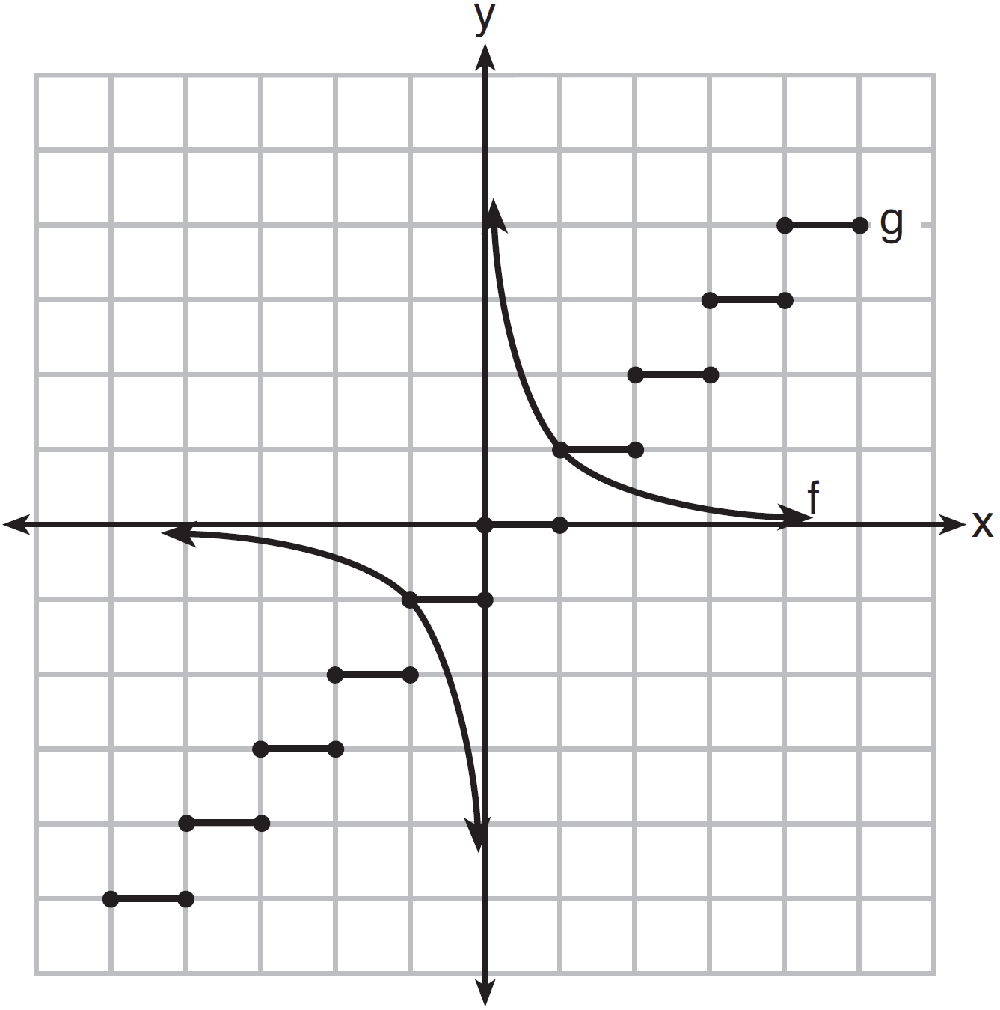
1) | f is a relation and g is a function. | 3) | Both f and g are functions.
2) | f is a function and g is a relation. | 4) | Neither f nor g is a function.

13 Which statement is true about the relation shown on the graph below?

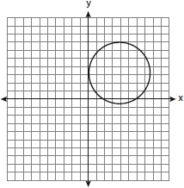
1) | It is a function because there exists one x-coordinate for each y-coordinate. | 3) | It is not a function because there are multiple y-values for a given x-value.
2) | It is a function because there exists one y-coordinate for each x-coordinate. | 4) | It is not a function because there are multiple x-values for a given y-value.

14 Which set of ordered pairs represents a function?
1) |  | 3)
2) |  | 4)

15 Which relation is not a function?
1) |  | 3)
2) |  | 4)

16 Which relation represents a function?
1) |  | 3)
2) |  | 4)

17 Which relation is not a function?
1) |  | 3)
2) |  | 4)

18 Which relation is a function?
1) |  | 3)
2) |  | 4)

19 Which set is a function?
1) |  | 3)
2) |  | 4)

20 Which set of points does not represent a function?
1) |  | 3)
2) |  | 4)

21 Which relation is a function?
1) | 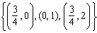 | 3)
2) | 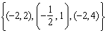 | 4)

22 Given the relation , which value of k will result in the relation not being a function?
1) | 1 | 3) | 3
2) | 2 | 4) | 4

23 Which relation does not represent a function?
1) | 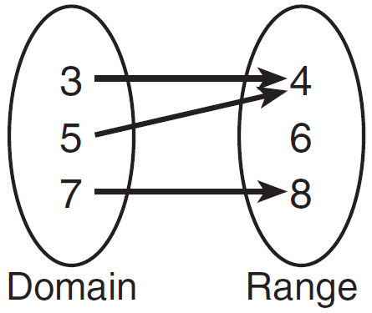 | 3) | 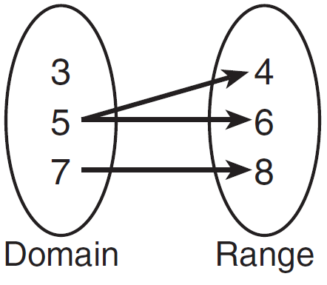
2) | 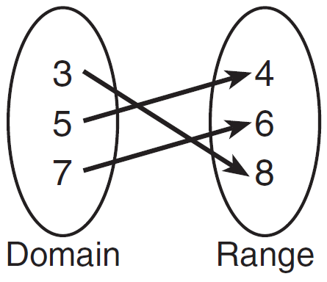 | 4) | 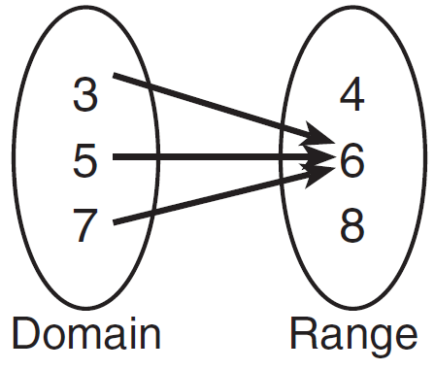

1 ANS: 4 REF: fall0908a2

2 ANS: 4 REF: 011101a2

3 ANS: 3 REF: 061114a2

4 ANS: 1 REF: 061409a2

5 ANS: 4 REF: fall0730ia

6 ANS: 4 REF: 010930ia

7 ANS: 4 REF: 061013ia

8 ANS: 3 REF: 011204ia

9 ANS: 1 REF: 061209ia

10 ANS: 3 REF: 011309ia

11 ANS: 3 REF: 081308ia

12 ANS: 2 REF: 011507a2

13 ANS: 3 REF: 060919ia

14 ANS: 2
In (2), each element in the domain corresponds to a unique element in the range.

REF: 061116ia

15 ANS: 3
An element of the domain, 1, is paired with two different elements of the range, 3 and 7.

REF: 080919ia

16 ANS: 4
In (4), each element in the domain corresponds to a unique element in the range.

REF: 011018ia

17 ANS: 4
An element of the domain, 1, is paired with two different elements of the range, 1 and .

REF: 011405ia

18 ANS: 1 REF: 061413ia

19 ANS: 2 REF: 011514ia

20 ANS: 3 REF: 061612ia

21 ANS: 4
In (4), each element in the domain corresponds to a unique element in the range.

REF: 011105ia

22 ANS: 3 REF: 011305a2

23 ANS: 3 REF: 011604a2

