1 A relation is graphed on the set of axes below.

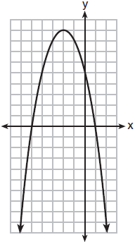

Based on this graph, the relation is
1) | a function because it passes the horizontal line test | 3) | not a function because it fails the horizontal line test
2) | a function because it passes the vertical line test | 4) | not a function because it fails the vertical line test

2 Which table represents a function?
1) | 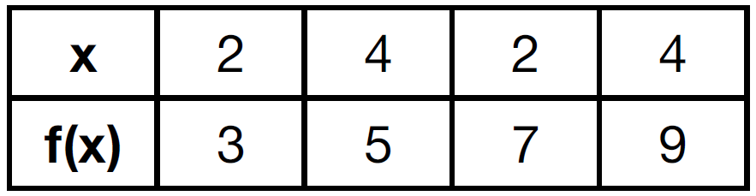 | 3) | 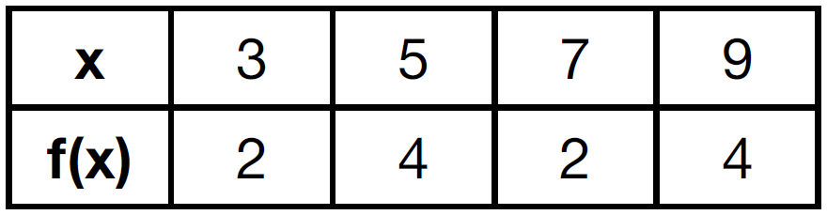
2) | 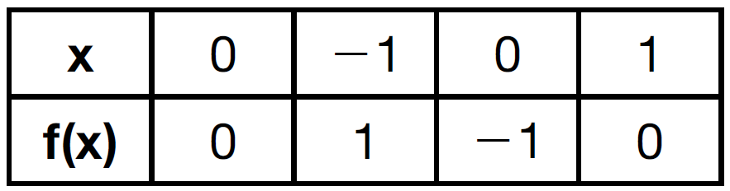 | 4) | 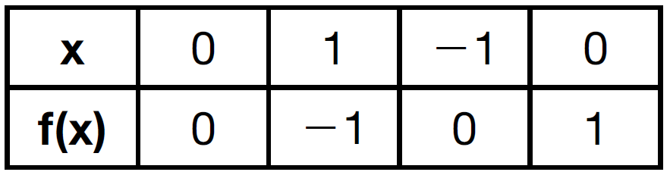

3 Which table represents a function?
1) | 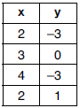 | 3) | 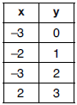
2) | 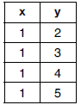 | 4) | 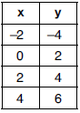

4 Which table could represent a function?
1) | 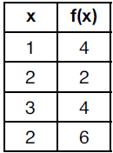 | 3) | 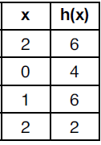
2) | 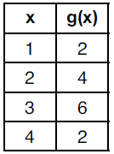 | 4) | 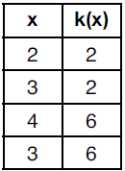

5 A mapping is shown in the diagram below.

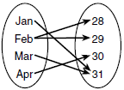

This mapping is
1) | a function, because Feb has two outputs, 28 and 29 | 3) | not a function, because Feb has two outputs, 28 and 29
2) | a function, because two inputs, Jan and Mar, result in the output 31 | 4) | not a function, because two inputs, Jan and Mar, result in the output 31

6 Which relation is not a function?
1) | 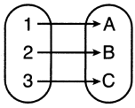 | 3) | 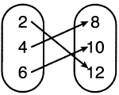
2) | 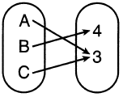 | 4) | 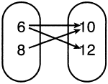

7 Which relation is a function?
1) |  | 3) | 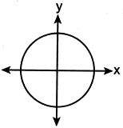
2) | 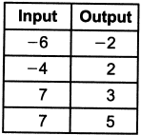 | 4) | 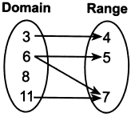

8 Which representations are functions?

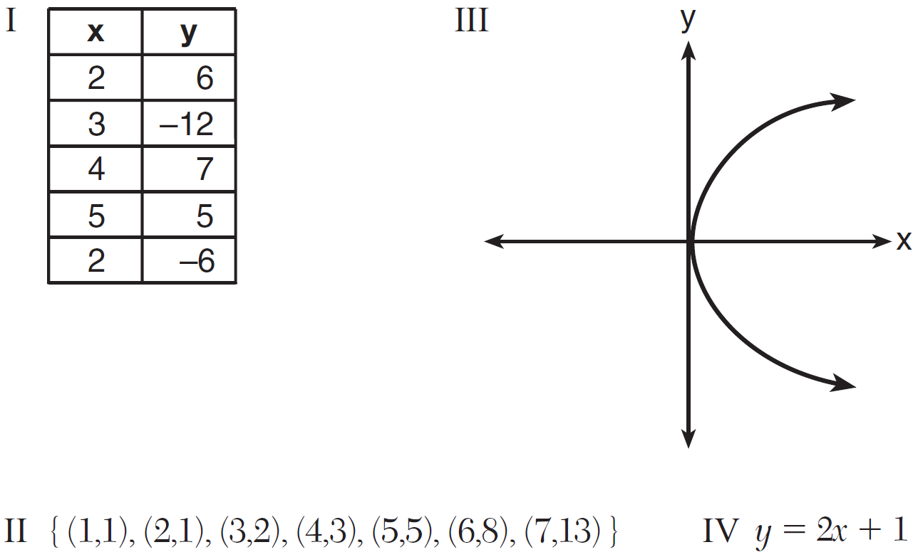
1) | I and II | 3) | III, only
2) | II and IV | 4) | IV, only

9 Which relation does not represent a function?
1) | 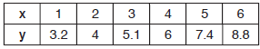 | 3)
2) | 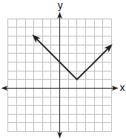 | 4) | 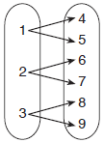

10 Which relation is not a function?
1) | 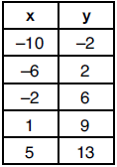 | 3) | 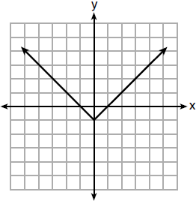
2) |  | 4) | 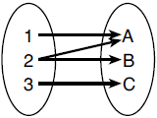

11 Which relation is a function?
1) | 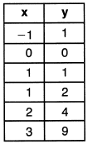 | 3) | 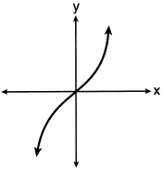
2) | 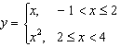 | 4)

12 Given the relation
Which value of x would make this relation a function?
1) |  | 3)
2) |  | 4)

13 Given the relation:
Which value of x will make this relation a function?
1) | 0 | 3) | 6
2) | 2 | 4) | 4

14 A function is defined as . Isaac is asked to create one more ordered pair for the function. Which ordered pair can he add to the set to keep it a function?
1) |  | 3)
2) |  | 4)

15 Marcel claims that the graph below represents a function.

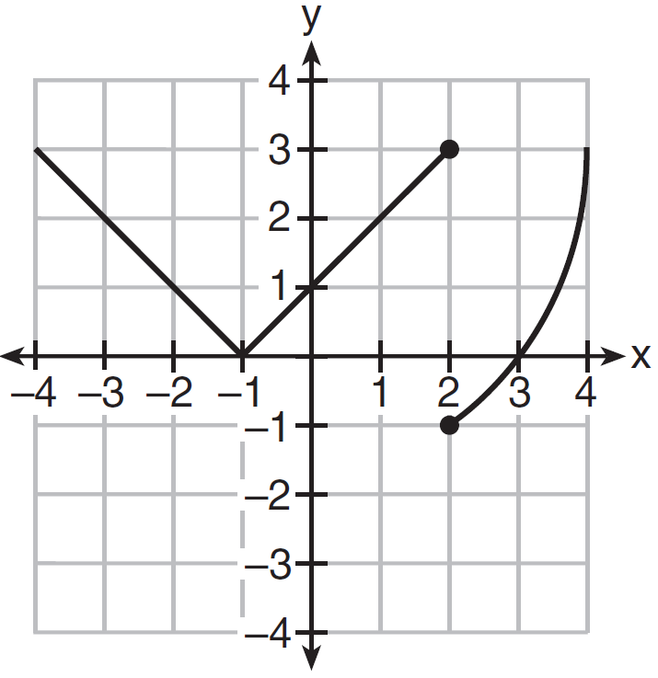

State whether Marcel is correct. Justify your answer.

16 A function is shown in the table below.
x | f(x)
 | 2
0
3 | 16

If included in the table, which ordered pair, or , would result in a relation that is no longer a function? Explain your answer.

17 Explain why the relation shown in the table below is a function.

x |  | 0 | 1 | 2
y | 2 | 4 | 4 | 5

Complete the table below with values for both x and y so that this new relation is not a function.

x |  | 0 | 1 | 2
y | 2 | 4 | 4 | 5

18 Given the relation . State a value for x that will make this relation a function. Explain why your answer makes this a function.

19 The two relations shown below are not functions.

Relation I:
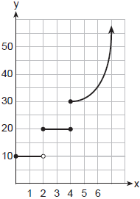

Relation II:

Explain how you could change each relation so that they each become a function.

20 Four relations are shown below.

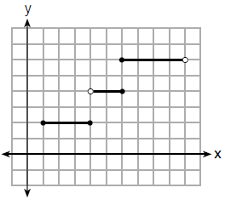
I

II

x | y
 | 1
0 | 3
4 | 5
6 | 6
III

IV

State which relation(s) are functions. Explain why the other relation(s) are not functions.

21 The function f has a domain of and a range of . Could f be represented by ? Justify your answer.

22 Nora says that the graph of a circle is a function because she can trace the whole graph without picking up her pencil. Mia says that a circle graph is not a function because multiple values of x map to the same y-value. Determine if either one is correct, and justify your answer completely.
1 ANS: 2 REF: 011804ai

2 ANS: 3 REF: 061504ai

3 ANS: 4 REF: 081902ai

4 ANS: 2 REF: 012004ai

5 ANS: 3 REF: 061709ai

6 ANS: 4 REF: 062104ai

7 ANS: 1 REF: 012305ai

8 ANS: 2 REF: 081511ai

9 ANS: 4 REF: 011907ai

10 ANS: 4 REF: 061903ai

11 ANS: 3 REF: 062210ai

12 ANS: 4 REF: 082204ai

13 ANS: 3 REF: 012402ai

14 ANS: 4 REF: 061811ai

15 ANS:
No, because the relation does not pass the vertical line test.

REF: 011626ai

16 ANS:
, because then every element of the domain is not assigned one unique element in the range.

REF: 011527ai

17 ANS:
For every value of x, there is a unique value of y. 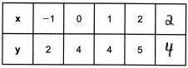

REF: 082427ai

18 ANS:
x may be any value other than , so that for any value of x, there is a unique y.

REF: 062427ai

19 ANS:
I: Change to an open circle. II: Remove .

REF: 062330ai

20 ANS:
III and IV are functions. I, for , has two y-values. II, for , has two y-values.
REF: 081826ai

21 ANS:
Yes, because every element of the domain is assigned one unique element in the range.
REF: 061430ai

22 ANS:
Neither is correct. Nora’s reason is wrong since a circle is not a function because it fails the vertical line test. Mia is wrong since a circle is not a function because multiple values of y map to the same x-value.
REF: 011732ai

