1 Beginning July 1, 2019, Michelle deposited $250 into an account that yields 0.15% each month. She continued to make $250 deposits into this account on the first of each month for 3 years. Which expression represents the amount of money that was in the account after her last deposit was made on June 1, 2022?
1) |  | 3) | 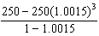
2) |  | 4) | 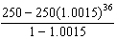

2 John and Margaret deposit $500 into a savings account for their son on his first birthday. They continue to make a deposit of $500 on the child's birthday, with the last deposit being made on the child's 21st birthday. If the account pays 4% annual interest, which equation represents the amount of money in the account after the last deposit is made?
1) |  | 3)
2) | 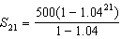 | 4) | 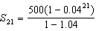

3 Jasmine decides to put $100 in a savings account each month. The account pays 3% annual interest, compounded monthly. How much money, S, will Jasmine have after one year?
1) |  | 3)
2) | 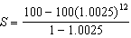 | 4) | 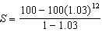

4 Jake wants to buy a car and hopes to save at least $5000 for a down payment. The table below summarizes the amount of money he plans to save each week.

Week | 1 | 2 | 3 | 4 | 5
Money Saved, in Dollars | 2 | 5 | 12.5 | 31.25 | ...

Based on this plan, which expression should he use to determine how much he has saved in n weeks?
1) | 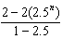 | 3) | 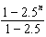
2) | 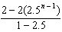 | 4) | 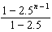

5 The sum of the first eight terms of the series is
1) |  | 3)
2) |  | 4)

6 The sum of the first 20 terms of the series is
1) |  | 3) | 1,743,392,200
2) |  | 4) | 2,324,522,934

7 The first term of a geometric sequence is 8 and the fourth term is 216. What is the sum of the first 12 terms of the corresponding series?
1) | 236,192 | 3) | 2,125,760
2) | 708,584 | 4) | 6,377,288

8 A ball is dropped from a height of 32 feet. It bounces and rebounds 80% of the height from which it was falling. What is the total downward distance, in feet, the ball traveled up to the 12th bounce?
1) | 29 | 3) | 120
2) | 58 | 4) | 149

9 Jay is training for a bike race over fifteen weeks. At the end of the first week, he has ridden ten miles, and he is planning to increase his weekly distance by nine percent each week. Approximately how many miles total will he have ridden from the beginning of his training to the end of the fifteenth week?
1) | 10.989 | 3) | 163.5
2) | 33.417 | 4) | 293.609

10 The crew aboard a small fishing boat caught 350 pounds of fish on Monday. From that Monday through the end of the week on Friday, the weight of the fish caught increased 15% per day. The total weight, in pounds, of fish caught is approximately
1) | 411 | 3) | 1748
2) | 612 | 4) | 2360

11 A 7-year lease for office space states that the annual rent is $85,000 for the first year and will increase by 6% each additional year of the lease. What will the total rent expense be for the entire 7-year lease?
1) | $42,809.63 | 3) | $595,000.00
2) | $90,425.53 | 4) | $713,476.20

12 A research assistant receives a first year salary of $90,000 and a 2% annual raise throughout the first ten years of employment. In total, how much money will be earned over the first ten years, to the nearest dollar?
1) | $91,837 | 3) | $877,917
2) | $109,709 | 4) | $985,475

13 Brian deposited 1 cent into an empty non-interest bearing bank account on the first day of the month. He then additionally deposited 3 cents on the second day, 9 cents on the third day, and 27 cents on the fourth day. What would be the total amount of money in the account at the end of the 20th day if the pattern continued?
1) | $11,622,614.67 | 3) | $116,226,146.80
2) | $17,433,922.00 | 4) | $1,743,392,200.00

14 Given the geometric series write a geometric series formula, , for the sum of the first n terms. Use the formula to find the sum of the first 10 terms, to the nearest tenth.

15 The initial push of a child on a swing causes the swing to travel a total of 6 feet. Each successive swing travels 80% of the distance of the previous swing. Determine the total distance, to the nearest hundredth of a foot, a child travels in the first five swings.

16 Rowan is training to run in a race. He runs 15 miles in the first week, and each week following, he runs 3% more than the week before. Using a geometric series formula, find the total number of miles Rowan runs over the first ten weeks of training, rounded to the nearest thousandth.

17 Sonja is cutting wire to construct a mobile. She cuts 100 inches for the first piece, 80 inches for the second piece, and 64 inches for the third piece. Assuming this pattern continues, write an explicit equation for , the length in inches of the nth piece. Sonja only has 40 feet of wire to use for the project and wants to cut 20 pieces total for the mobile using her pattern. Will she have enough wire? Justify your answer.

18 Alexa earns $33,000 in her first year of teaching and earns a 4% increase in each successive year. Write a geometric series formula, , for Alexa's total earnings over n years. Use this formula to find Alexa's total earnings for her first 15 years of teaching, to the nearest cent.
1 ANS: 4 REF: 012423aii

2 ANS: 2 REF: 062324aii

3 ANS: 2 REF: 061724aii

4 ANS: 1 REF: 081813aii

5 ANS: 3
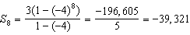

REF: 061304a2

6 ANS: 3
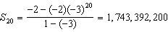

REF: 012306aii

7 ANS: 3
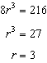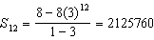

REF: 081902aii

8 ANS: 4
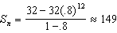

REF: 081721aii

9 ANS: 4
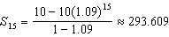

REF: 062424aii

10 ANS: 4
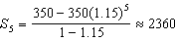

REF: 012524aii

11 ANS: 4
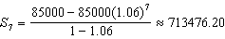

REF: 061905aii

12 ANS: 4
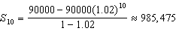

REF: 082424aii

13 ANS: 2
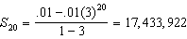

REF: 011822aii

14 ANS:
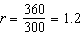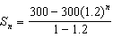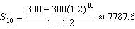

REF: 012029aii

15 ANS:
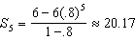

REF: 062226aii

16 ANS:
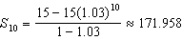

REF: 011929aii

17 ANS:
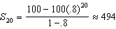 No, because .

REF: 012033aii

18 ANS:
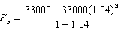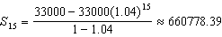

REF: 061634aii

