1 Which summation represents ?
1) |  | 3) | 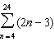
2) | 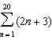 | 4) | 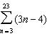

2 Mrs. Hill asked her students to express the sum using sigma notation. Four different student answers were given. Which student answer is correct?
1) | 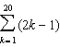 | 3) | 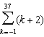
2) | 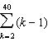 | 4) | 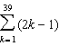

3 Which expression represents the sum of the sequence ?
1) | 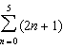 | 3) | 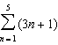
2) | 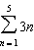 | 4) | 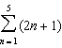

4 Which expression is equivalent to the sum of the sequence ?
1) | 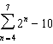 | 3) | 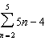
2) | 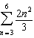 | 4) | 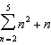

5 A jogger ran mile on day 1, and mile on day 2, and miles on day 3, and miles on day 4, and this pattern continued for 3 more days. Which expression represents the total distance the jogger ran?
1) | 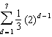 | 3) | 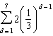
2) | 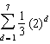 | 4) | 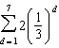

6 Which summation will not produce ?
1) |  | 3) | 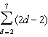
2) | 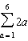 | 4) | 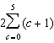

7 Kristin wants to increase her running endurance. According to experts, a gradual mileage increase of 10% per week can reduce the risk of injury. If Kristin runs 8 miles in week one, which expression can help her find the total number of miles she will have run over the course of her 6-week training program?
1) | 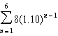 | 3) | 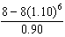
2) | 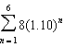 | 4) | 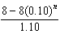

8 A company fired several employees in order to save money. The amount of money the company saved per year over five years following the loss of employees is shown in the table below.

Year | Amount Saved  (in dollars)
1 | 59,000
2 | 64,900
3 | 71,390
4 | 78,529
5 | 86,381.9

Which expression determines the total amount of money saved by the company over 5 years?
1) | 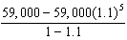 | 3) | 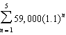
2) | 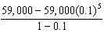 | 4) | 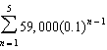

9 Jonathan’s teacher required him to express the sum 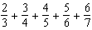 using sigma notation. Jonathan proposed four possible answers. Which of these four answers is not correct?
1) | 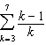 | 3) | 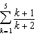
2) | 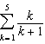 | 4) | 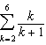

10 The expression is equivalent to
1) | 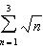 | 3) | 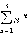
2) | 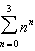 | 4) | 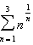

11 Express the sum using sigma notation.

1 ANS: 2 REF: 061205a2

2 ANS: 1 REF: 061025a2

3 ANS: 4 REF: 060807b

4 ANS: 4 REF: 011504a2

5 ANS: 1 REF: 061420a2

6 ANS: 1 REF: 011709a2

7 ANS: 1 REF: 081609aii

8 ANS: 1 REF: 082221aii

9 ANS: 2
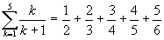.

REF: 080614b

10 ANS: 4
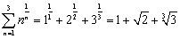

REF: 060714b

11 ANS:
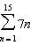

REF: 081029a2

