1 Simplify: 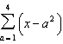.

2 The expression 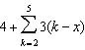 is equal to
1)
2)
3)
4)

3 What is the value of 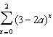?
1)
2)
3)
4)

4 Which expression is equivalent to 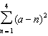?
1)
2)
3)
4)

5 If represents the number of combinations of n items taken r at a time, what is the value of 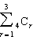?
1) | 24
2) | 14
3) | 6
4) | 4

6 What is the value of 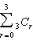?
1) | 8
2) | 9
3) | 3
4) | 4

7 The value of 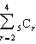 is
1) | 5
2) | 10
3) | 25
4) | 45

8 Evaluate: 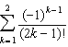

9 The value of , where i is the imaginary unit, is
1) | 1
2) | -1
3) | i
4) | -i

10 What is the value of 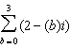?
1)
2)
3)
4)

11 If , what is the value of the expression 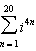?

12 What is the value of 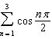?
1) | 1
2)
3) | 0
4)

13 The summation 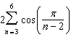 equals
1) | 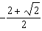
2)
3) | 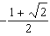
4)

14 Find the value of 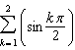

15 Evaluate: 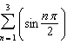

16 Evaluate: 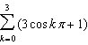

1 ANS:

REF: 081535a2

2 ANS: 4
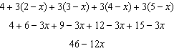

REF: 061315a2

3 ANS: 4

REF: 061526a2

4 ANS: 4
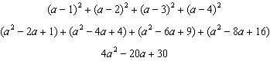

REF: 011414a2

5 ANS: 2
r |  | 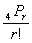
1 |  |  |  | 4
2 |  | 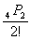 | 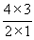 | 6
3 |  | 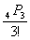 | 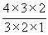 | 4
Σ |  |  |  | 14

REF: 080213b

6 ANS: 1
r
0 |  |  |  | 1
1 |  |  |  | 3
2 |  |  | 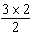 | 3
3 |  |  | 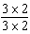 | 1
Σ |  |  |  | 8

REF: 061007b

7 ANS: 3
r |  | 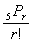
2 |  | 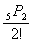 | 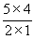 | 10
3 |  | 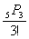 | 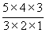 | 10
4 |  | 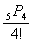 | 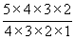 | 5
Σ |  |  |  | 25

REF: 010505b

8 ANS:
k | 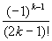
1 | 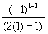 |  | 1
2 | 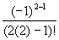
Σ

REF: 060624b

9 ANS: 1

REF: 081612a2

10 ANS: 4
b
0
1
2
3
Σ

REF: 010304b

11 ANS:
20. Since 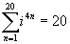.

REF: 010825b

12 ANS: 2
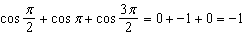

REF: 011617a2

13 ANS: 4

REF: 061605a2

14 ANS:
1

REF: 068111siii

15 ANS:
n | 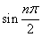
1 | 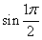 | 1
2 | 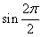 | 0
3 | 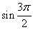 | -1
Σ |  | 0

REF: 010922b

16 ANS:
k | 3cos kπ + 1
0 | 3cos 0 + 1 | 3 + 1 | 4
1 | 3cos π + 1 | -3 + 1 | -2
2 | 3cos 2π + 1 | 3 + 1 | 4
3 | 3cos 3π + 1 | -3 + 1 | -2
Σ |  |  | 4

REF: 060523b

