1 What is the value of 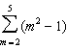?
1) | 58
2) | 54
3) | 53
4) | 50

2 What is the value of 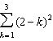?
1) | 1
2) | 2
3) | 3
4) | 0

3 The value of the expression 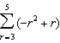 is
1)
2)
3) | 26
4) | 62

4 What is the value of 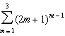?
1) | 15
2) | 55
3) | 57
4) | 245

5 The value of the expression 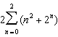 is
1) | 12
2) | 22
3) | 24
4) | 26

6 Evaluate: 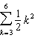

7 Compute: 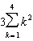

8 Evaluate: 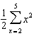.

9 Evaluate: 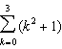

10 Evaluate: 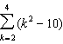

11 Evaluate: 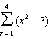

12 Evaluate: 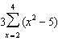

13 Evaluate: 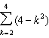

14 Evaluate: 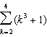

15 Evaluate: 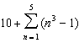

16 Evaluate: 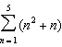

17 Evaluate: 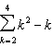

18 Evaluate: 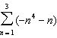

19 Evaluate: 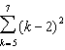

20 Evaluate: 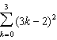

21 Evaluate: 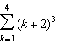

22 Evaluate: 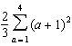

23 Evaluate: 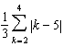

24 Evaluate: 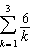

25 Find the value of 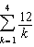

26 Evaluate: 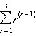

1 ANS: 4
m
2 |  | 3
3 |  | 8
4 |  | 15
5 |  | 24
Σ |  | 50

REF: 060201b

2 ANS: 2
k
1 |  | 1
2 |  | 0
3 |  | 1
Σ |  | 2

REF: 060903b

3 ANS: 1
n | 3 | 4 | 5

REF: 061118a2

4 ANS: 2
m
1 |  |  | 1
2 |  |  | 5
3 |  |  | 49
Σ |  |  | 55

REF: 060117b

5 ANS: 3
n | 0 | 1 | 2
 |  |  |  | 12

REF: fall0911a2

6 ANS:
43

REF: 080209siii

7 ANS:
90

REF: 068406siii

8 ANS:
27

REF: 068906siii

9 ANS:
18

REF: 088604siii

10 ANS:

REF: 018704siii

11 ANS:
18

REF: 089807siii

12 ANS:
x
2 |  | -1
3 |  | 4
4 |  | 11
Σ |  | 14

REF: 080823b

13 ANS:

REF: 089010siii

14 ANS:
102

REF: 088905siii

15 ANS:
230.

REF: 011131a2

16 ANS:
n
1 |  | 2
2 |  | 6
3 |  | 12
4 |  | 20
5 |  | 30
Σ |  | 70

REF: 080521b

17 ANS:
20

REF: 019505siii

18 ANS:
. 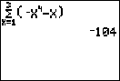

REF: 011230a2

19 ANS:
50
REF: 068006siii

20 ANS:
70
REF: 060114siii

21 ANS:
432
REF: 019806siii

22 ANS:
36
REF: 069511siii

23 ANS:
2
REF: 010414siii

24 ANS:
11
REF: 019004siii

25 ANS:
25
REF: 088504siii

26 ANS:
12
REF: 069611siii

