1 Find the value of 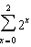.

2 Evaluate: 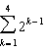

3 Find the value of 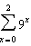.

4 What is the value of 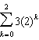?
1) | 15
2) | 19
3) | 21
4) | 43

5 A ball is dropped from a height of 8 feet and allowed to bounce. Each time the ball bounces, it bounces back to half its previous height. The vertical distance the ball travels, d, is given by the formula 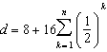, where n is the number of bounces. Based on this formula, what is the total vertical distance that the ball has traveled after four bounces?
1) | 8.9 ft
2) | 15.0 ft
3) | 22.0 ft
4) | 23.0 ft

1 ANS:
7

REF: 089706siii

2 ANS:
15

REF: 010108siii

3 ANS:
91

REF: 089511siii

4 ANS: 3
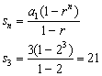

REF: 080904b

5 ANS: 4
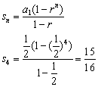. 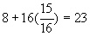.

REF: 080418b

