1 If , then is
1)
2)
3)
4)

2 If and , then equals
1) | 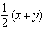
2) | 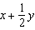
3)
4)

3 If and , then is equivalent to
1) | 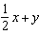
2) | 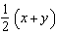
3)
4)

4 If and , what is ?
1)
2)
3) | 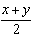
4) | 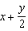

5 If , , and , then 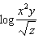 is equivalent to
1) | 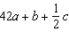
2) | 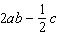
3) | 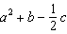
4) | 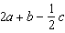

6 If and , then is equal to
1)
2)
3)
4)

7 If , then can be expressed as
1)
2)
3)
4)

8 If and , the expression 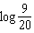 is equivalent to
1)
2)
3)
4) | 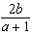

9 If and , what is the numerical value of 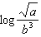?
1) | 8
2)
3) | 25
4)

10 Given: and
Express in terms of x and y: 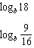

11 Given: and
Express in terms of x and y: 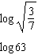

12 Given: and
Express in terms of x and y: 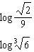

13 Given: and
Express in terms of p and q: 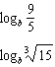

14 Given:
Express in terms of x and y: 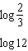

15 Given: and
Express in terms of a and b: 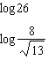

16 Given: and
Express in terms of x and y: 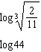

17 Given: and
Find

18 Given: and
Find: 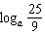 and

19 Given: and
Find: and 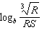

1 ANS: 2 REF: 089620siii

2 ANS: 3

REF: 081618a2

3 ANS: 2 REF: 069026siii

4 ANS: 4
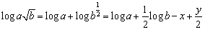

REF: 060510b

5 ANS: 4
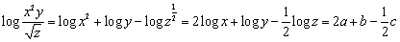

REF: 010409b

6 ANS: 2 REF: 088419siii

7 ANS: 2

REF: 080110b

8 ANS: 2
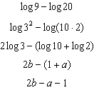

REF: 011326a2

9 ANS: 2
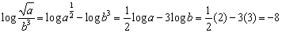

REF: 060316b

10 ANS:
,

REF: 010439siii

11 ANS:
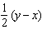,

REF: 019637siii

12 ANS:
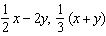

REF: 069640siii

13 ANS:
, 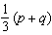

REF: 069838siii

14 ANS:

REF: 010041siii

15 ANS:
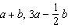

REF: 060140siii

16 ANS:
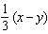,

REF: 060339siii

17 ANS:
1.2424

REF: 089342siii

18 ANS:
1.47, 2.745

REF: 069441siii

19 ANS:
1.75,

REF: 019840siii

