1 The expression is equivalent to
1)
2) | 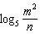
3)
4) | 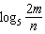

2 The expression is equivalent to
1) | 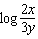
2)
3) | 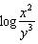
4) | 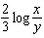

3 The expression is equivalent to
1) | 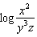
2) | 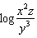
3) | 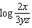
4) | 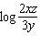

4 The expression is equivalent to
1)
2) | 2
3) | 100
4)

5 The expression 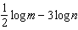 is equivalent to
1)
2) | 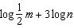
3) | 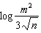
4) | 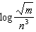

6 The expression 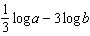 is equivalent to
1)
2) | 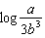
3) | 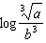
4) | 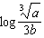

7 The expression 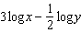 is equal to
1) | 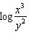
2) | 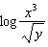
3) | 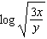
4) | 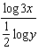

8 The expression 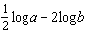 is equivalent to
1) | 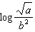
2)
3) | 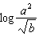
4)

9 The expression 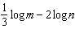 is equivalent to
1) | 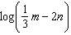
2) | 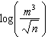
3)
4) | 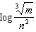

10 If , then x equals
1)
2)
3)
4)

11 If , k equals
1)
2)
3)
4)

12 If , then x is equal to
1)
2)
3)
4)

13 If , is equal to
1)
2)
3)
4)

14 If 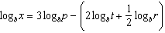, then the value of x is
1) | 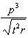
2) | 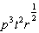
3) | 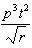
4) | 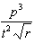

1 ANS: 1 REF: 068423siii

2 ANS: 3 REF: 080226siii

3 ANS: 1
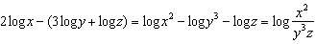

REF: 061010a2

4 ANS: 2
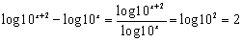

REF: 010316b

5 ANS: 4 REF: 080809b

6 ANS: 3 REF: 018431siii

7 ANS: 2 REF: 088528siii

8 ANS: 1 REF: 018920siii

9 ANS: 4 REF: 019529siii

10 ANS: 1
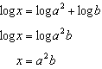

REF: 061517a2

11 ANS: 1
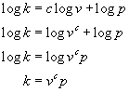

REF: 080212b

12 ANS: 2 REF: 011014b

13 ANS: 4 REF: 010333siii

14 ANS: 4 REF: 061207a2

