1 Which expression is not equivalent to ?
1)
2)
3)
4)

2 The expression is equivalent to
1)
2)
3)
4)

3 The expression is equivalent to
1)
2)
3)
4)

4 The expression is equivalent to
1)
2)
3)
4)

5 If , equals
1)
2)
3)
4)

6 If , then equals
1)
2)
3)
4)

7 If 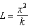, then is equal to
1) | 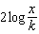
2)
3)
4) | 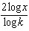

8 The expression 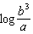 is equivalent to
1)
2)
3)
4) | 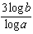

9 If 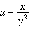, which expression is equivalent to ?
1)
2)
3)
4)

10 If 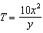, then is equivalent to
1)
2)
3)
4)

11 The expression is equivalent to
1)
2)
3) | 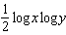
4) | 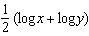

12 If , which expression is equivalent to ?
1)
2) | 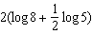
3) | 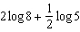
4) | 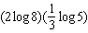

13 If 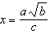, then is equal to
1) | 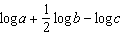
2)
3) | 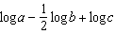
4)

14 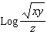 is equal to
1) | 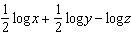
2) | 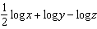
3) | 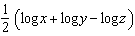
4) | 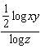

15 The expression 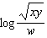 is equivalent to
1) | 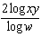
2)
3) | 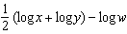
4) | 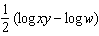

16 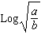 is equivalent to
1) | 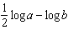
2) | 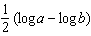
3) | 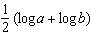
4) | 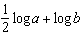

17 The expression 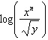 is equivalent to
1) | 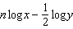
2)
3) | 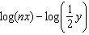
4)

18 The expression 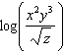 is equivalent to
1) | 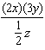
2) | 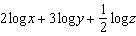
3) | 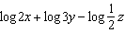
4) | 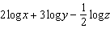

19 The expression 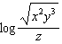 is equivalent to
1) | 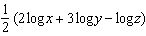
2) | 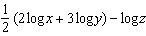
3)
4) | 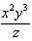

20 The expression 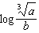 is equivalent to
1) | 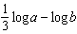
2) | 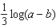
3)
4)

21 If 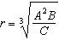, then can be represented by
1) | 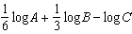
2)
3) | 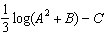
4) | 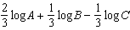

22 The equation 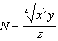 is equivalent to
1) | 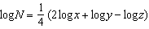
2) | 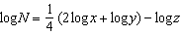
3) | 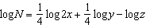
4) | 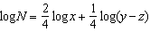

23 The expression 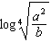 is equivalent to
1) | 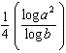
2)
3) | 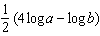
4) | 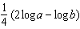

24 If , then expressed in terms of is equivalent to
1) | 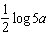
2) | 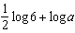
3)
4)

25 is equivalent to
1)
2)
3)
4)

26 The magnitude (R) of an earthquake is related to its intensity (I) by 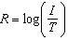, where T is the threshold below which the earthquake is not noticed. If the intensity is doubled, its magnitude can be represented by
1)
2)
3)
4)

27 The speed of sound, v, at temperature T, in degrees Kelvin, is represented by the equation 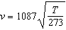. Which expression is equivalent to ?
1) | 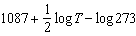
2) | 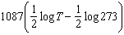
3) | 
4)

28 A black hole is a region in space where objects seem to disappear. A formula used in the study of black holes is the Schwarzschild formula, 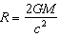. Based on the laws of logarithms, can be represented by
1)
2)
3)
4)

29 Banks use the formula when they compound interest annually. If P represents the amount of money invested and r represents the rate of interest, which expression represents , where A represents the amount of money in the account after x years?
1)
2)
3)
4)

30 The equation used to determine the time it takes a swinging pendulum to return to its starting point is 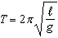, where T represents time, in seconds, represents the length of the pendulum, in feet, and g equals . How is this equation expressed in logarithmic form?
1)
2) | 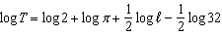
3) | 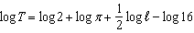
4) | 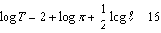

1 ANS: 1
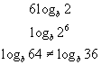

REF: 010208b

2 ANS: 2 REF: 060029siii

3 ANS: 3 REF: 080022siii

4 ANS: 3

REF: 061321a2

5 ANS: 2 REF: 010220siii

6 ANS: 4

REF: 061426a2

7 ANS: 3 REF: 068529siii

8 ANS: 3 REF: 060319siii

9 ANS: 4 REF: 089315siii

10 ANS: 1
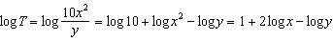

REF: 011615a2

11 ANS: 4 REF: 068122siii

12 ANS: 3 REF: 068918siii

13 ANS: 1 REF: 068023siii

14 ANS: 1 REF: 019025siii

15 ANS: 3 REF: 010124siii

16 ANS: 2 REF: 069519siii

17 ANS: 1 REF: 089718siii

18 ANS: 4 REF: 069917siii

19 ANS: 2 REF: 080122siii

20 ANS: 1 REF: 068821siii

21 ANS: 4 REF: 061120a2

22 ANS: 2 REF: 069420siii

23 ANS: 4 REF: 019619siii

24 ANS: 2
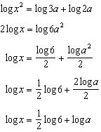

REF: 011224a2

25 ANS: 4 REF: 018625siii

26 ANS: 4
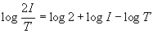

REF: 060102b

27 ANS: 3
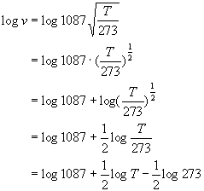

REF: 010611b

28 ANS: 3

REF: 010717b

29 ANS: 2

REF: 080911b

30 ANS: 2
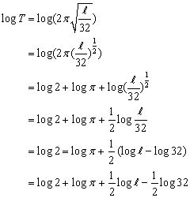

REF: 080709b

