1 If , what is the value of x?
1) 7 2) 14 3) 24 4) 32

2 In the equation , x is equal to
1) 2) 6 3) 6.5 4) 18

3 If , then x equals
1) 2) 3) 4)

4 Solve for x:

5 Solve for x:

6 Solve for all values of x:

7 Solve for x:

8 Solve for x:

9 Solve algebraically for all values of x:

10 Solve algebraically, to the nearest hundredth, for all values of x:

11 Solve for p algebraically: 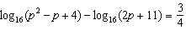

1 ANS: 1 REF: 069626siii

2 ANS: 2
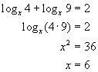
REF: 080209b

3 ANS: 3
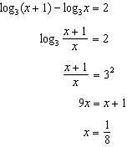
REF: 011711a2

4 ANS:
18. 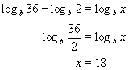
REF: 080624b

5 ANS:
10
REF: 089342siii

6 ANS:
5
REF: 010439siii

7 ANS:
. 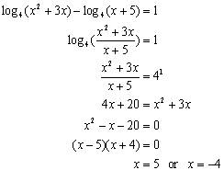
REF: 060230b

8 ANS:
11. 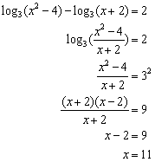
REF: 060833b

9 ANS: 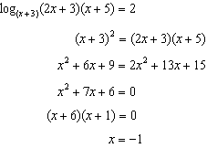 is extraneous
REF: 011439a2

10 ANS: 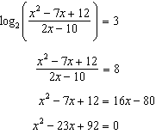 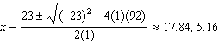
REF: 081539a2

11 ANS: 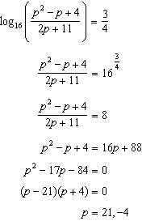
REF: 061639a2

