1 If , then x is equal to
1) | 7 | 3) | 64
2) | 12 | 4) | 81

2 If , what is the value of ?
1) |  | 3) | 5
2) |  | 4) | 25

3 What is the value of x in the equation ?
1) | 1.16 | 3) | 625
2) | 20 | 4) | 1,024

4 If , then the solution set for x is
1) |  | 3)
2) |  | 4)

5 If , find x.

6 If , find the value of m.

7 If , find x.

8 Find the value of x that satisfies the equation .

9 Solve for x:

10 Solve for x: 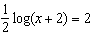

11 If , find the value of N, to the nearest integer.

12 The relationship between the relative size of an earthquake, S, and the measure of the earthquake on the Richter scale, R, is given by the equation . If an earthquake measured 3.2 on the Richter scale, what was its relative size to the nearest hundredth?

13 Solve for the positive value of x:

14 Solve for x:

15 If , find the value of n.

16 Solve for x:

17 Solve algebraically for all values of x:

18 If , find the value of x.

19 If , find the value of x.

20 Solve algebraically for x: 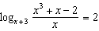

21 Solve for x to the nearest tenth:

22 The solution of is
1) |  | 3)
2) |  | 4)

23 Solve algebraically for the exact value of x:

1 ANS: 3 REF: 019920siii

2 ANS: 3
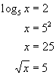

REF: 010519b

3 ANS: 3

REF: 061106a2

4 ANS: 1 REF: 069919siii

5 ANS:
64

REF: 068017siii

6 ANS:
32

REF: 018508siii

7 ANS:
16

REF: 060206siii

8 ANS:
81

REF: 080307siii

9 ANS:
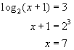

REF: 060623b

10 ANS:
9998

REF: 019442siii

11 ANS:
7259

REF: 088715siii

12 ANS:
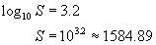

REF: 010324b

13 ANS:
3

REF: 018703siii

14 ANS:
6

REF: 068904siii

15 ANS:
2

REF: 089813siii

16 ANS:
5

REF: 069604siii

17 ANS:
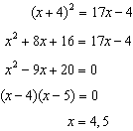

REF: 011336a2

18 ANS:
2

REF: 069004siii

19 ANS:
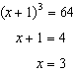

REF: 061531a2

20 ANS:
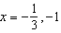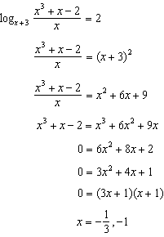

REF: 081039a2

21 ANS:
1.7

REF: 018439siii

22 ANS: 2 REF: 080228siii

23 ANS:
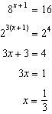

REF: 011630a2

