1 If the point lies on the graph , the graph of must contain point
1)
2)
3)
4)

2 The image of function is found by mapping each point on the function to the point . This image is a reflection of in
1) | the x-axis
2) | the y-axis
3) | the line whose equation is
4) | the line whose equation is

3 The inverse function of is
1)
2)
3)
4)

4 If , which statement is true?
1) | m and its inverse are both functions.
2) | m is a function and its inverse is not a function.
3) | m is not a function and its inverse is a function.
4) | Neither m nor its inverse is a function.

5 Given the relation
Which statement is true?
1) | Both A and are functions.
2) | Neither A nor is a function.
3) | Only A is a function.
4) | Only is a function.

6 Given:
If the inverse of the set is , which statement is true?
1) | A and are functions.
2) | A nor are not functions.
3) | A is a function and is not a function.
4) | A is not a function and is a function.

7 Write the inverse of the given function:

8 By what transformation can the set representing the inverse of a function be found?
1) | reflection in the origin
2) | reflection in the line
3) | rotation of 90º about the origin
4) | reflection in the y-axis

9 The accompanying diagram represents the graph of .

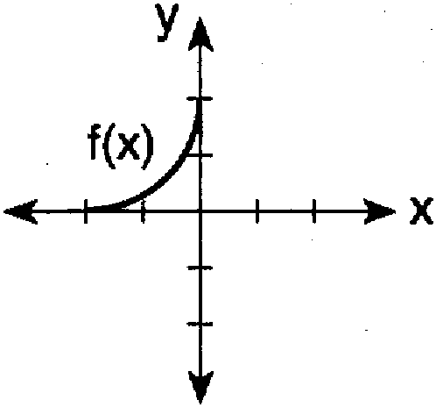

Which graph represents ?
1) | 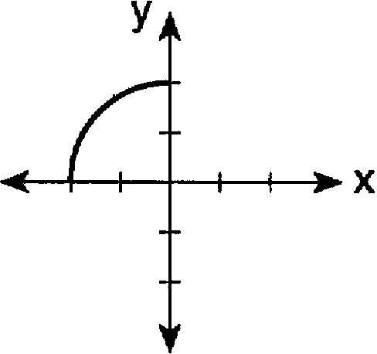
2) | 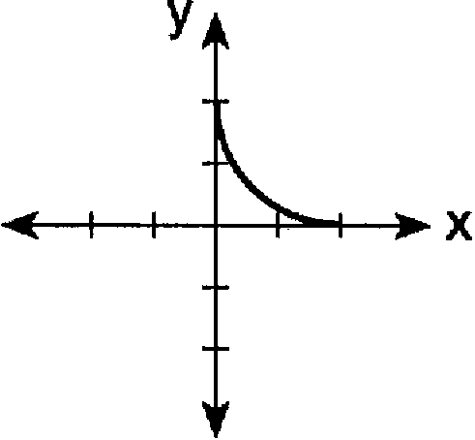
3) | 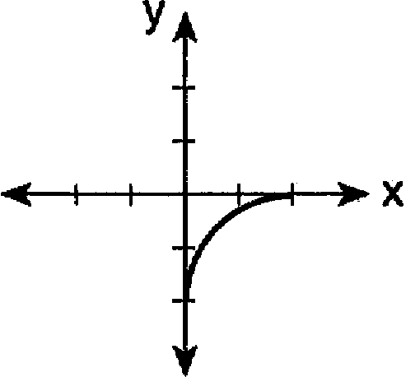
4) | 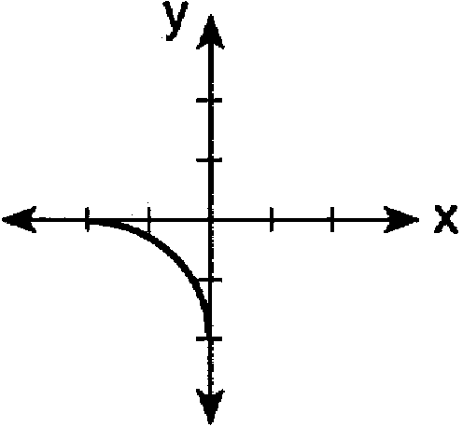

10 The graph of is shown below. Which graph represents ?
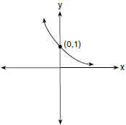
1) | 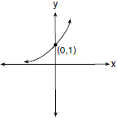
2) | 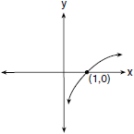
3) | 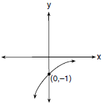
4) | 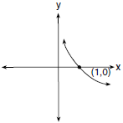

11 The accompanying graph shows the relationship between kinetic energy, y, and velocity, x.

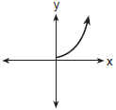

The reflection of this graph in the line is
1) | 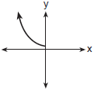
2) | 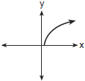
3) | 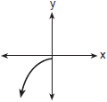
4) | 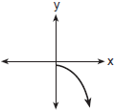

12 Which graph represents the inverse of ?
1) | 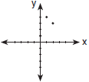
2) | 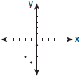
3) | 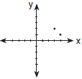
4) | 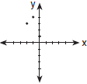

13 Which graph has an inverse that is a function?
1) | 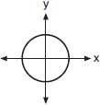
2) | 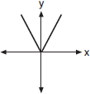
3) | 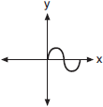
4) | 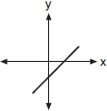

14 The accompanying diagram shows the graph of the line whose equation is 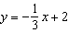. On the same set of axes, sketch the graph of the inverse of this function. State the coordinates of a point on the inverse function.

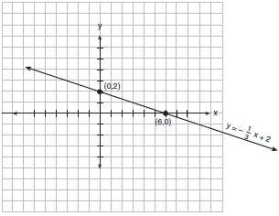

15 The function, f, is drawn on the accompanying set of axes. On the same set of axes, sketch the graph of , the inverse of f.

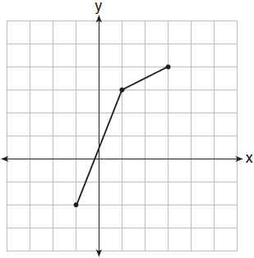

16 The accompanying graph shows the relationship between the cooling time of magma and the size of the crystals produced after a volcanic eruption. On the same graph, sketch the inverse of this function.

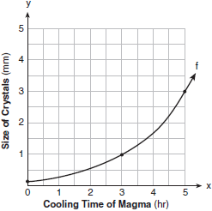

17 On the accompanying set of axes, graph the function and its inverse, .

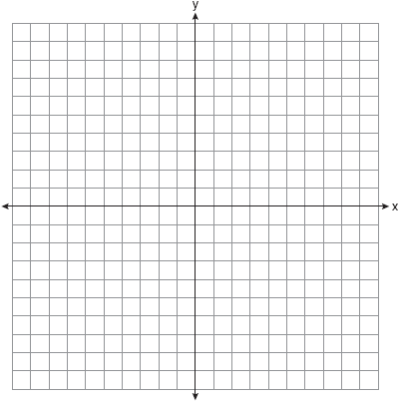

18 Draw and in the interval on the accompanying set of axes. State the coordinates of the points of intersection.



19 If , find .

20 If and 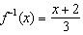, then equals
1) | x
2)
3) | 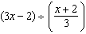
4) | 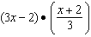

21 When 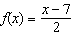, what is the value of ?
1)
2)
3) | 3
4)

22 Given: and .
Find: , , , ,

1 ANS: 1 REF: 080216b

2 ANS: 3 REF: 011010b

3 ANS: 3 REF: 019024siii

4 ANS: 2 REF: 081523a2

5 ANS: 3
A is a function because for every x, there is a unique y. is not a function. For the element “2” in the domain, there are two elements in the range, “3” and “6”.

REF: 010914b

6 ANS: 1 REF: 069424siii

7 ANS:

REF: 069009siii

8 ANS: 2 REF: 018730siii

9 ANS: 3 REF: 069623siii

10 ANS: 4 REF: 011727a2

11 ANS: 2 REF: 080820b

12 ANS: 3

REF: 060220b

13 ANS: 4
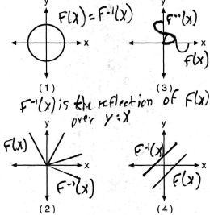

REF: 080712b

14 ANS:
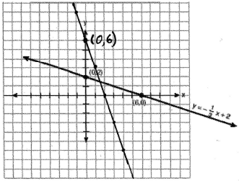. 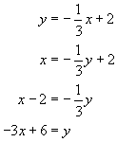

REF: 010521b

15 ANS:
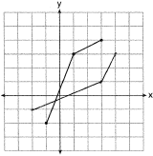

REF: 011024b

16 ANS:
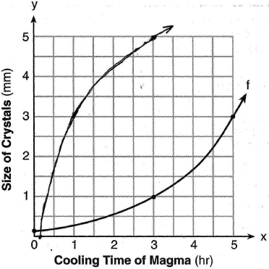

REF: 060926b

17 ANS:
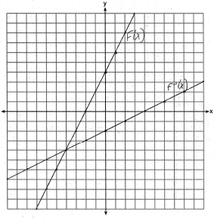

REF: 080826b

18 ANS:
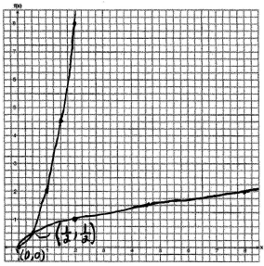. 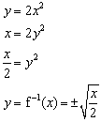

REF: 060130b

19 ANS:
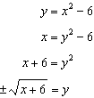

REF: 061132a2

20 ANS: 1
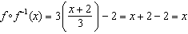
REF: 011726a2

21 ANS: 3
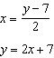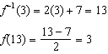
REF: 061619a2

22 ANS:
25, 5, 10, 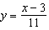, 9
REF: 019641siii

