1 What is the inverse of 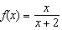, where ?
1) | 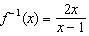 | 3) | 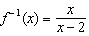
2) | 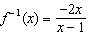 | 4) | 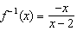

2 The inverse of the function 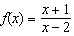 is
1) | 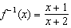 | 3) | 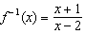
2) | 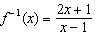 | 4) | 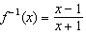

1 ANS: 2
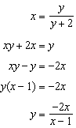

REF: 081924aii

2 ANS: 2
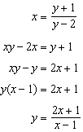

REF: 081714aii

