1 If where , then the inverse of the function is
1) |  | 3)
2) |  | 4)

2 The inverse of a function is a logarithmic function in the form . Which equation represents the original function?
1) |  | 3)
2) |  | 4)

3 What is the inverse of the function ?
1) |  | 3)
2) |  | 4)

4 What is the inverse of the function ?
1) |  | 3)
2) |  | 4)

5 Which equation defines a function whose inverse is not a function?
1) |  | 3)
2) |  | 4)

6 Which two functions are inverse functions of each other?
1) | and | 3) | and
2) | and | 4) | and 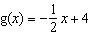

7 Consider the function . Is an even function? Justify your answer. Write an equation for , the function that results after is shifted up 5 units. Write an equation for , the inverse of .

1 ANS: 3 REF: 011917aii

2 ANS: 1
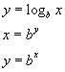

REF: 060115b

3 ANS: 3 REF: 011708aii

4 ANS: 2 REF: 061521a2

5 ANS: 1 REF: 068932siii

6 ANS: 3 REF: 081027a2

7 ANS:
No, because 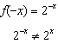 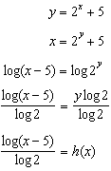

REF: 082435aii

