1 For the function , the inverse function, , equals
1) |  | 3)
2) |  | 4)

2 Given and , the value of b is
1) | 1 | 3) | 3
2) |  | 4)

3 What is the inverse of ?
1) |  | 3)
2) |  | 4)

4 For the function , find .

1 ANS: 4
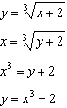

REF: 062419aii

2 ANS: 2
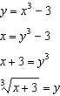

REF: 012419aii

3 ANS: 3
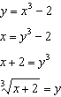

REF: 061815aii

4 ANS:
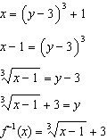

REF: fall1509aii

