1 If the graph of the equation is reflected in the line , the equation of the image is
1)
2) | 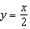
3)
4) | 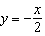

2 Which equation is the inverse of ?
1)
2) | 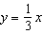
3)
4) | 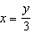

3 What is the inverse of 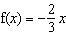?
1) | 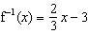
2) | 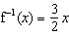
3) | 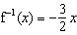
4) | 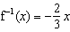

4 Which is an equation of the inverse of 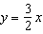?
1) | 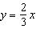
2) | 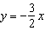
3)
4) | 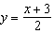

5 What is the inverse of the function ?
1)
2)
3) | 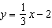
4) | 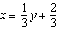

6 If a function is defined by the equation , which equation defines the inverse of this function?
1) | 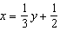
2) | 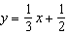
3) | 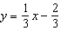
4)

7 A function is defined by the equation . Which equation defines the inverse of this function?
1) | 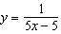
2)
3) | 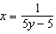
4)

8 What is the inverse of the function ?
1)
2) | 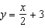
3)
4) | 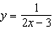

9 What is the inverse of the function ?
1)
2) | 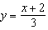
3) | 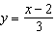
4)

10 What is an equation of the line formed when the line is reflected in the line ?
1)
2) | 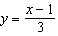
3) | 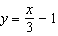
4)

11 What is the inverse of the function ?
1) | 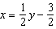
2) | 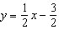
3)
4)

12 What is the inverse of the function ?
1) | 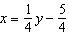
2) | 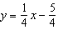
3)
4) | 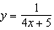

13 If , then the inverse function is
1) | 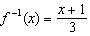
2) | 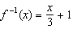
3) | 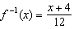
4) | 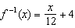

14 What equation is the inverse of ?
1)
2)
3) | 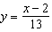
4) | 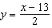

15 The inverse of the function is
1) | 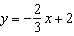
2) | 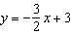
3) | 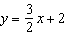
4) | 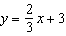

16 The inverse of the function is
1) | 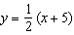
2) | 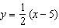
3)
4)

17 What is the inverse of the function ?
1) | 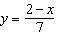
2) | 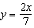
3)
4) | 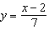

18 If 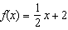, then the inverse function is
1) | 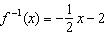
2) | 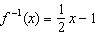
3)
4)

19 Given 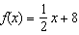, which equation represents the inverse, ?
1)
2)
3) | 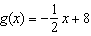
4) | 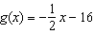

20 A function is defined by the equation . Which equation defines the inverse of this function?
1)
2)
3) | 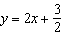
4) | 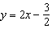

21 What is the inverse of ?
1) | 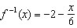
2) | 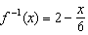
3) | 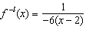
4)

22 The inverse of 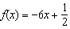 is
1) | 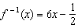
2) | 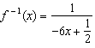
3) | 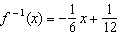
4) | 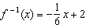

23 Given 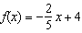, which statement is true of the inverse function ?
1) | is a line with slope .
2) | is a line with slope .
3) | passes through the point .
4) | has a y-intercept at .

24 Given 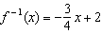, which equation represents ?
1) | 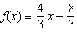
2) | 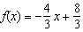
3) | 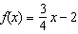
4) | 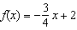

25 Given the inverse function 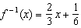, which function represents ?
1) | 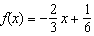
2) | 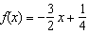
3) | 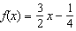
4) | 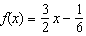

1 ANS: 2 REF: 088927siii

2 ANS: 2 REF: 089532siii

3 ANS: 3 REF: 088432siii

4 ANS: 1 REF: 089728siii

5 ANS: 2 REF: 019626siii

6 ANS: 3
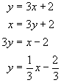

REF: 010209b

7 ANS: 4
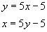

REF: 080205b

8 ANS: 1
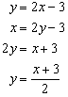

REF: 080918b

9 ANS: 2 REF: 011011b

10 ANS: 2 REF: 088530siii

11 ANS: 2 REF: 068635siii

12 ANS: 2
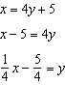

REF: 061909aii

13 ANS: 3
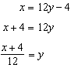

REF: 082304aii

14 ANS: 3 REF: 010434siii

15 ANS: 2 REF: 089024siii

16 ANS: 1 REF: 080028siii

17 ANS: 4 REF: 060126siii

18 ANS: 3
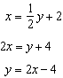

REF: 012315aii

19 ANS: 2
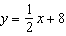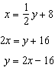

REF: 081806aii

20 ANS: 1
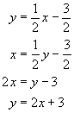

REF: 080319b

21 ANS: 2
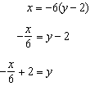

REF: 011821aii

22 ANS: 3
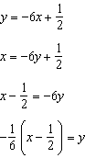

REF: 062217aii

23 ANS: 3
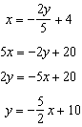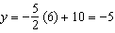

REF: 082223aii

24 ANS: 2
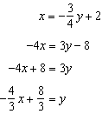

REF: 061616aii

25 ANS: 3
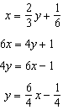

REF: 062321aii

