1 Which transformation of moves the graph 7 units to the left and 3 units down?
1)
2)
3)
4)

2 The maximum point on the graph of the equation is . What is the maximum point on the graph of the equation ?
1)
2)
3)
4)

3 The minimum point on the graph of the equation is . What is the minimum point on the graph of the equation ?
1)
2)
3)
4)

4 The graph of the equation is shown in the diagram below.

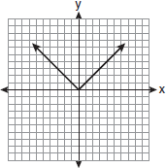

Which diagram could represent a graph of the equation when ?
1) | 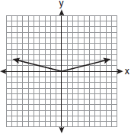
2) | 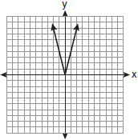
3) | 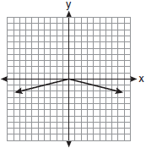
4) | 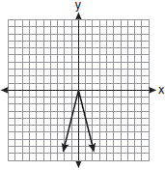

5 The diagram below shows the graph of .

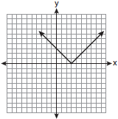

Which diagram shows the graph of ?
1) | 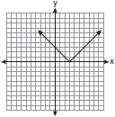
2) | 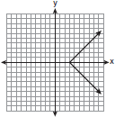
3) | 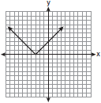
4) | 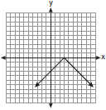

6 The graph of is shown below.

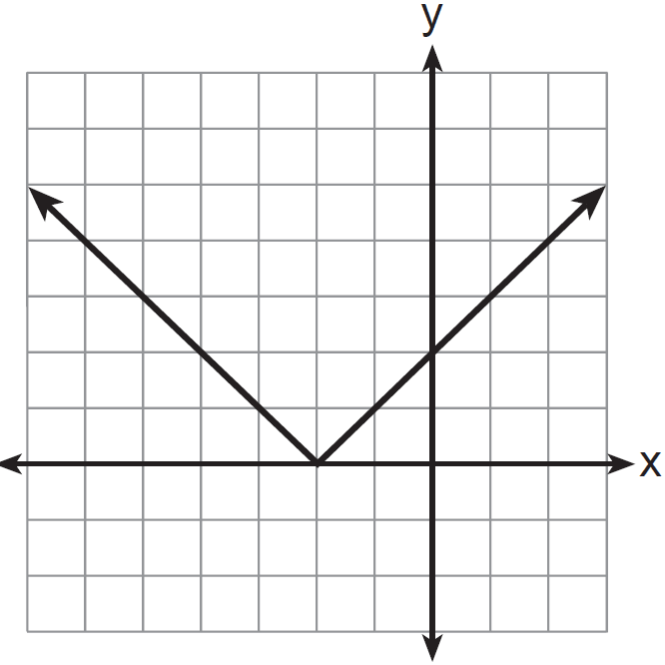

Which graph represents ?
1) | 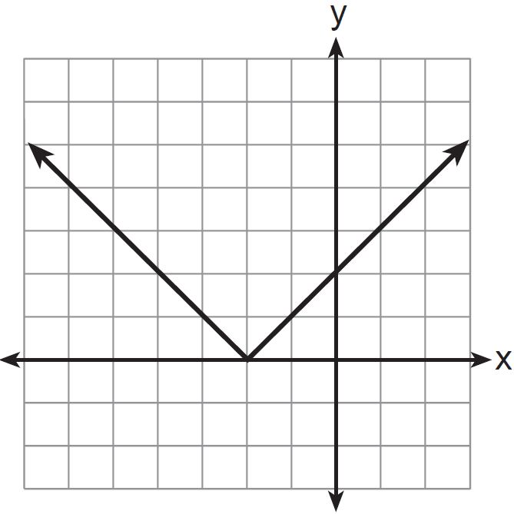
2) | 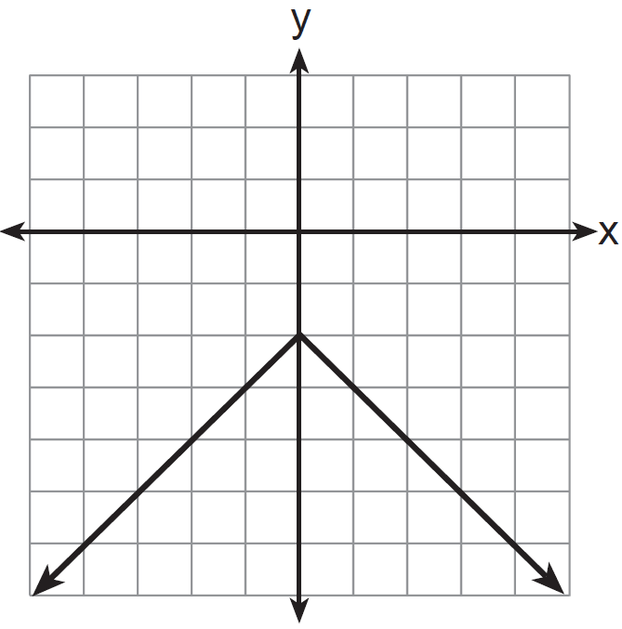
3) | 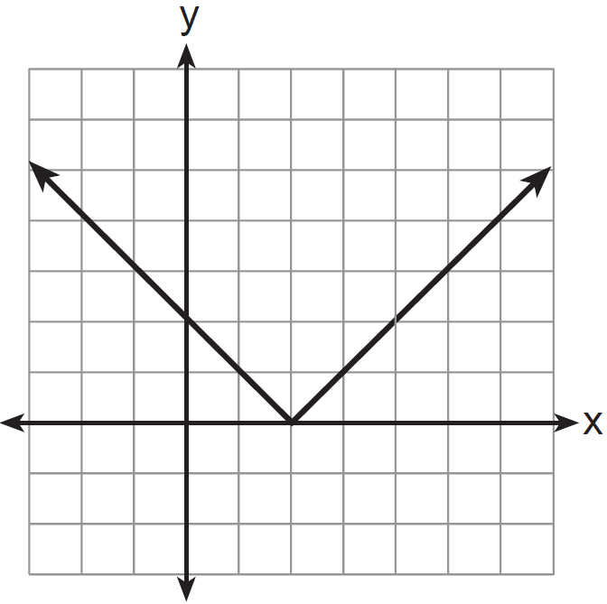
4) | 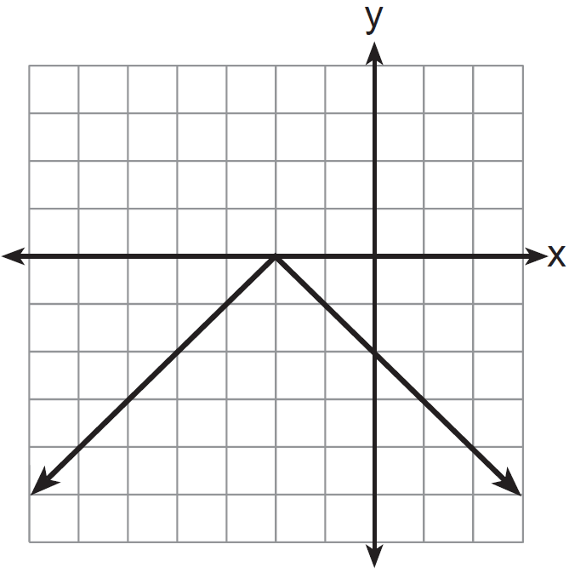

7 Dominick graphs the equation where a is a positive integer. If Gina multiplies a by , the new graph will become
1) | narrower and open downward
2) | narrower and open upward
3) | wider and open downward
4) | wider and open upward

8 Graph and label the functions and on the set of axes below.

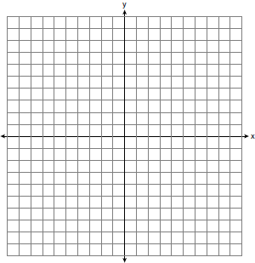

Explain how increasing the coefficient of x affects the graph of .

9 On the set of axes below, graph and label the equations and for the interval .

Explain how changing the coefficient of the absolute value from 1 to 3 affects the graph.

10 Graph and label the following equations on the set of axes below.
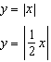
Explain how decreasing the coefficient of x affects the graph of the equation .

11 The graph of is shown below.

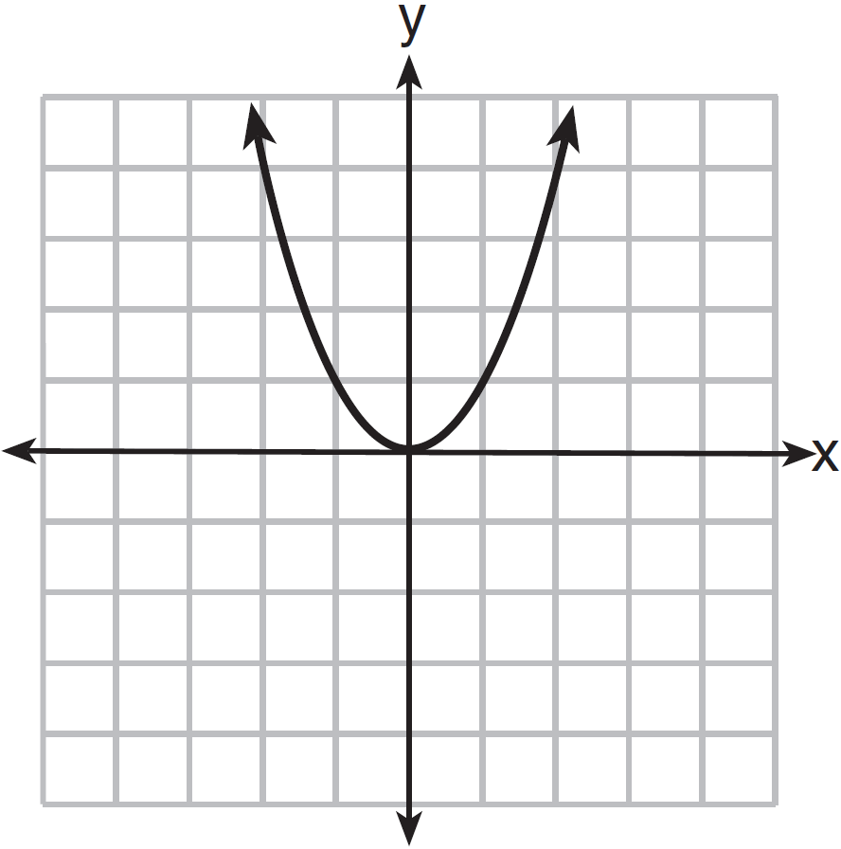

Which graph represents ?
1) | 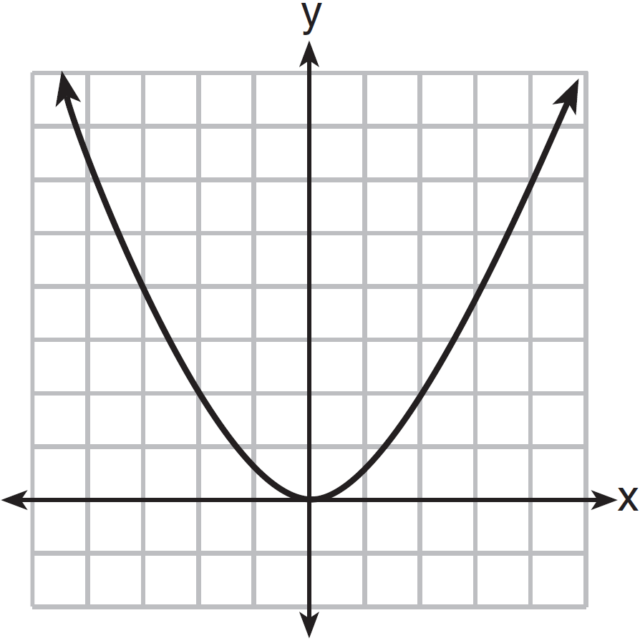
2) | 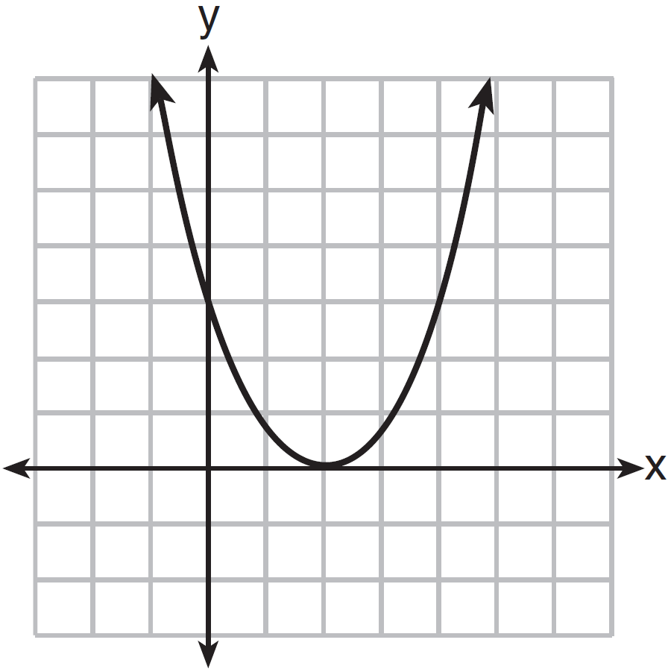
3) | 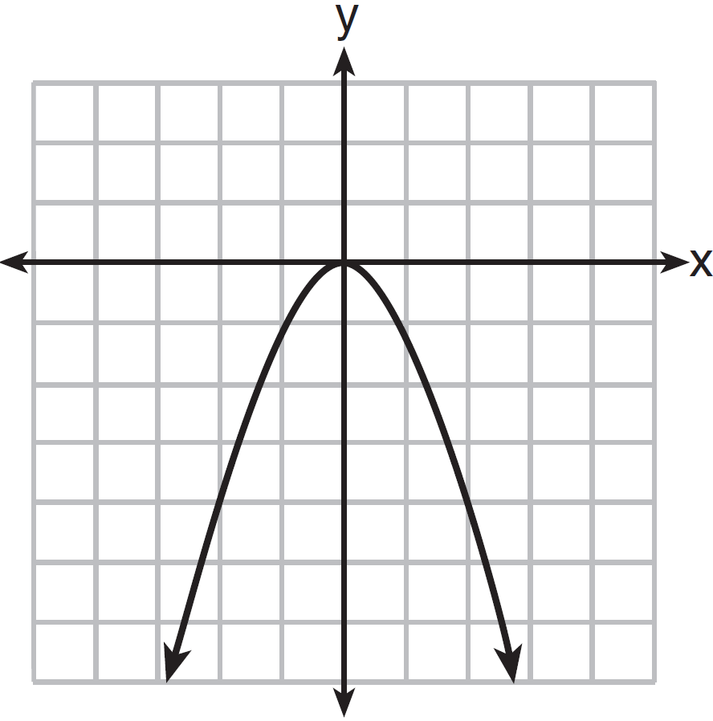
4) | 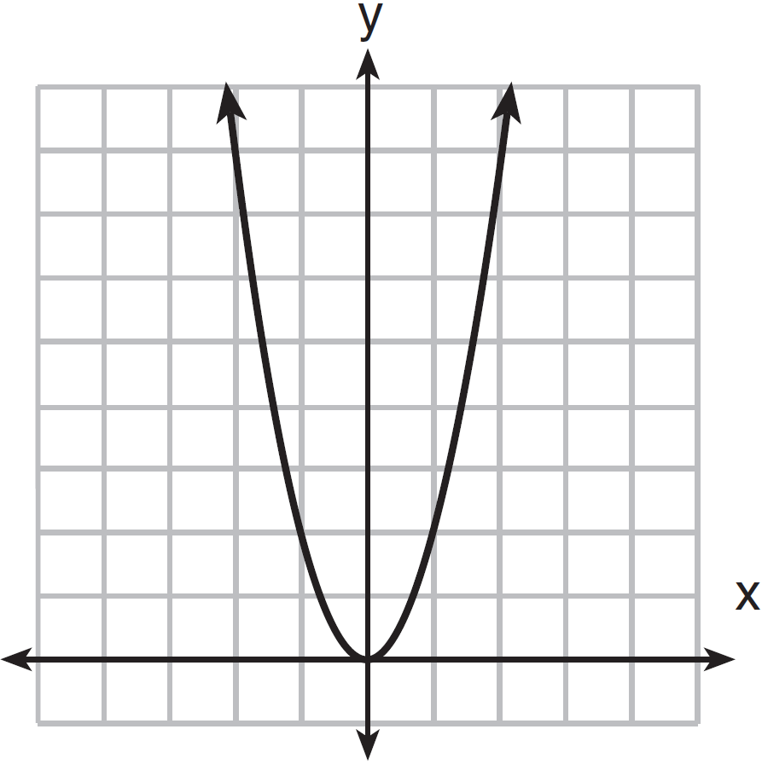

12 The graph below shows the function .

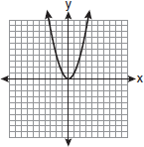

Which graph represents the function ?
1) | 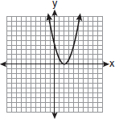
2) | 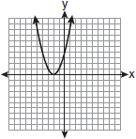
3) | 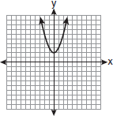
4) | 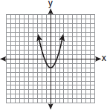

13 The diagram below shows the graph of .

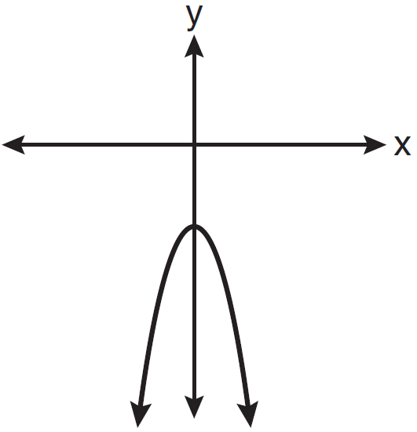

Which diagram shows the graph of ?
1) | 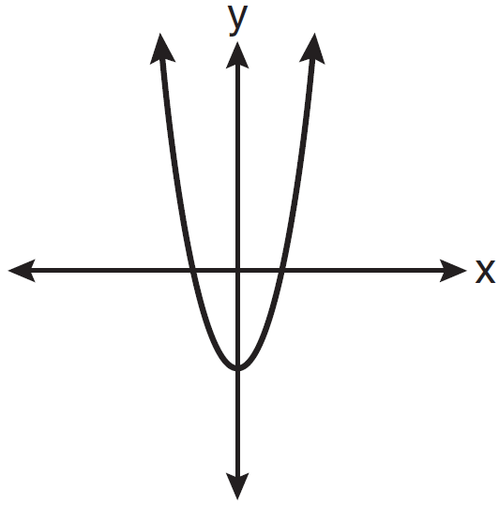
2) | 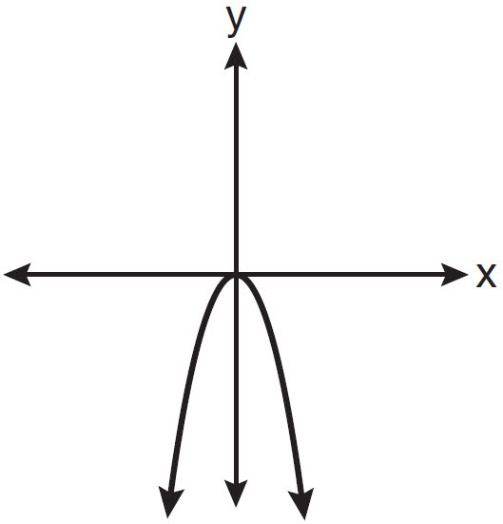
3) | 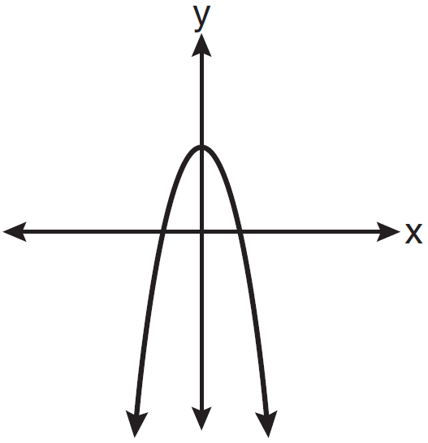
4) | 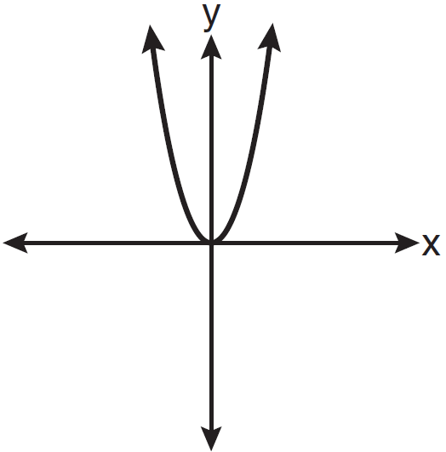

14 The graph of the equation is shown below.

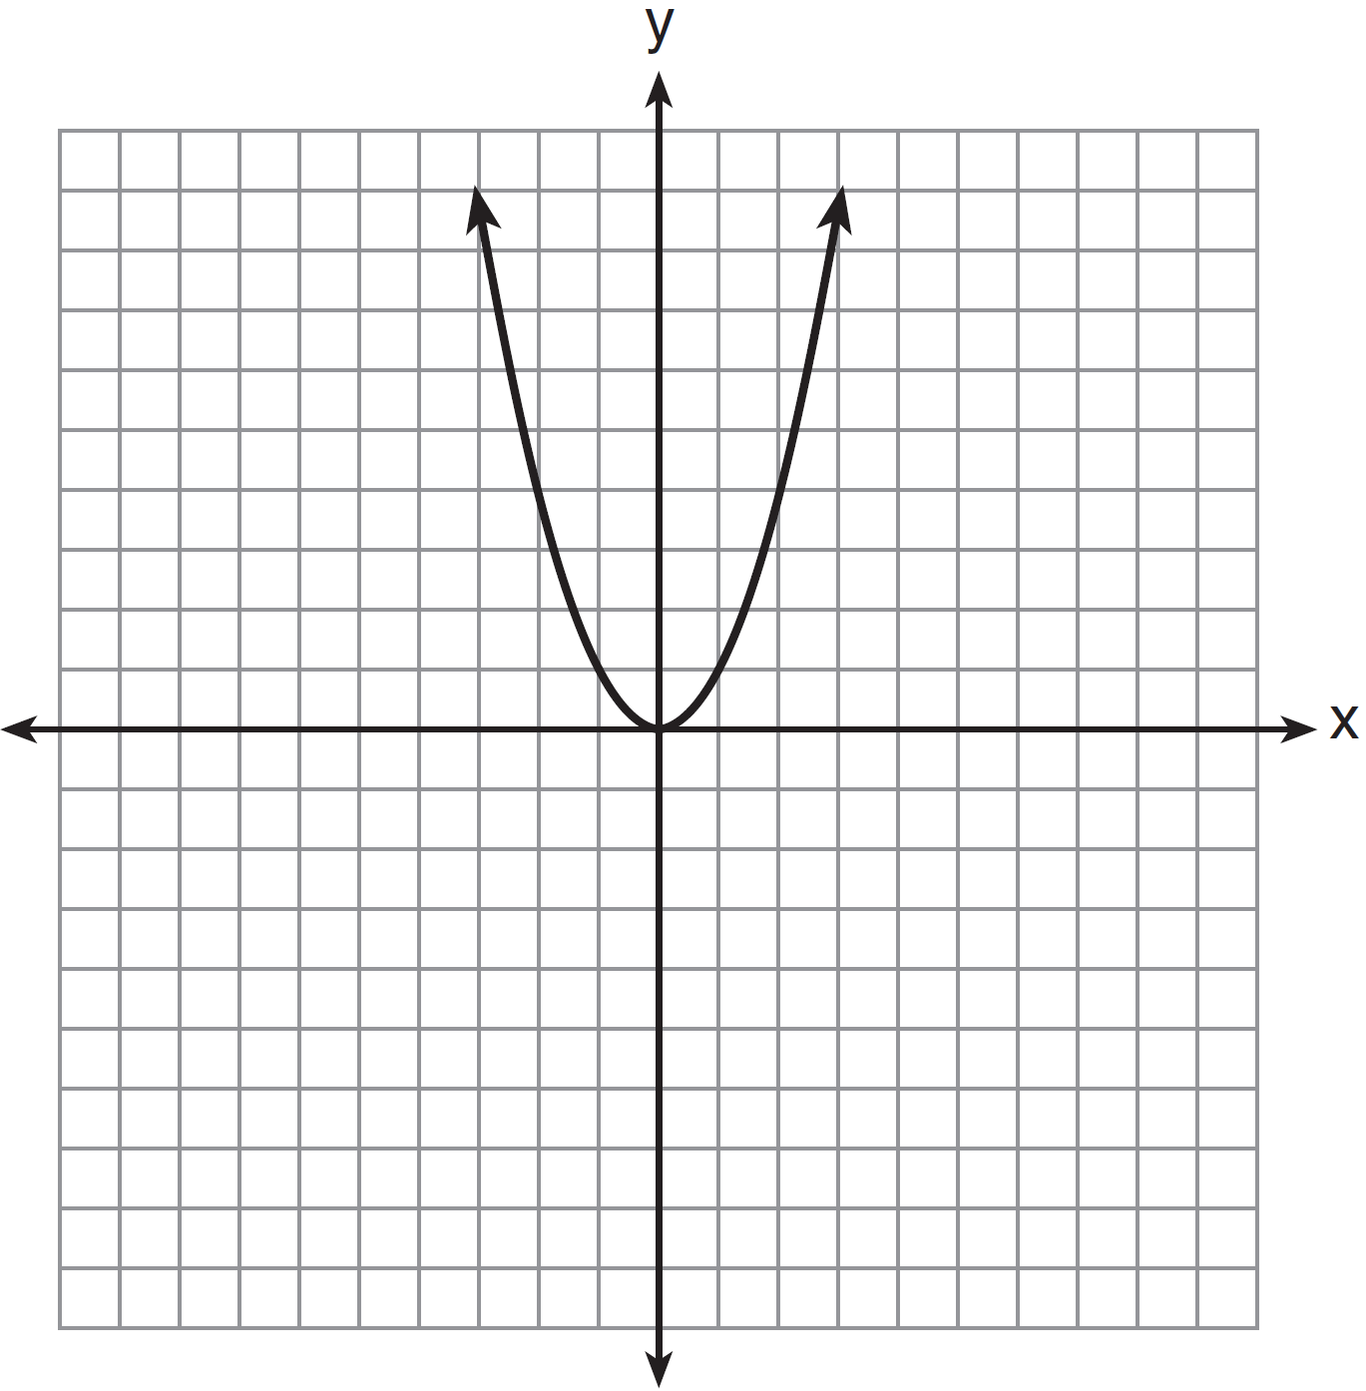

Which statement best describes the change in this graph when the coefficient of is multiplied by 4?
1) | The parabola becomes wider.
2) | The parabola becomes narrower.
3) | The parabola will shift up four units.
4) | The parabola will shift right four units.

15 The parabola shown in the accompanying diagram undergoes a reflection in the y-axis.

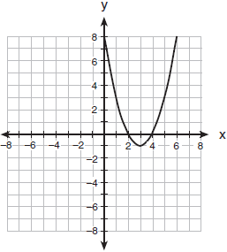

What will be the coordinates of the turning point after the reflection?
1)
2)
3)
4)

16 Which is the equation of a parabola that has the same vertex as the parabola represented by , but is wider?
1)
2)
3)
4) | 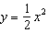

17 Melissa graphed the equation and Dave graphed the equation on the same coordinate grid. What is the relationship between the graphs that Melissa and Dave drew?
1) | Dave's graph is wider and opens in the opposite direction from Melissa's graph.
2) | Dave's graph is narrower and opens in the opposite direction from Melissa's graph.
3) | Dave's graph is wider and is three units below Melissa's graph.
4) | Dave's graph is narrower and is three units to the left of Melissa's graph.

18 The graph of a parabola is represented by the equation where a is a positive integer. If a is multiplied by 2, the new parabola will become
1) | narrower and open downward
2) | narrower and open upward
3) | wider and open downward
4) | wider and open upward

19 Which transformation of the graph of would result in the graph of ?
1)
2)
3)
4)

20 What is the translation that maps the function onto the function ?
1)
2)
3)
4)

21 The graph of is shifted left 4 units and down 2 units. What is the axis of symmetry of the transformed graph?
1)
2)
3)
4)

22 Consider the graph of the equation , when . If a is multiplied by 3, what is true of the graph of the resulting parabola?
1) | The vertex is 3 units above the vertex of the original parabola.
2) | The new parabola is 3 units to the right of the original parabola.
3) | The new parabola is wider than the original parabola.
4) | The new parabola is narrower than the original parabola.

23 How is the graph of affected when the coefficient of is changed to a smaller positive number?
1) | The graph becomes wider, and the y-intercept changes.
2) | The graph becomes wider, and the y-intercept stays the same.
3) | The graph becomes narrower, and the y-intercept changes.
4) | The graph becomes narrower, and the y-intercept stays the same.

24 The function is graphed on the set of axes below. On the same set of axes, graph .

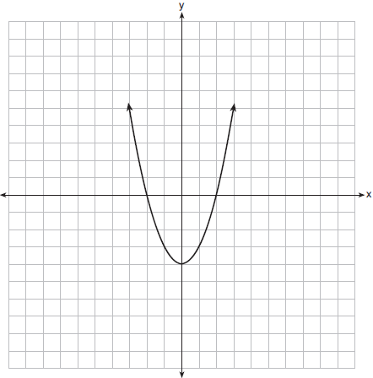

25 Graph and label the following equations, a and b, on the accompanying set of coordinate axes.
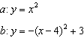
Describe the composition of transformations performed on a to get b.

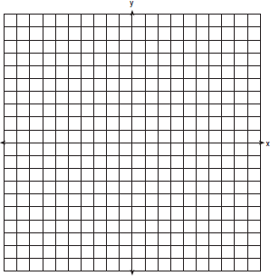

26 Two parabolic arches are to be built. The equation of the first arch can be expressed as , with a range of , and the second arch is created by the transformation . On the accompanying set of axes, graph the equations of the two arches. Graph the line of symmetry formed by the parabola and its transformation and label it with the proper equation.

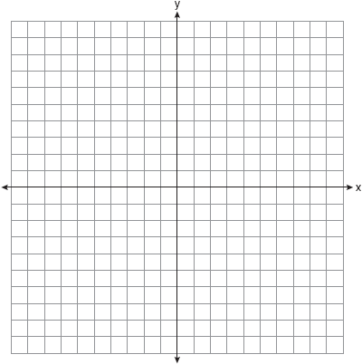

27 a On the accompanying grid, graph the equation in the interval and label it a.
b On the same grid, sketch the image of a under and label it b.



1 ANS: 1 REF: 061516a2

2 ANS: 4 REF: 011714a2

3 ANS: 1 REF: 081022a2

4 ANS: 3 REF: 011017ia

5 ANS: 4
The transformation is a reflection in the x-axis.

REF: fall0722ia

6 ANS: 4
The transformation is a reflection in the x-axis.

REF: 011206ia

7 ANS: 1 REF: 011529ia

8 ANS:
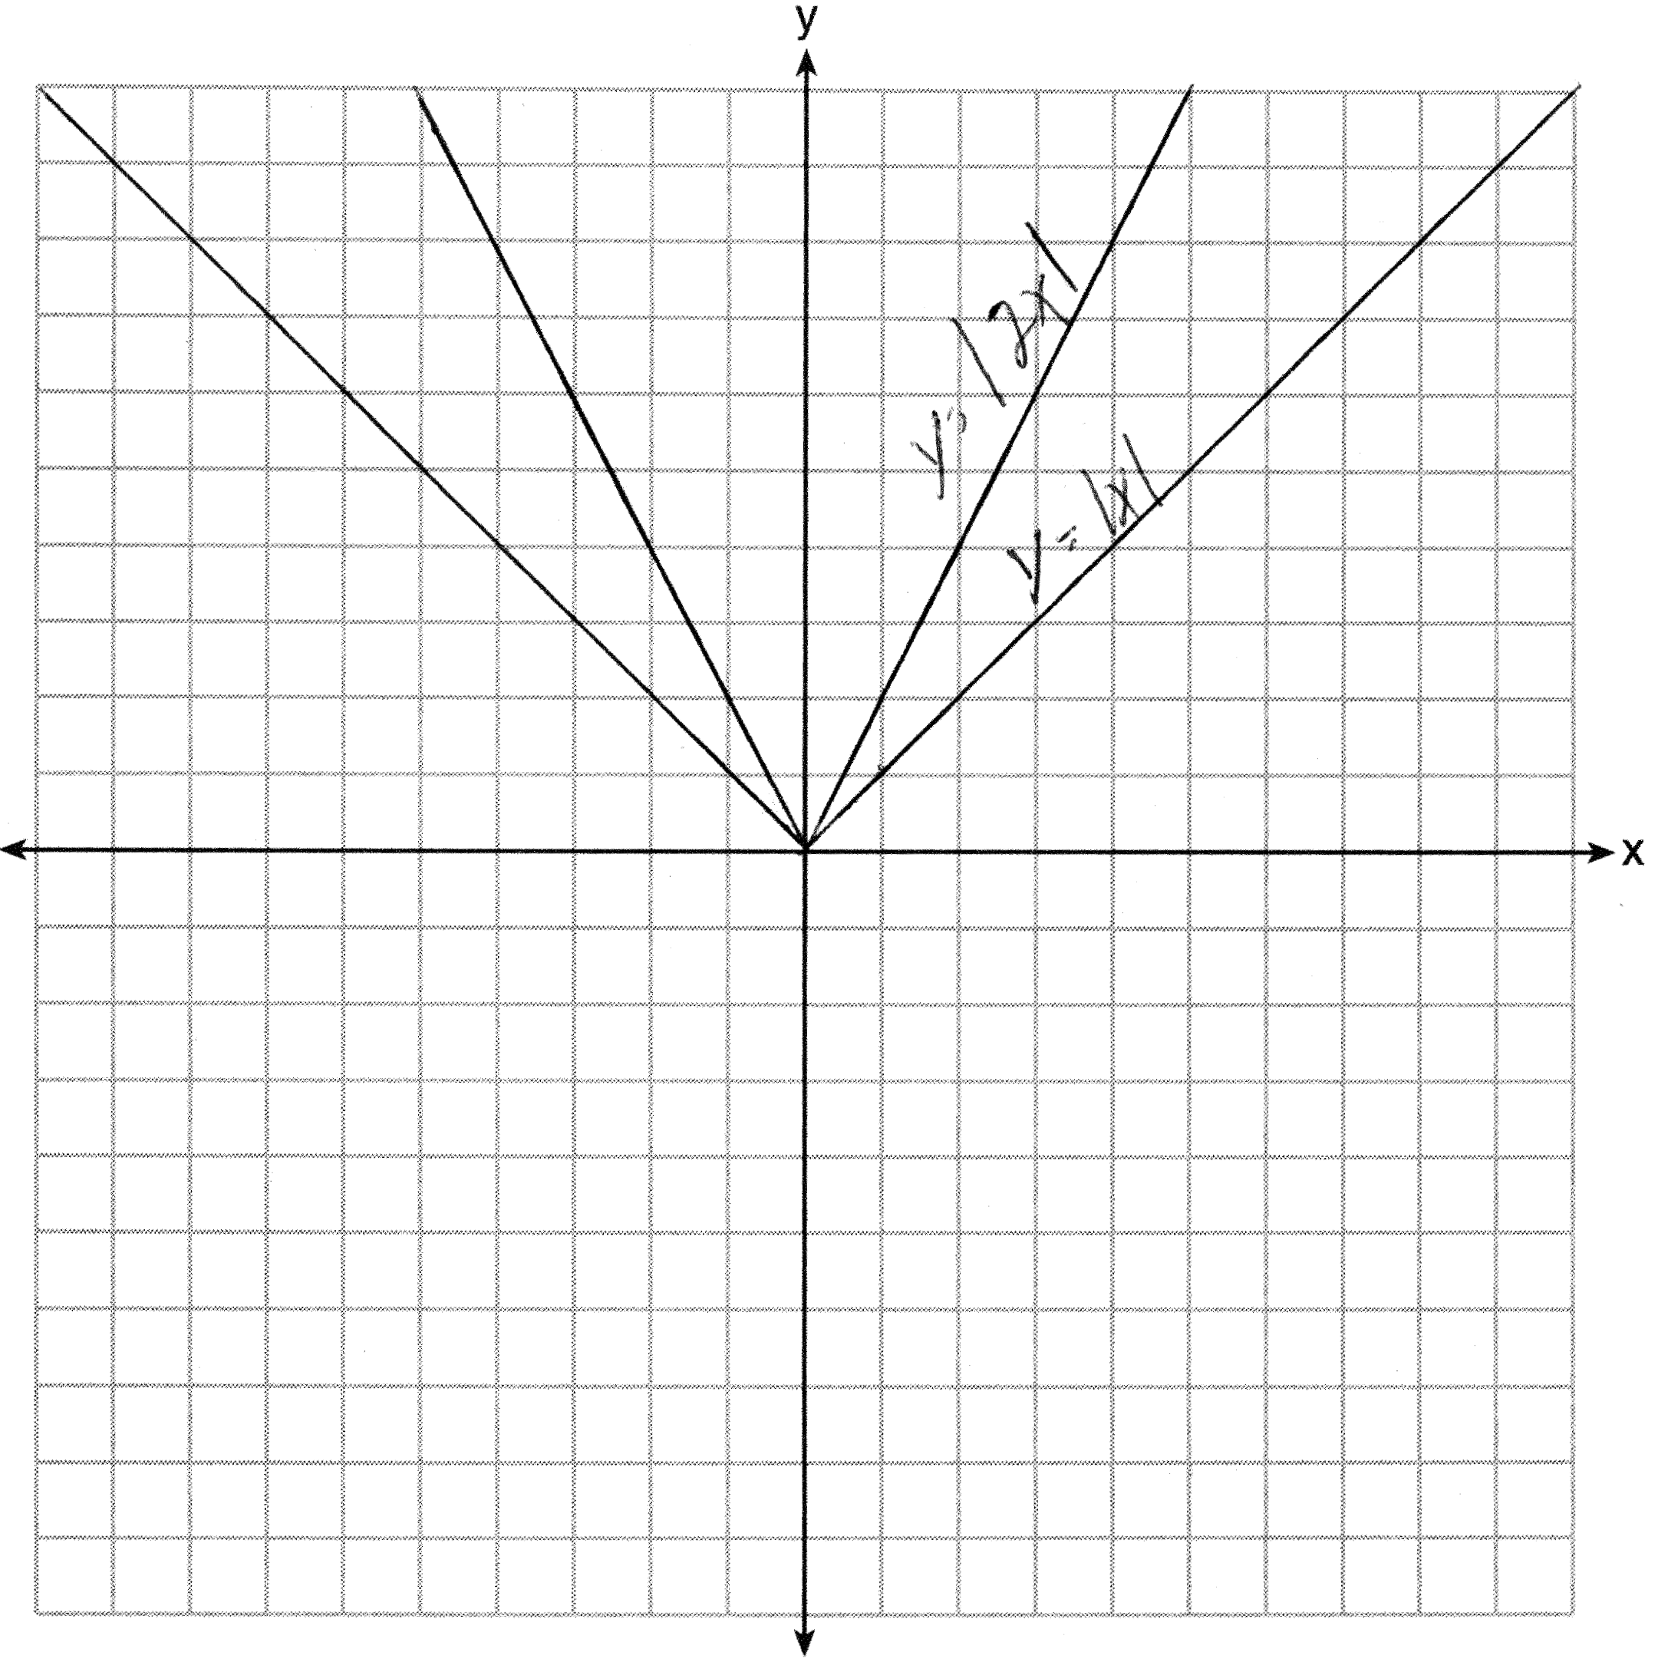. Graph becomes narrower as the coefficient increases.

REF: 011434ia

9 ANS:
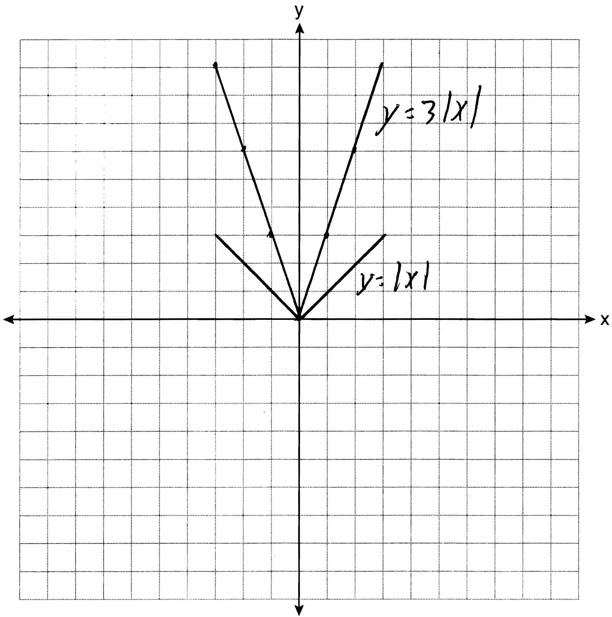 The graph becomes steeper.

REF: 081134ia

10 ANS:
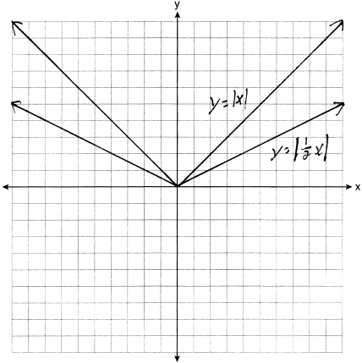. Graph becomes wider as the coefficient approaches 0.

REF: 061035ia

11 ANS: 4 REF: 061503ia

12 ANS: 2 REF: fall0926a2

13 ANS: 1 REF: 081015ia

14 ANS: 2 REF: 081414ia

15 ANS: 4 REF: 010901b

16 ANS: 4 REF: 081322ia

17 ANS: 2 REF: 061113ia

18 ANS: 2 REF: 081218ia

19 ANS: 2 REF: 010605b

20 ANS: 1 REF: 010906b

21 ANS: 2
is in vertex form, so the vertex of this quadratic is (3, 0), and the axis of symmetry is . Shifting the graph left 4 units moves the axis of symmetry to .

REF: 060611b

22 ANS: 4 REF: 060829ia

23 ANS: 2 REF: 011330ia

24 ANS:
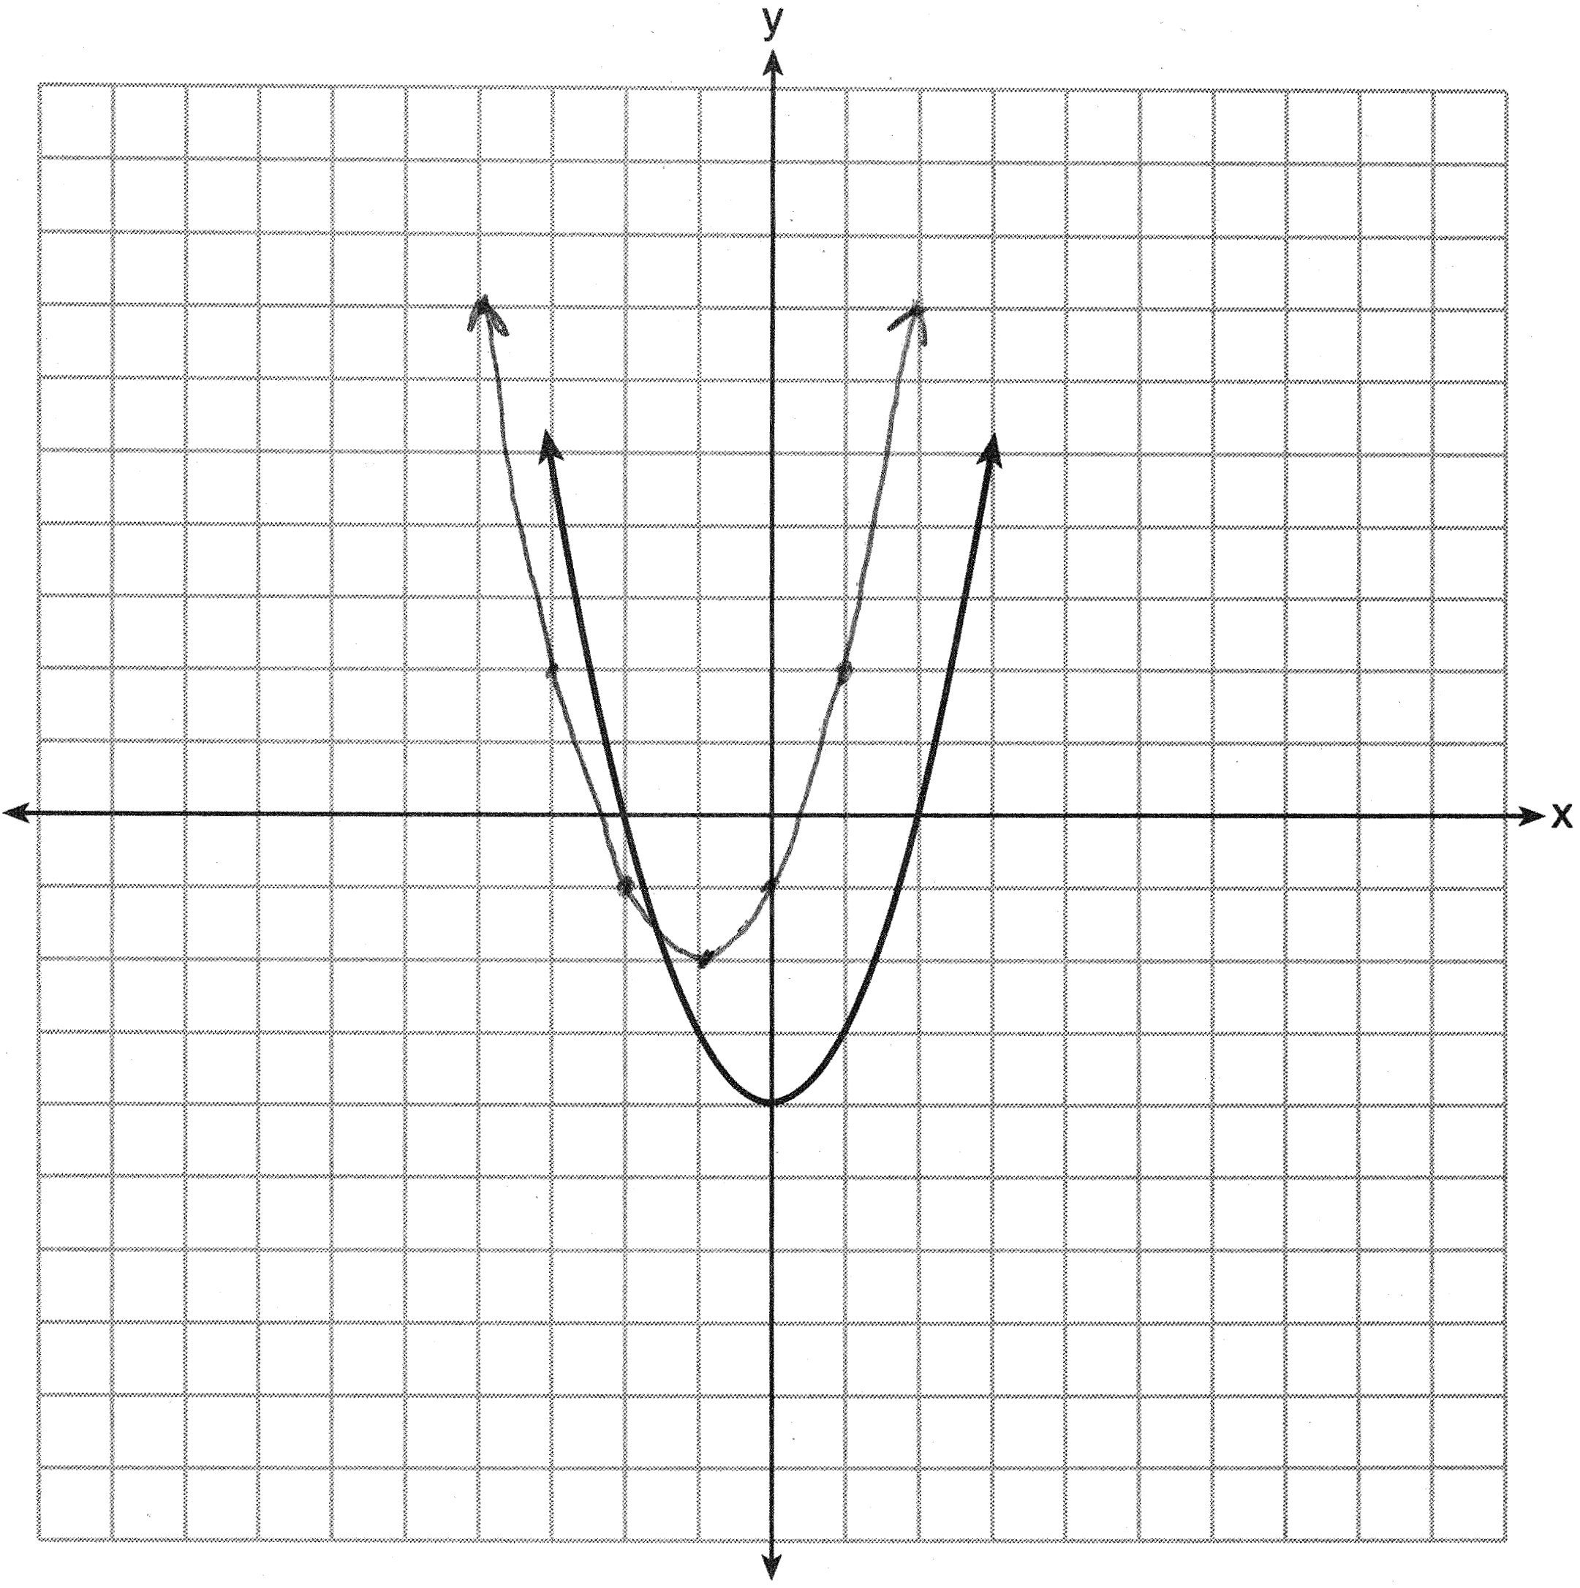

REF: 061435a2

25 ANS:
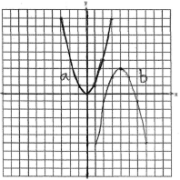 , or

REF: 080231b

26 ANS:
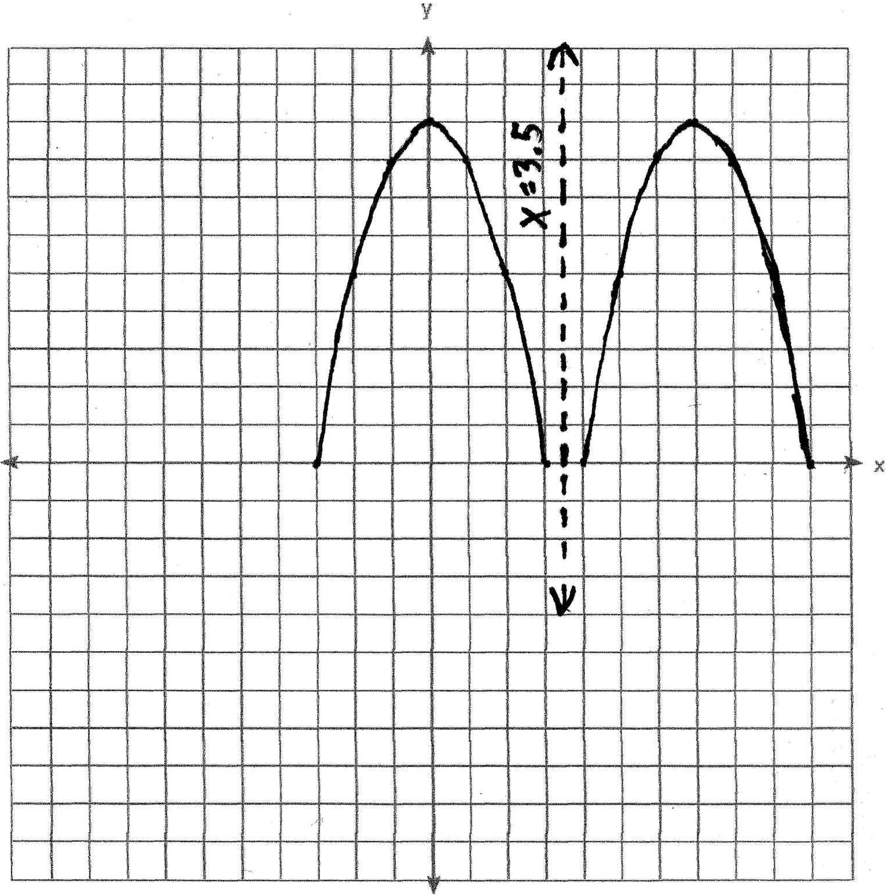

REF: 060129b

27 ANS:
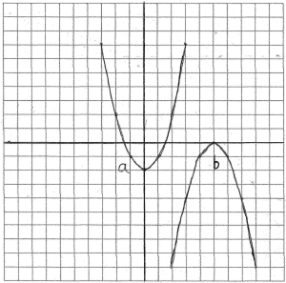

REF: 010232b

