1 Describe the effect that each transformation below has on the function , where .

2 Graph the function on the set of axes below.

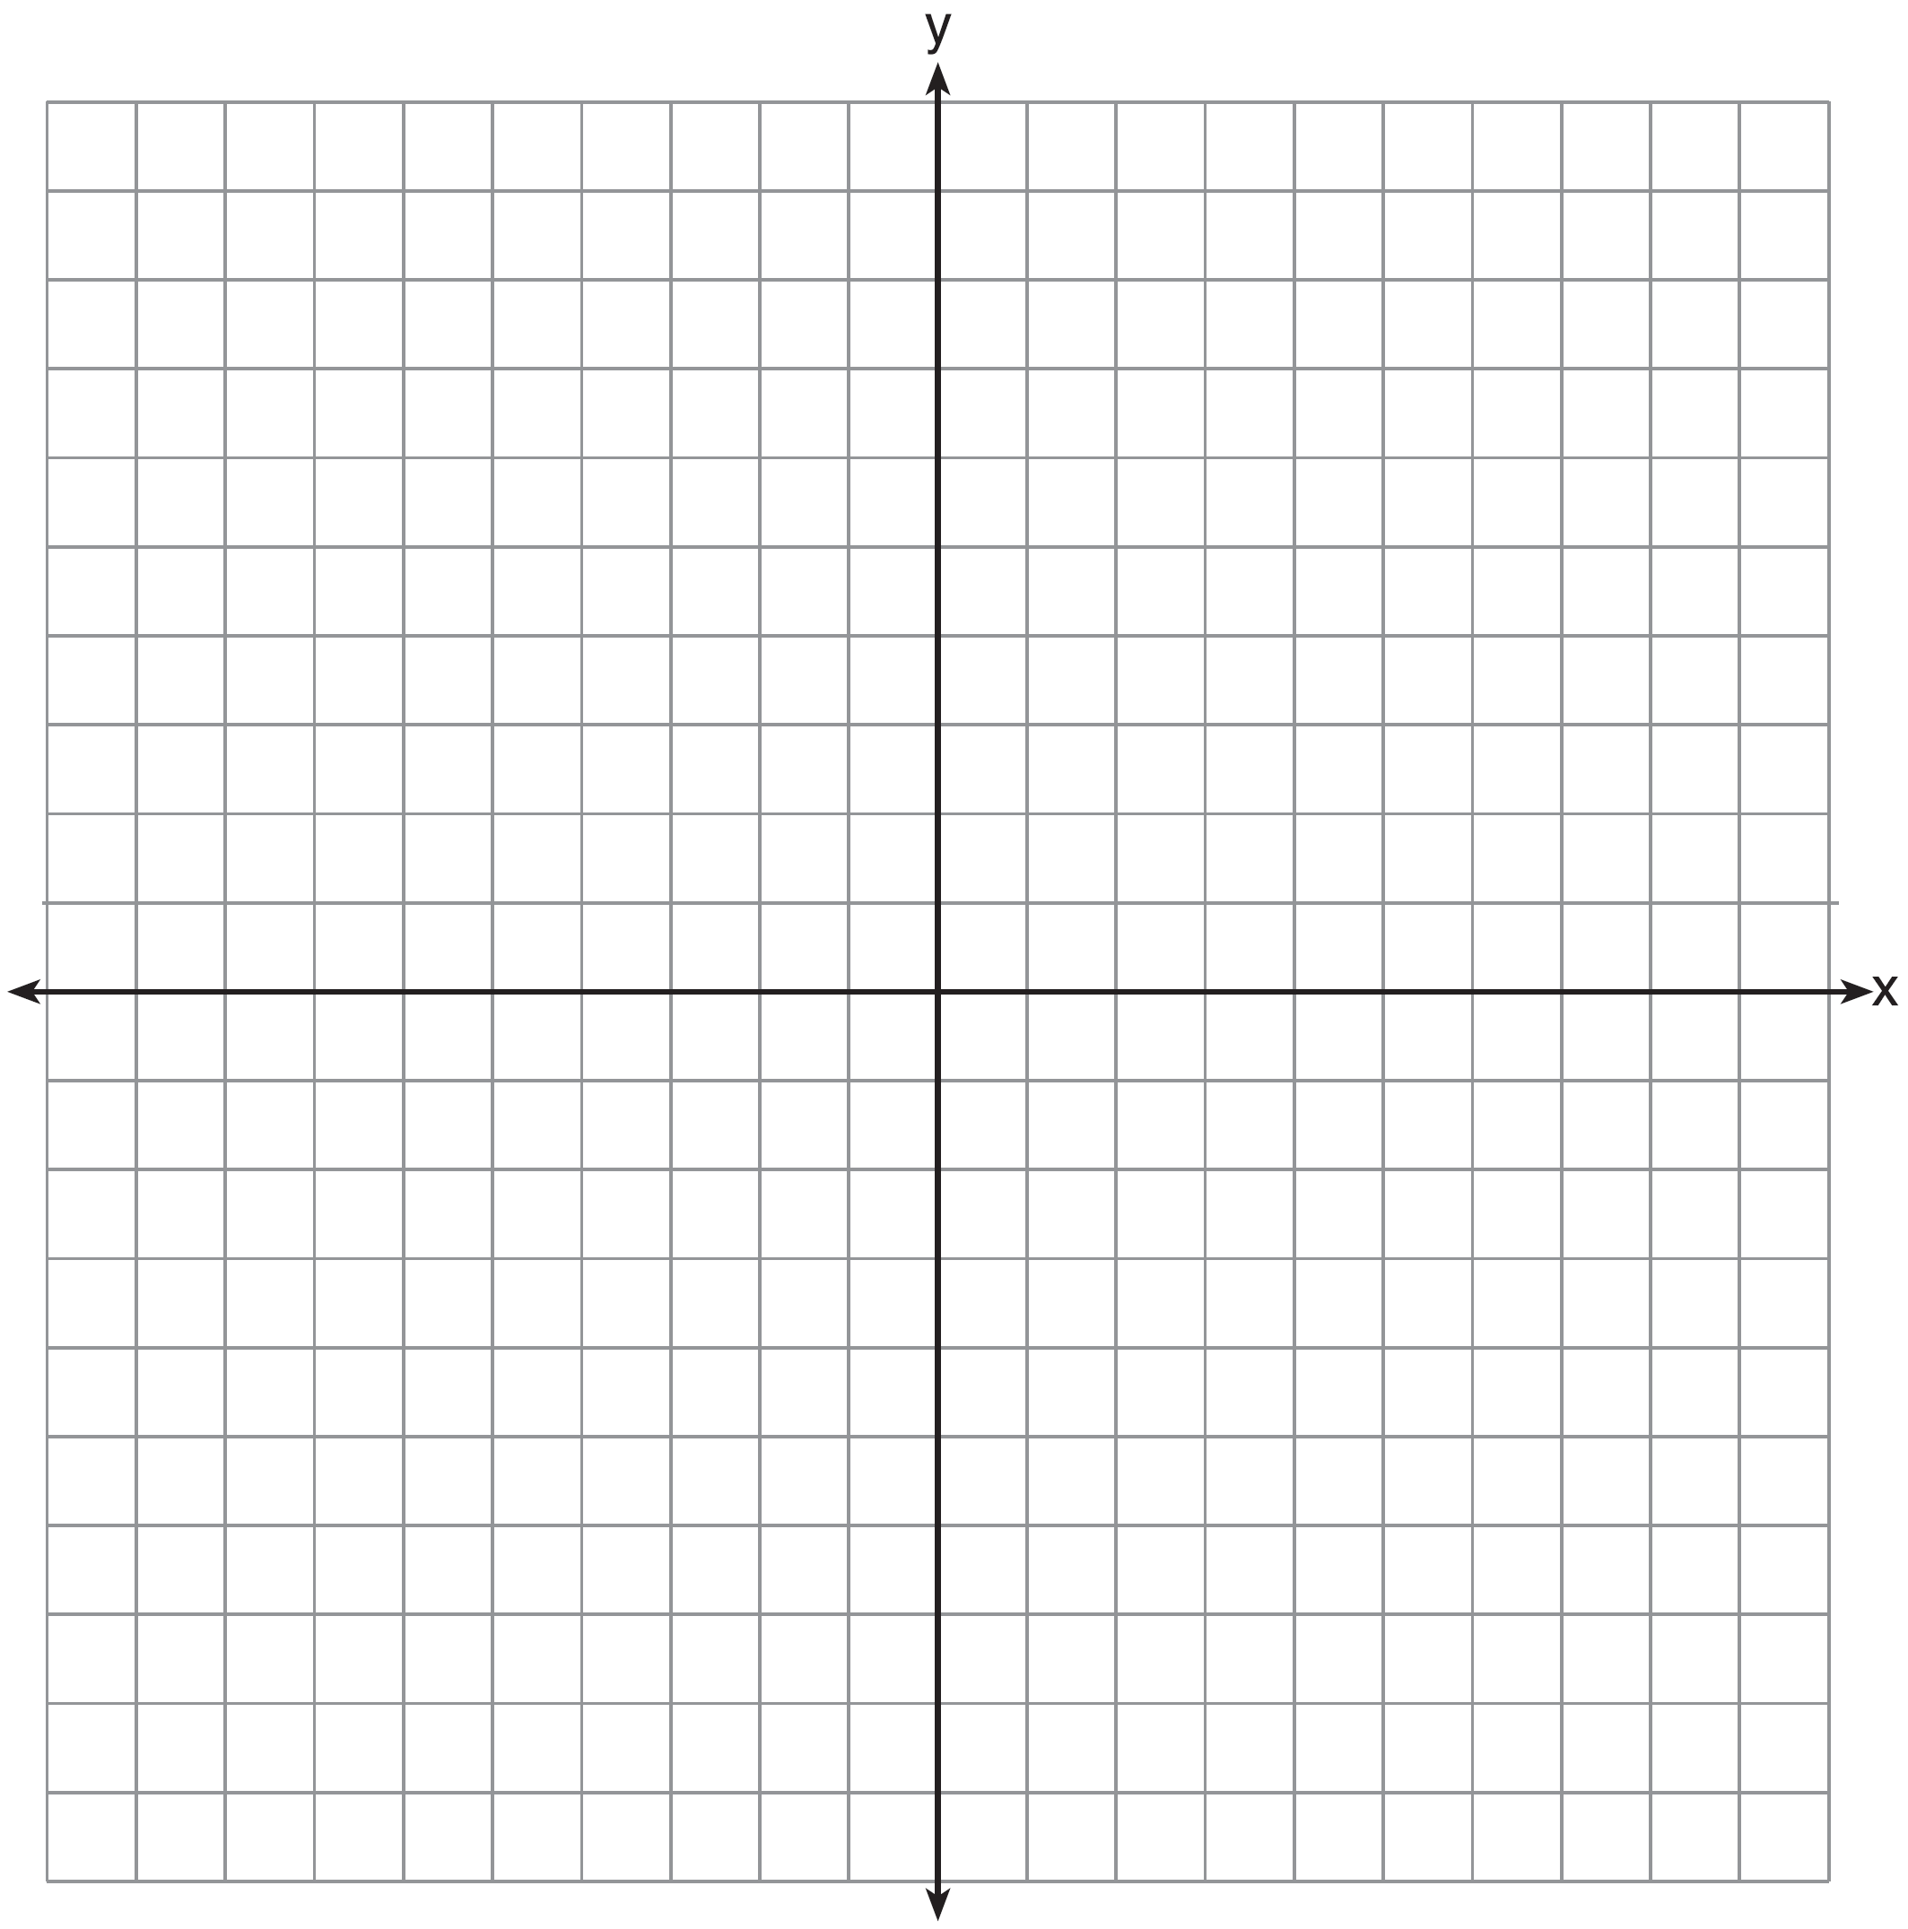

Explain how the graph of has changed from the related graph .

3 On the axes below, graph .

If , how is the graph of translated to form the graph of ? If , how is the graph of translated to form the graph of ?

4 Describe the transformations performed on the graph of to obtain the graph of when .

5 A student is given the functions and . Describe the transformation that maps onto .

6 The vertex of the parabola represented by has coordinates . Find the coordinates of the vertex of the parabola defined by . Explain how you arrived at your answer. [The use of the set of axes below is optional.]
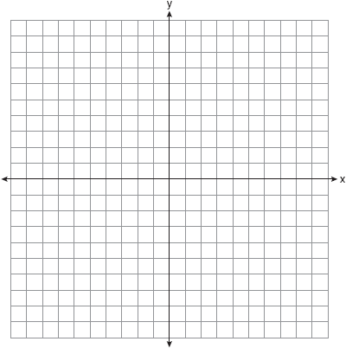

7 The graph of the function is represented below. On the same set of axes, sketch the function .
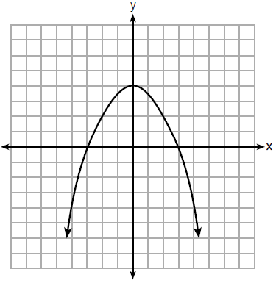

1 ANS:
is shifted right by a, is shifted down by a.

REF: 061732ai

2 ANS:
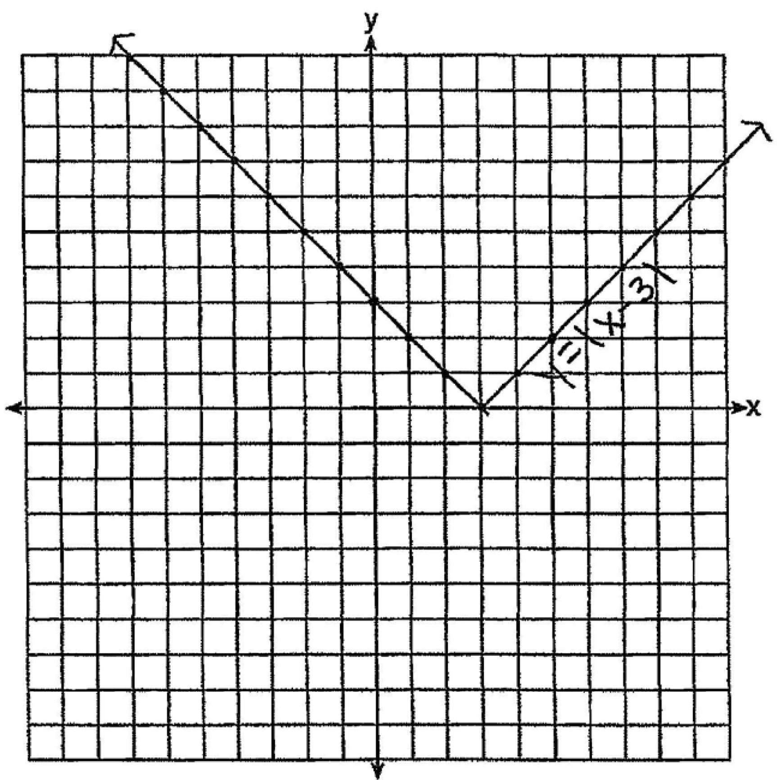 The graph has shifted three units to the right.

REF: 061525ai

3 ANS:
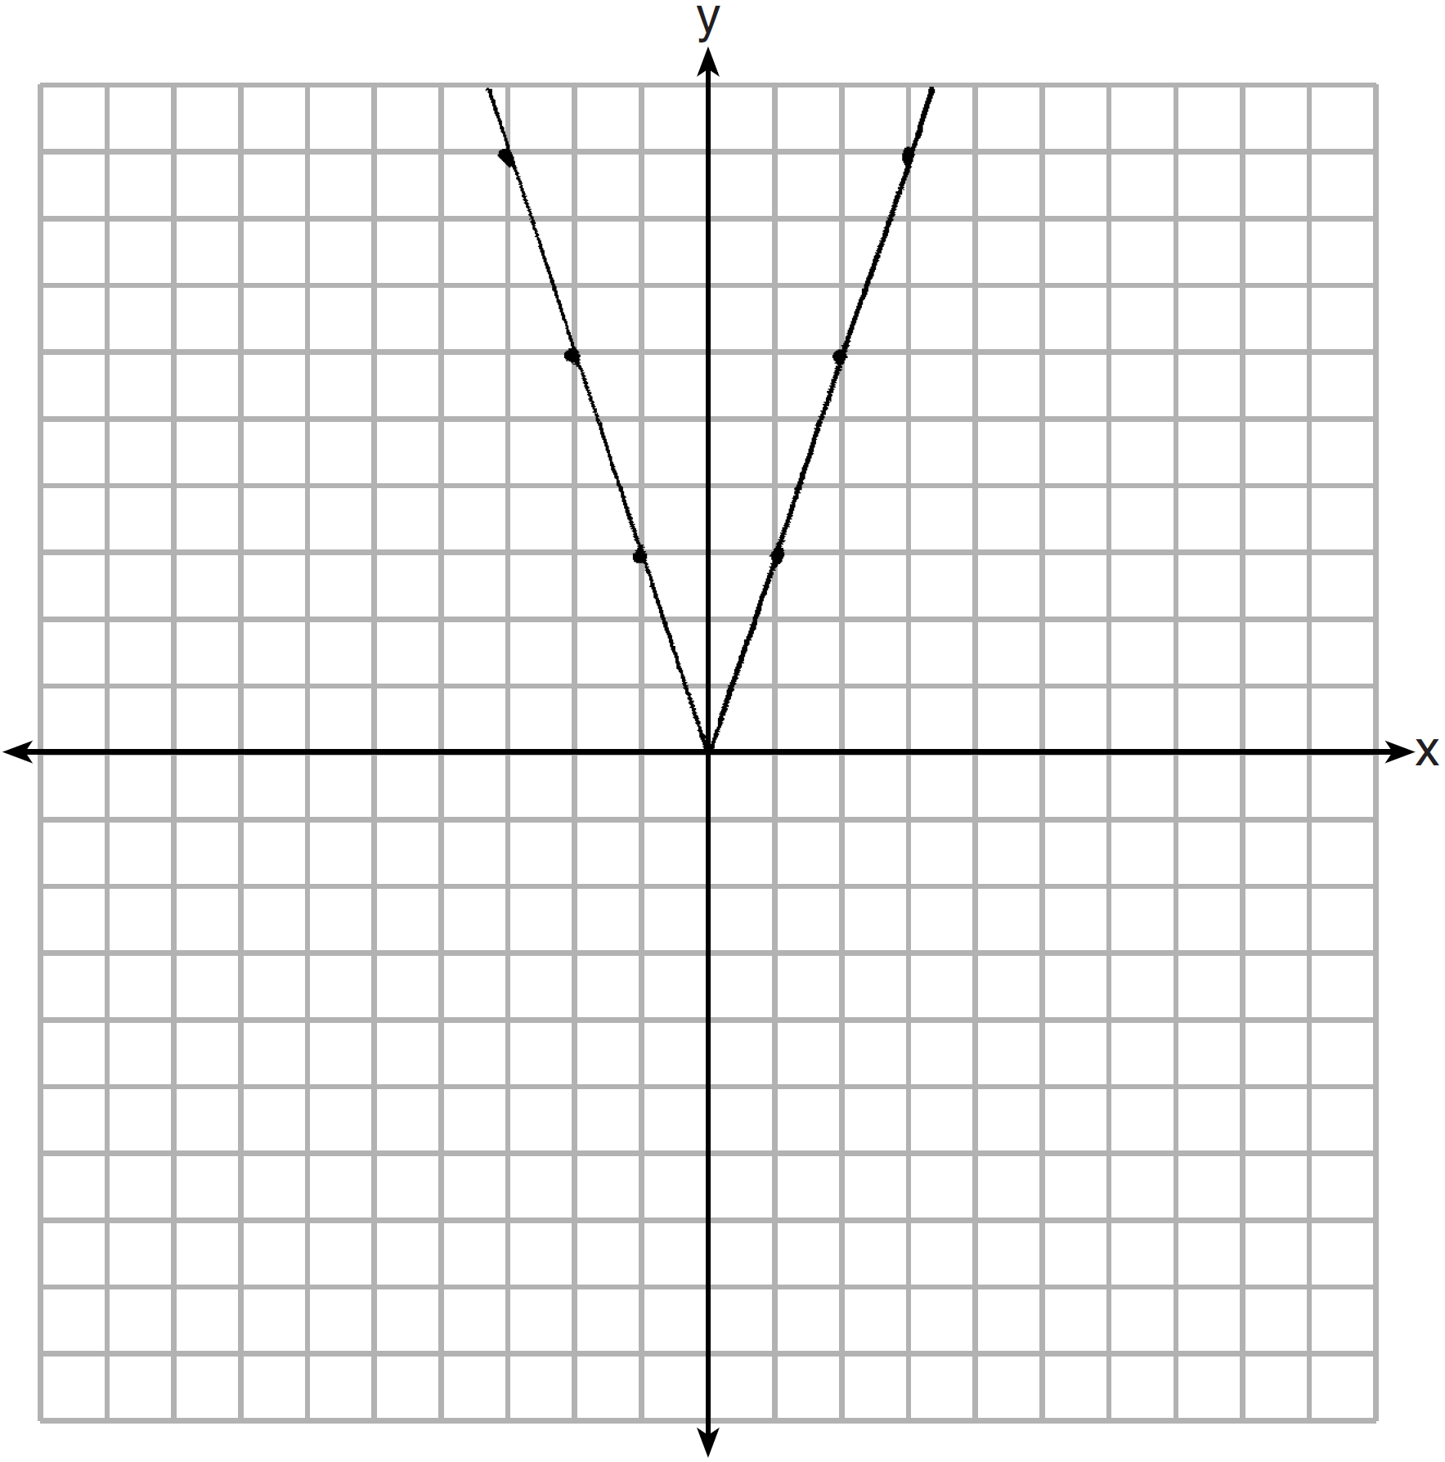 2 down. 4 right.

REF: 081433ai

4 ANS:
3 right and 4 down.

REF: 062226ai

5 ANS:
translate 2 left

REF: 082230ai

6 ANS:
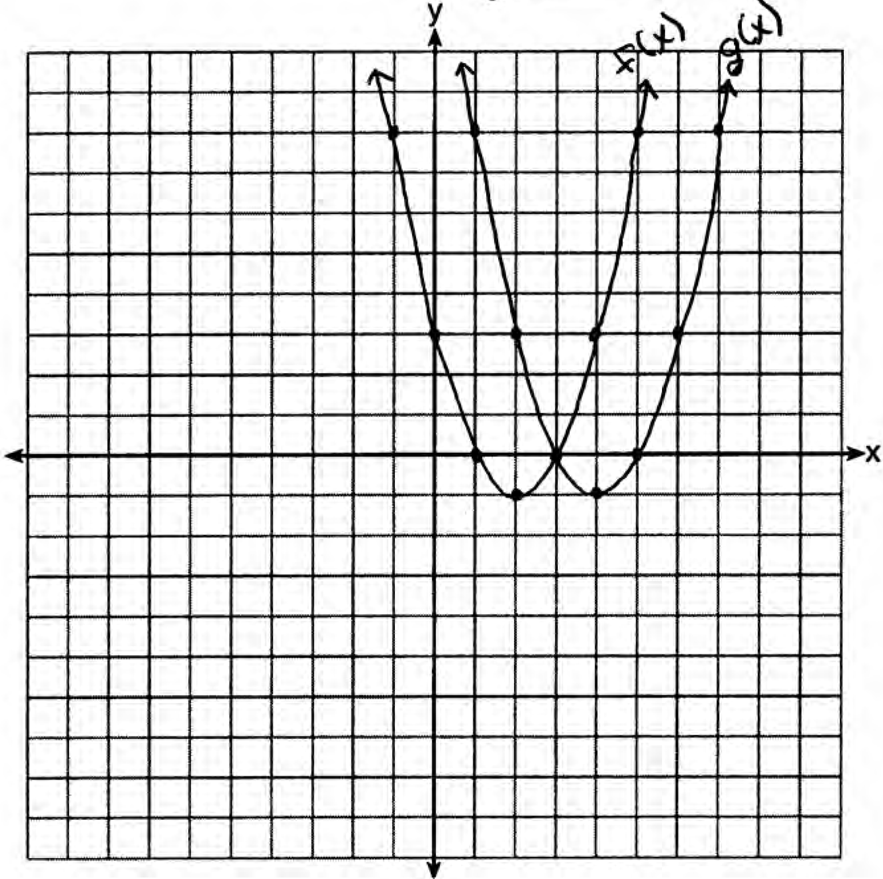 . is a horizontal shift two units to the right.

REF: 061428ai

7 ANS:
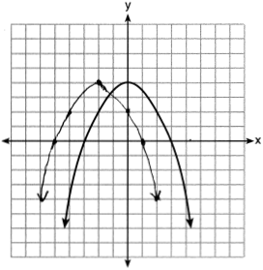

REF: 061828ai

