1 Given the graph of the line represented by the equation , if b is increased by 4 units, the graph of the new line would be shifted 4 units
1) | right
2) | up
3) | left
4) | down

2 The function is multiplied by k to create the new function . Which statement is true about the graphs of and if 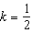?
1) | is a reflection of over the y-axis.
2) | is a reflection of over the x-axis.
3) | is wider than .
4) | is narrower than .

3 In the functions and , k is a positive integer. If k is replaced by , which statement about these new functions is true?
1) | The graphs of both and become wider.
2) | The graph of becomes narrower and the graph of shifts left.
3) | The graphs of both and shift vertically.
4) | The graph of shifts left and the graph of becomes wider.

4 Compared to the graph of , the graph of is the result of translating
1) | 2 units up and 3 units right
2) | 2 units down and 3 units up
3) | 2 units right and 3 units up
4) | 2 units left and 3 units right

5 If the parent function of is then the graph of the function where would be a shift of
1) | k units to the left and a move of 5 units up
2) | k units to the left and a move of 5 units down
3) | k units to the right and a move of 5 units up
4) | k units to the right and a move of 5 units down

6 If , which function is the result of shifting 3 units left and 2 units down?
1)
2)
3)
4)

7 If , then which function represents a shift of the graph of 4 units to the right and 3 units down?
1)
2)
3)
4)

8 What would be the order of these quadratic functions when they are arranged from the narrowest graph to the widest graph?
1)
2)
3)
4)

9 When the function is multiplied by the value a, where , the graph of the new function,
1) | opens upward and is wider
2) | opens upward and is narrower
3) | opens downward and is wider
4) | opens downward and is narrower

10 Caitlin graphs the function , where a is a positive integer. If Caitlin multiplies a by , when compared to , the new graph will become
1) | narrower and open downward
2) | narrower and open upward
3) | wider and open downward
4) | wider and open upward

11 The graph of the equation is shown below.

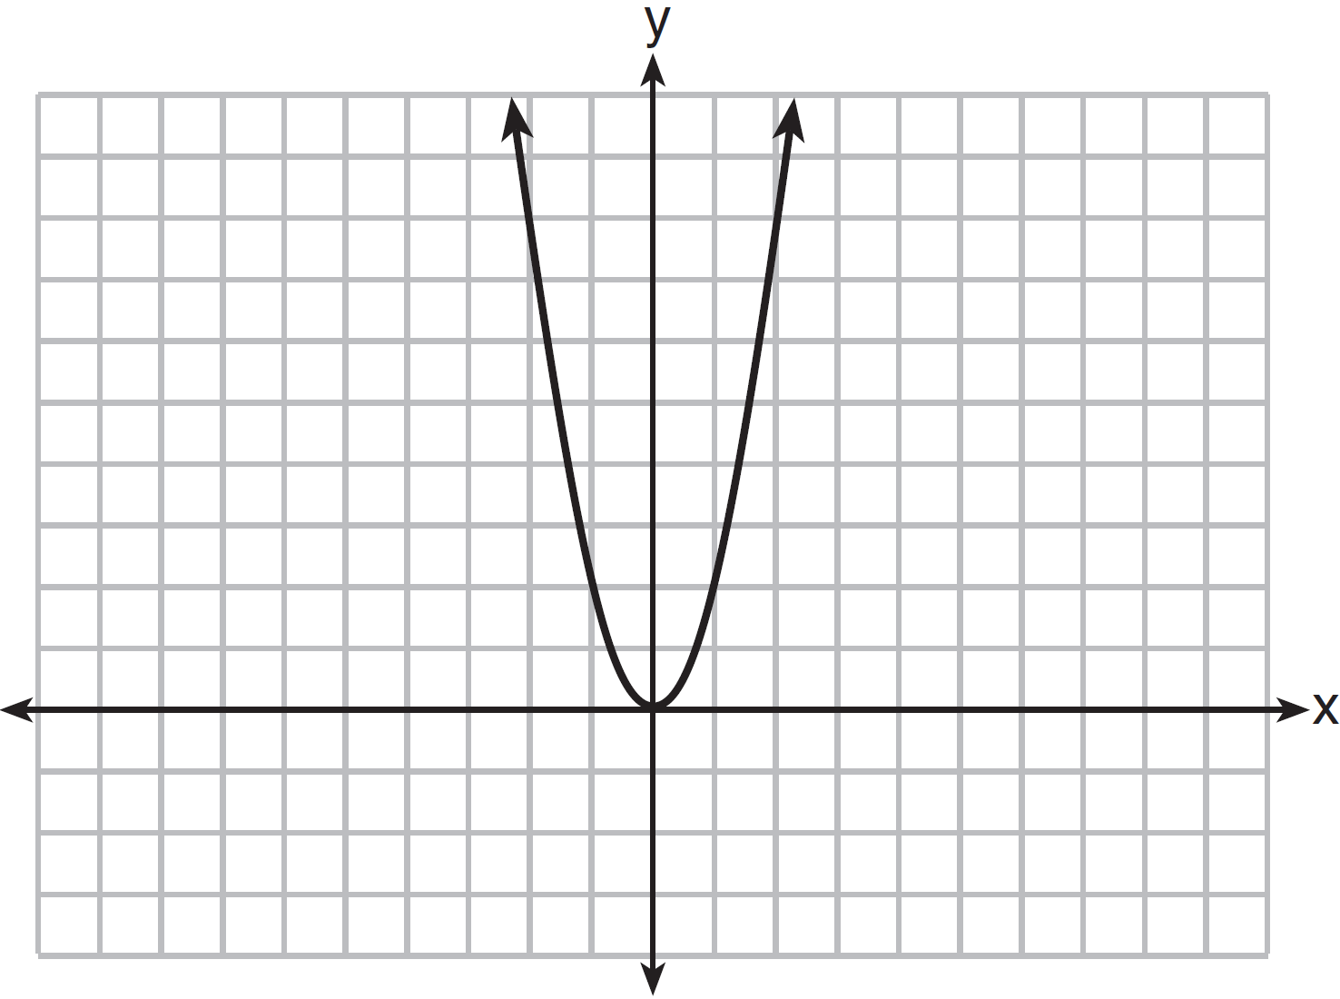

If a is multiplied by , the graph of the new equation is
1) | wider and opens downward
2) | wider and opens upward
3) | narrower and opens downward
4) | narrower and opens upward

12 The students in Mrs. Smith's algebra class were asked to describe the graph of compared to the graph of . Which student response is correct?
1) | Ashley said that the graph of is wider and shifted left 3 units.
2) | Beth said that the graph of is narrower and shifted left 3 units.
3) | Carl said that the graph of is wider and shifted right 3 units.
4) | Don said that the graph of is narrower and shifted right 3 units.

13 How does the graph of compare to the graph of ?
1) | The graph of is wider than the graph of , and its vertex is moved to the left 2 units and up 1 unit.
2) | The graph of is narrower than the graph of , and its vertex is moved to the right 2 units and up 1 unit.
3) | The graph of is narrower than the graph of , and its vertex is moved to the left 2 units and up 1 unit.
4) | The graph of is wider than the graph of , and its vertex is moved to the right 2 units and up 1 unit.

14 The graph of is shown below.

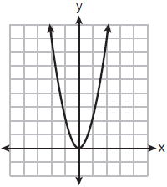

Which graph represents ?
1) | 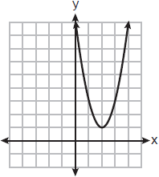
2) | 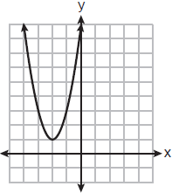
3) | 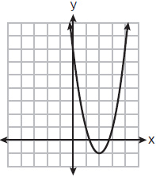
4) | 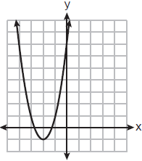

15 The functions and are graphed below.

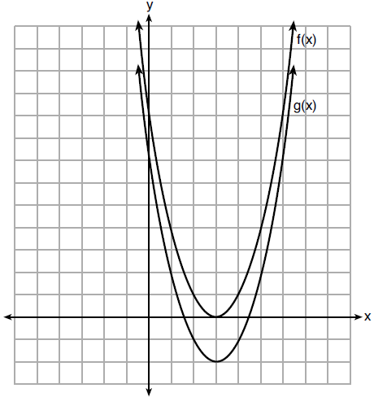

Which value of k would result in the graph of ?
1) | 0
2) | 2
3)
4)

16 If the original function is shifted to the left 3 units to make the function , which expression would represent ?
1)
2)
3)
4)

17 Given:
When compared to the graph of the graph of is
1) | shifted 3 units to the left
2) | shifted 3 units to the right
3) | shifted 5 units to the left
4) | shifted 5 units to the right

18 Josh graphed the function . He then graphed the function on the same coordinate plane. The vertex of is
1) | 7 units below the vertex of
2) | 7 units above the vertex of
3) | 7 units to the right of the vertex of
4) | 7 units to the left of the vertex of

19 The graph of is shown below.

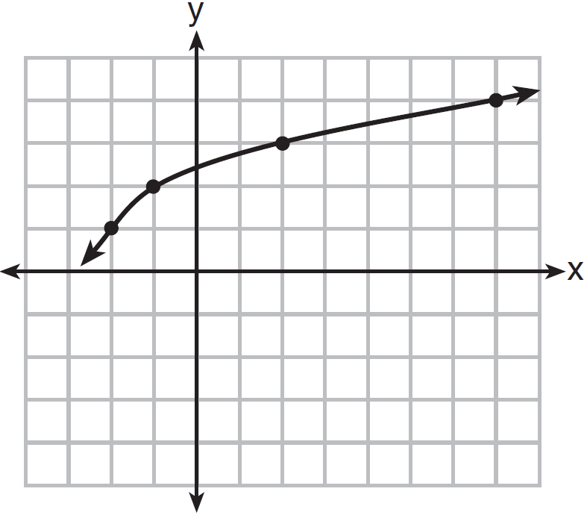

What is the graph of ?
1) | 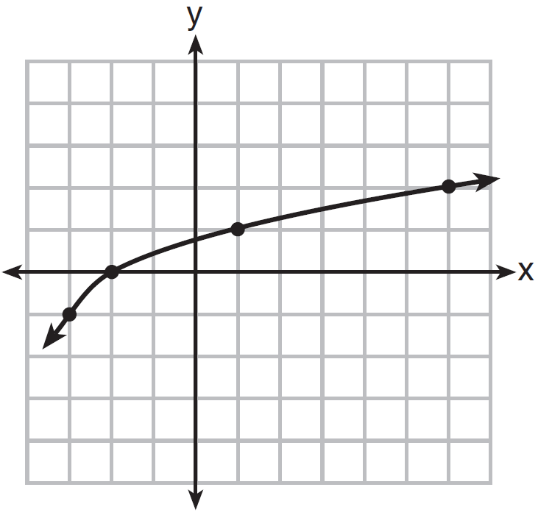
2) | 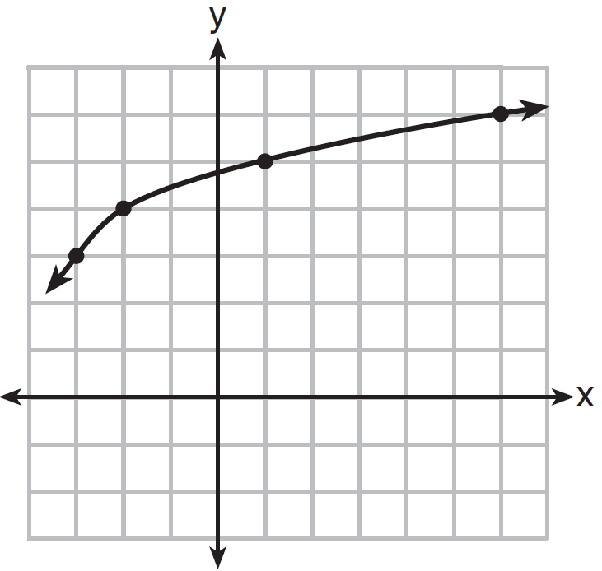
3) | 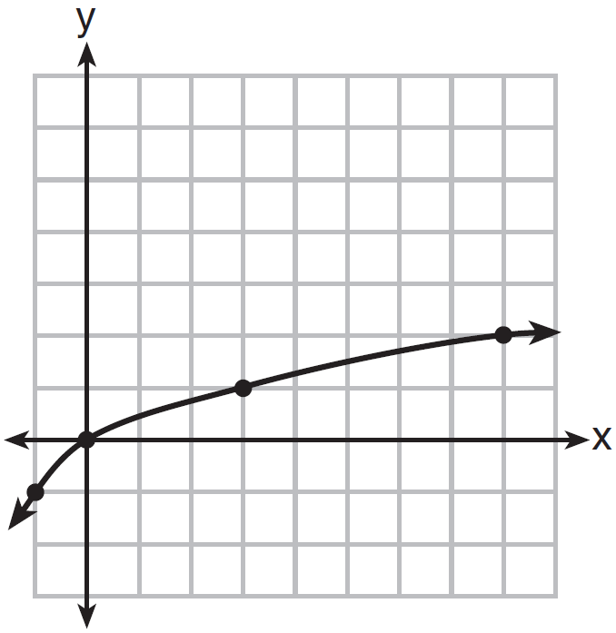
4) | 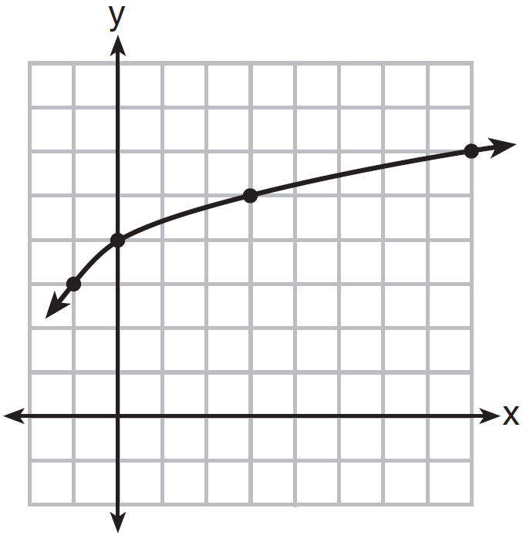

1 ANS: 2 REF: 081501ai

2 ANS: 3 REF: 062316ai

3 ANS: 1 REF: 081706ai

4 ANS: 3 REF: 081808ai

5 ANS: 3 REF: 062113ai

6 ANS: 3 REF: 012407ai

7 ANS: 3 REF: 082411ai

8 ANS: 4 REF: 082211ai

9 ANS: 2 REF: 011717ai

10 ANS: 1 REF: 012310ai

11 ANS: 1 REF: 081417ai

12 ANS: 4 REF: 062417ai

13 ANS: 2 REF: 011512ai

14 ANS: 1 REF: 082305ai

15 ANS: 4 REF: 012007ai

16 ANS: 2 REF: 011819ai

17 ANS: 2 REF: 061904ai

18 ANS: 1

REF: 081905ai

19 ANS: 1 REF: 011620ai

