1 Functions f, g, and h are given below.

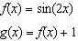

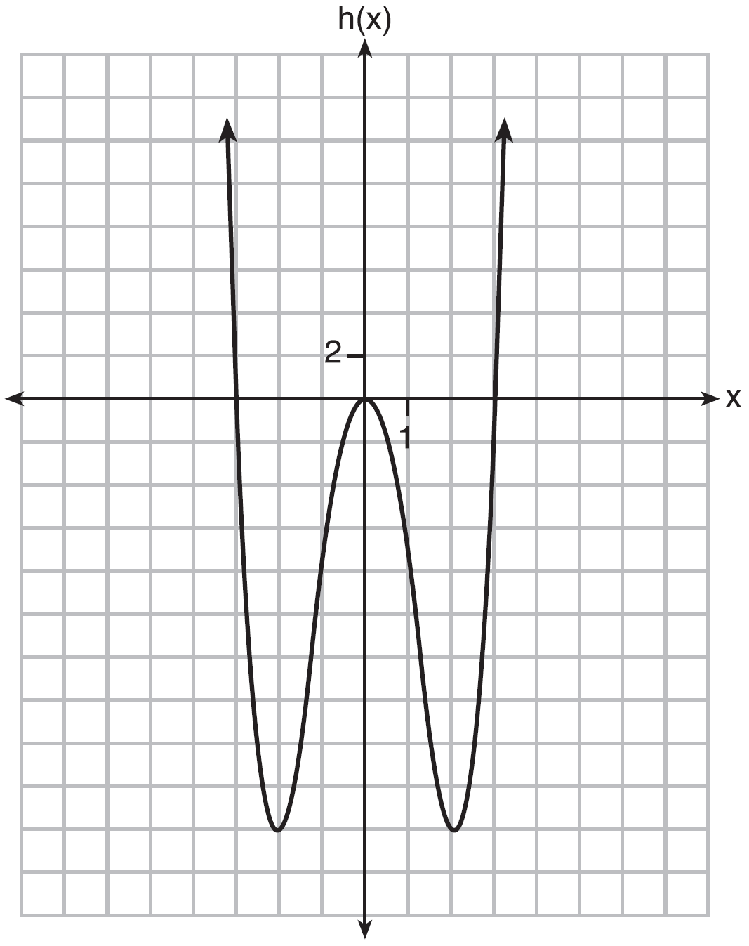

Which statement is true about functions f, g, and h?
1) | and are odd, is even. | 3) | is odd, is neither, is even.
2) | and are even, is odd. | 4) | is even, is neither, is odd.

2 Which graph has line symmetry with respect to the y-axis?
1) |  | 3)
2) |  | 4)

3 Which function is even?
1) |  | 3)
2) |  | 4)

4 Which function is even?
1) |  | 3)
2) |  | 4)

5 Which equation represents an odd function?
1) |  | 3)
2) |  | 4)

6 If is an even function, which function must also be even?
1) |  | 3)
2) |  | 4)

7 For , which statement is true?
1) | and are even functions. | 3) | and 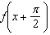 are odd functions.
2) | and are odd functions. | 4) | is an odd function and is an even function.

8 Can be classified as an odd function? Justify your answer.

9 The entire graph of is symmetric with respect to the origin. If the accompanying graph represents for , sketch, on the same set of axes, the graph of for .

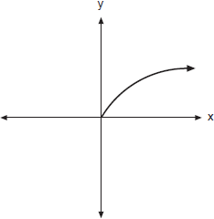

1 ANS: 3
, so is odd. , so is not even. , so is not odd. , so is even.

REF: fall1502aii

2 ANS: 2 REF: 068120siii

3 ANS: 2
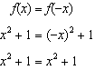

REF: 082323aii

4 ANS: 2
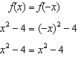

REF: 061806aii

5 ANS: 1
The graph of is unchanged when rotated 180º about the origin.

REF: 081614aii

6 ANS: 2 REF: 081911aii

7 ANS: 1 REF: 062318aii

8 ANS:
No, because a 180º rotation of f about the origin does not map f onto itself.

REF: 062432aii

9 ANS:
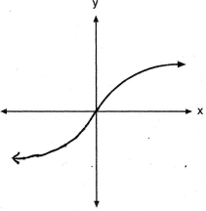

REF: 060821b

