1 Which function is not one-to-one?
1)
2)
3)
4)

2 Which list of ordered pairs does not represent a one-to-one function?
1)
2)
3)
4)

3 Which diagram represents a one-to-one function?
1) | 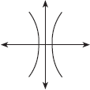
2) | 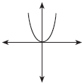
3) | 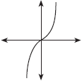
4) | 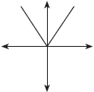

4 Which graph represents a one-to-one function?
1) | 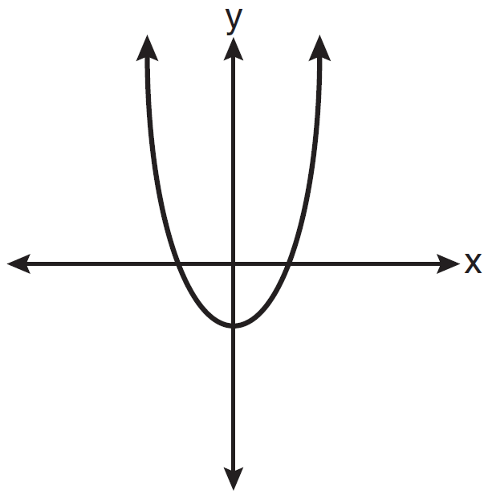
2) | 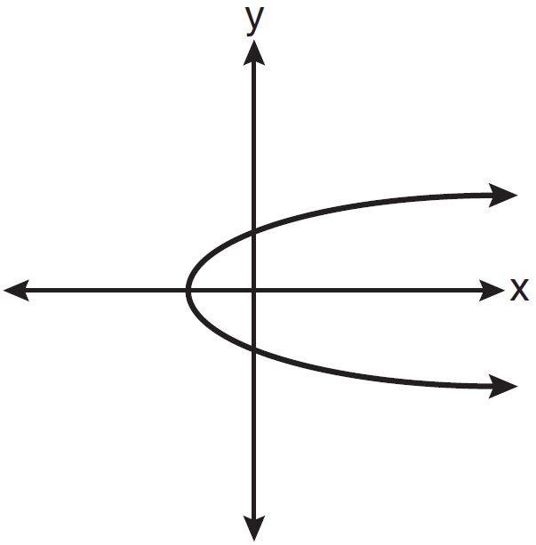
3) | 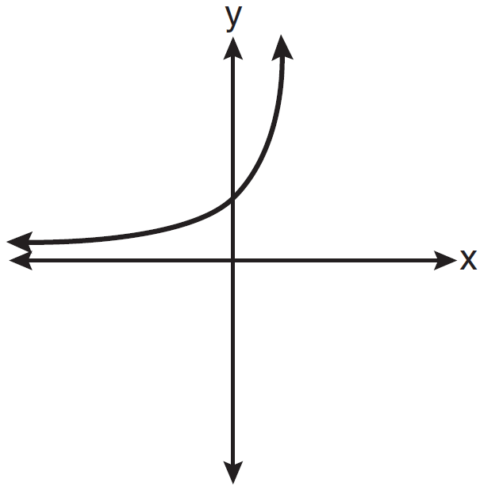
4) | 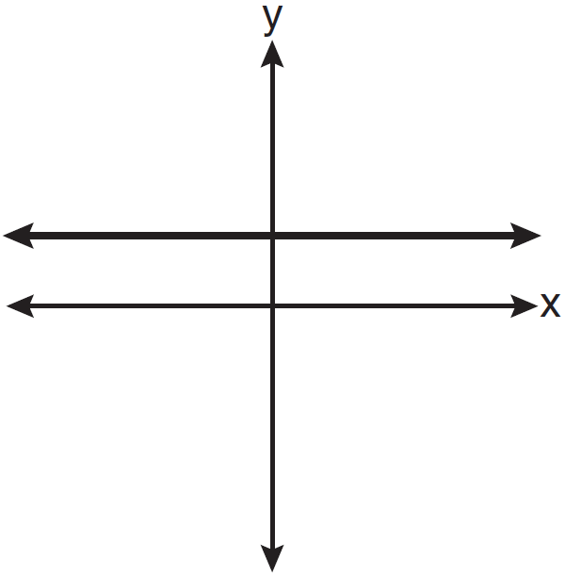

5 Which function is one-to-one?
1)
2)
3)
4)

6 Which relation is one-to-one?
1)
2)
3)
4)

7 Which function is one-to-one?
1)
2)
3)
4)

8 Which diagram represents a relation that is both one-to-one and onto?
1) | 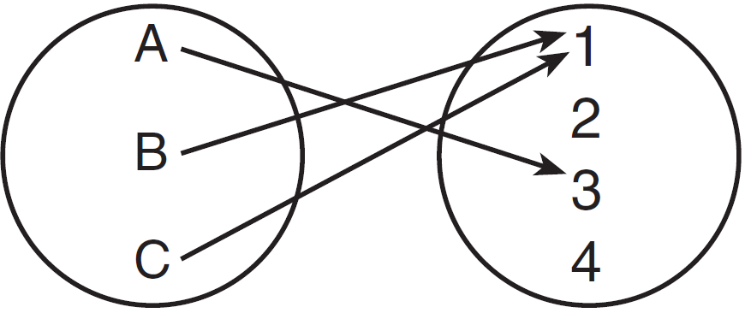
2) | 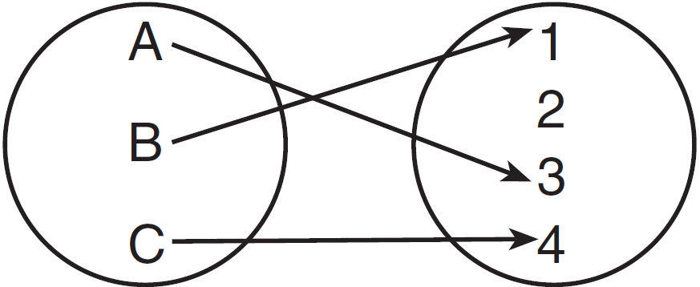
3) | 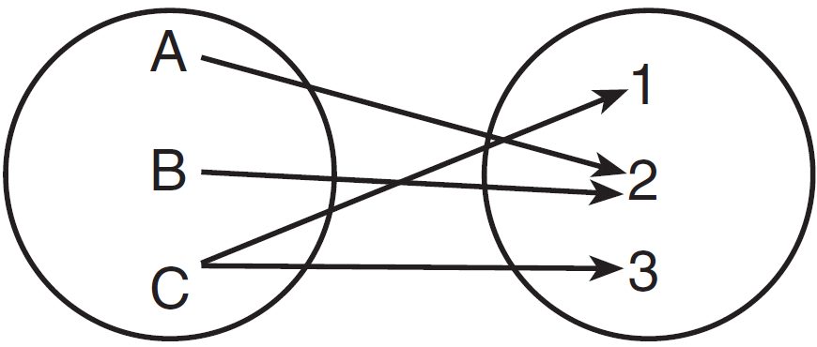
4) | 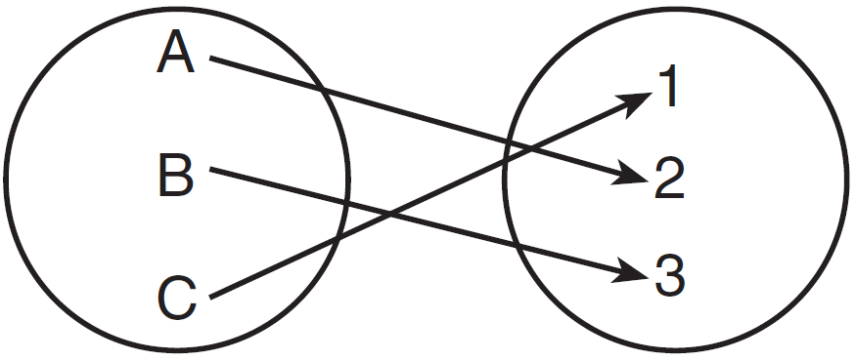

9 Which relation is both one-to-one and onto?
1) | 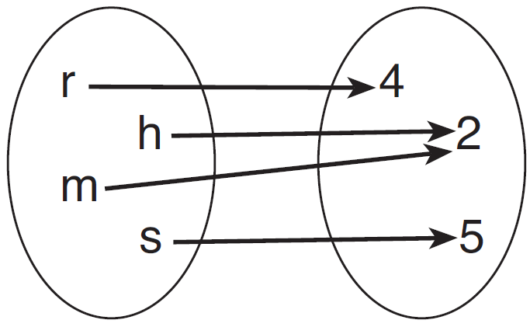
2) | 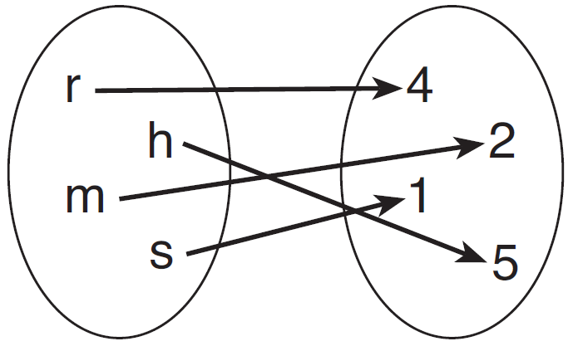
3) | 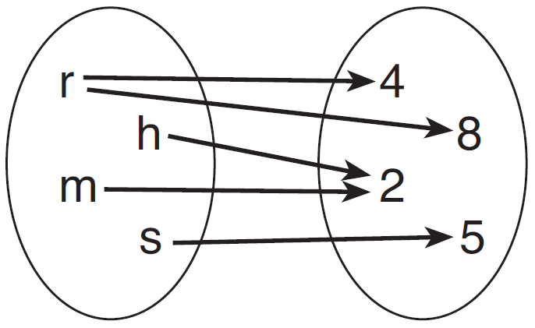
4) | 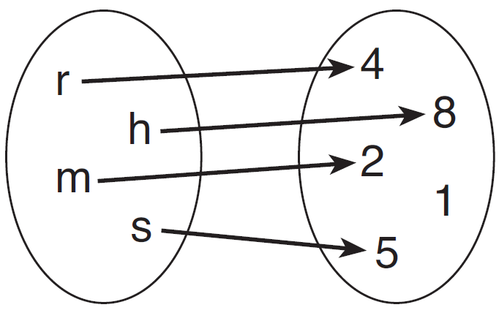

1 ANS: 4
(4) fails the horizontal line test. Not every element of the range corresponds to only one element of the domain.

REF: fall0906a2

2 ANS: 3 REF: 061501a2

3 ANS: 3
In a one-to-one function, if , then . The graph of a one-to-one function passes the horizontal line test.

REF: 060216b

4 ANS: 3
(1) and (4) fail the horizontal line test and are not one-to-one. Not every element of the range corresponds to only one element of the domain. (2) fails the vertical line test and is not a function. Not every element of the domain corresponds to only one element of the range.

REF: 081020a2

5 ANS: 2 REF: 011225a2

6 ANS: 3
passes the horizontal line test.

REF: 081617a2

7 ANS: 2 REF: 061218a2

8 ANS: 4 REF: 061303a2

9 ANS: 2 REF: 011407a2

