1 The formula of the nth term of the sequence is
1) |  | 3)
2) |  | 4)

2 In a geometric sequence, the first term is 4 and the common ratio is . The fifth term of this sequence is
1) | 324 | 3)
2) | 108 | 4)

3 The eleventh term of the sequence , is
1) |  | 3) | 3072
2) |  | 4) | 6144

4 What is the fifteenth term of the sequence ?
1) |  | 3) | 81,920
2) |  | 4) | 327,680

5 What is the fifteenth term of the geometric sequence ?
1) |  | 3)
2) |  | 4)

6 The seventh term of the geometric sequence is
1) |  | 3)
2) |  | 4)

7 The eighth and tenth terms of a sequence are 64 and 100. If the sequence is either arithmetic or geometric, the ninth term can not be
1) |  | 3) | 80
2) |  | 4) | 82

8 When a ball bounces, the heights of consecutive bounces form a geometric sequence. The height of the first bounce is 121 centimeters and the height of the third bounce is 64 centimeters. To the nearest centimeter, what is the height of the fifth bounce?
1) | 25 | 3) | 36
2) | 34 | 4) | 42

9 Simon lost his library card and has an overdue library book. When the book was 5 days late, he owed $2.25 to replace his library card and pay the fine for the overdue book. When the book was 21 days late, he owed $6.25 to replace his library card and pay the fine for the overdue book. Suppose the total amount Simon owes when the book is n days late can be determined by an arithmetic sequence. Determine a formula for , the nth term of this sequence. Use the formula to determine the amount of money, in dollars, Simon needs to pay when the book is 60 days late.

1 ANS: 4 REF: 011715a2

2 ANS: 1

REF: 012317ai

3 ANS: 3

REF: 012404ai

4 ANS: 3
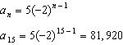

REF: 011105a2

5 ANS: 1
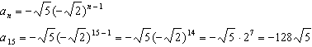

REF: 061109a2

6 ANS: 3
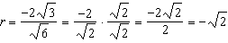

REF: 012410aii

7 ANS: 1
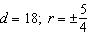

REF: 011714aii

8 ANS: 2
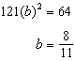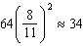

REF: 011904aii

9 ANS:
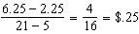 fine per day. replacement fee. .

REF: 081734aii

