1 Given: the sequence
When using the arithmetic sequence formula to determine the 10th term, which variable would be replaced with the number 3?
1)
2) | n
3)
4) | d

2 What is the nth term of the sequence ?
1)
2)
3)
4)

3 For the sequence , the expression that defines the nth term where is
1)
2)
3)
4)

4 The equation that represents the sequence is
1)
2)
3)
4)

5 The third term in an arithmetic sequence is 10 and the fifth term is 26. If the first term is , which is an equation for the nth term of this sequence?
1)
2)
3)
4)

6 What is a formula for the nth term of sequence B shown below?
1)
2)
3)
4)

7 In a sequence, the first term is 4 and the common difference is 3. The fifth term of this sequence is
1)
2)
3) | 16
4) | 19

8 An arithmetic sequence has a first term of 10 and a sixth term of 40. What is the 20th term of this sequence?
1) | 105
2) | 110
3) | 124
4) | 130

9 The 24th term of the sequence is
1)
2)
3) | 133
4) | 139

10 A theater has 35 seats in the first row. Each row has four more seats than the row before it. Which expression represents the number of seats in the nth row?
1)
2)
3)
4)

11 On the main floor of the Kodak Hall at the Eastman Theater, the number of seats per row increases at a constant rate. Steven counts 31 seats in row 3 and 37 seats in row 6. How many seats are there in row 20?
1) | 65
2) | 67
3) | 69
4) | 71

12 The diagrams below represent the first three terms of a sequence.

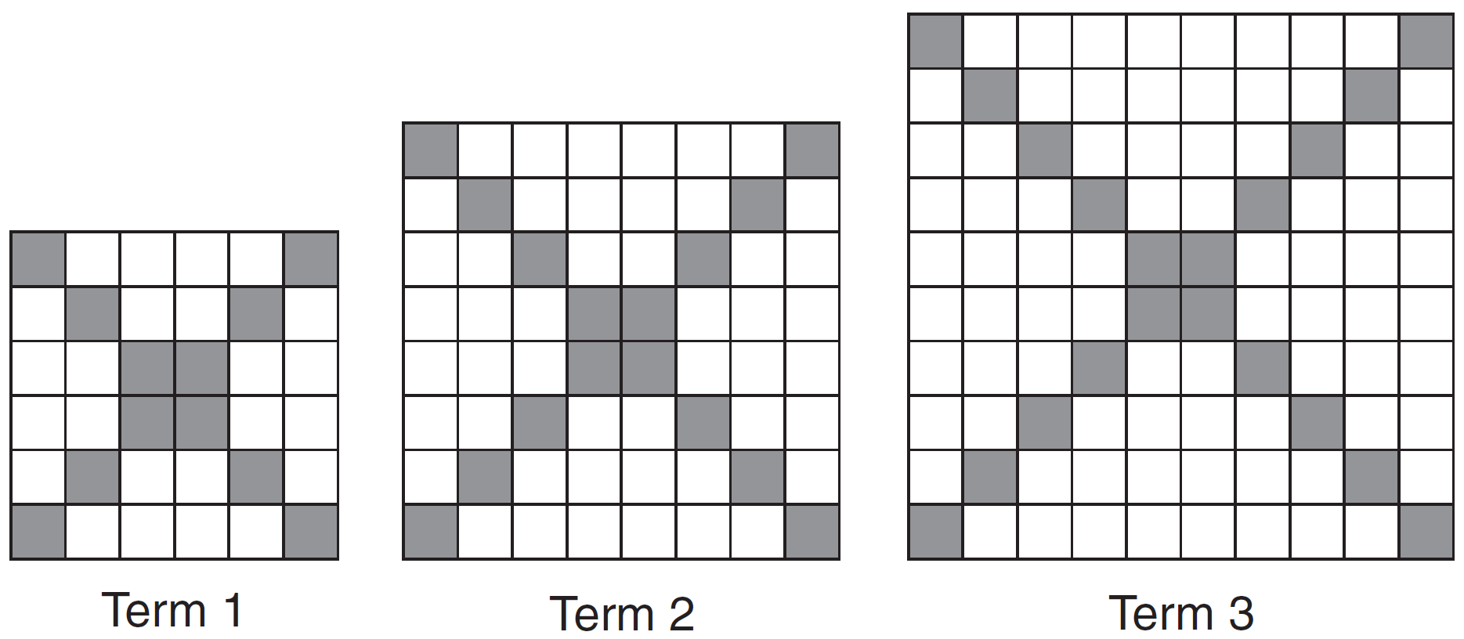

Assuming the pattern continues, which formula determines , the number of shaded squares in the nth term?
1)
2)
3)
4)

13 The shaded boxes in the figures below represent a sequence.

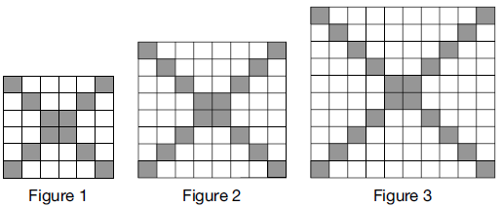

If figure 1 represents the first term and this pattern continues, how many shaded blocks will be in figure 35?
1) | 55
2) | 148
3) | 420
4) | 805

14 In an arithmetic sequence, and . Determine a formula for , the term of this sequence.

15 Determine the common difference of the arithmetic sequence in which and . Determine the 21st term of this sequence.

16 A sequence has the following terms: , , , . Which formula represents the nth term in the sequence?
1)
2)
3)
4)

17 What is the formula for the nth term of the sequence ?
1) | 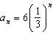
2) | 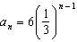
3) | 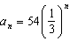
4) | 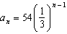

1 ANS: 4

REF: 062118ai

2 ANS: 2 REF: 061624a2

3 ANS: 4 REF: 081820ai

4 ANS: 2 REF: 062415ai

5 ANS: 2 REF: 081416ai

6 ANS: 1
common difference is 2. 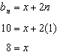

REF: 081014a2

7 ANS: 3
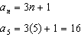

REF: 061613ai

8 ANS: 3
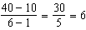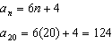

REF: 081510a2

9 ANS: 2

REF: 062305ai

10 ANS: 4 REF: 061520a2

11 ANS: 1
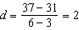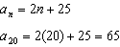

REF: 061807ai

12 ANS: 2 REF: 061424ai

13 ANS: 2
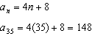

REF: 012008ai

14 ANS:
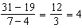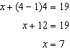

REF: 011434a2

15 ANS:
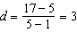;

REF: 082330ai

16 ANS: 4
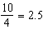

REF: 011217a2

17 ANS: 4 REF: 061026a2

