1 Which quadratic function is shown in the accompanying graph?

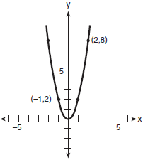
1)
2)
3) | 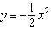
4) | 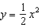

2 Which equation is represented by the accompanying graph?

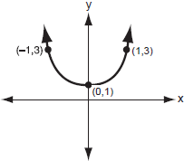
1)
2)
3)
4)

3 Which is an equation of the parabola shown in the accompanying diagram?

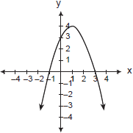
1)
2)
3)
4)

4 Which equation represents the parabola shown in the accompanying graph?

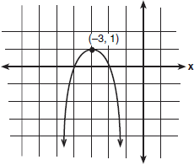
1)
2)
3)
4)

5 What is the equation of a parabola that goes through points , , and ?
1)
2)
3)
4)

6 The graph of a quadratic equation is shown in the accompanying diagram. The scale on the axes is a unit scale. Write an equation of this graph in standard form.

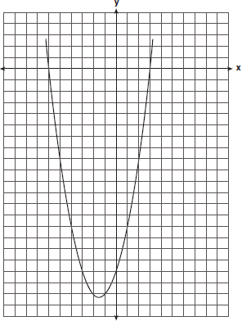

1 ANS: 2
Since the parabola is cupped up, a > 0, eliminating (1) and (3). The point (2, 8) satisfies only . You can also use a graphing calculator’s STAT function, input at least three ordered pairs, and calculate the quadratic regression line of best fit. 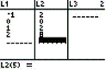. 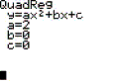

REF: 060404b

2 ANS: 1 REF: 010801b

3 ANS: 1
Since the parabola is cupped down, a < 0, eliminating (3) and (4). Based upon the graph, the axis of symmetry is x = 1. 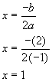.

REF: 080017a

4 ANS: 3
When the equation of a quadratic is in vertex form, , (h, k) is the vertex.

REF: 010303b

5 ANS: 4
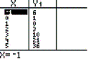. You can also use a graphing calculator’s STAT function, input the three ordered pairs, and calculate the quadratic regression line of best fit. 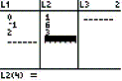. 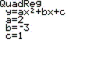.

REF: 060209b

6 ANS:
. a > 0, the y-intercept is , and the roots are and 3. 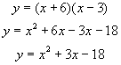. You can also use a graphing calculator’s STAT function, input at least three ordered pairs, and calculate the quadratic regression line of best fit. 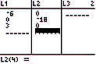. 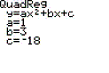

REF: 010328a

