1 If and , then is equal to
1)
2)
3)
4)

2 If and , which expression is equivalent to ?
1)
2)
3)
4)

3 If and , then is equal to
1)
2)
3)
4)

4 If and , which expression is equivalent to ?
1)
2)
3)
4)

5 If f and g are two functions defined by and , then is
1)
2)
3)
4)

6 If and , what is ?
1)
2)
3)
4)

7 If 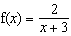 and 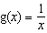, then is equal to
1) | 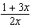
2) | 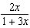
3) | 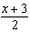
4) | 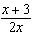

8 If and , which number satisfies ?
1)
2)
3) | 5
4) | 4

9 If and , the expression equals 0 when x is equal to
1) | 1 and –1
2) | 0, only
3) | –2, only
4) | 0 and –2

10 If and , determine in simplest form.

11 Given: and , find and .

12 If 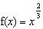 and 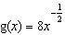, find and .

13 Given and , express as a polynomial in simplest form.

14 Which expression is equivalent to , given , , and ?
1)
2)
3)
4)

1 ANS: 3

REF: 061015b

2 ANS: 3

REF: 010909b

3 ANS: 2

REF: 011109a2

4 ANS: 4
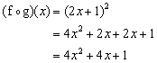

REF: 080917b

5 ANS: 2
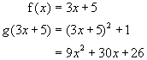

REF: 080313b

6 ANS: 1

REF: 061419a2

7 ANS: 3
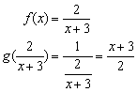

REF: 010408b

8 ANS: 1
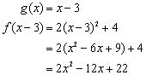. 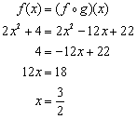

REF: 060210b

9 ANS: 4
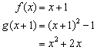. 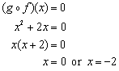

REF: 060417b

10 ANS:

REF: 081530a2

11 ANS:

REF: 080341siii

12 ANS:
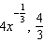. 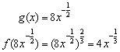. 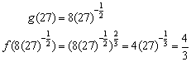

REF: 010331b

13 ANS:

REF: 011733a2

14 ANS: 2 REF: 061216a2

