1 If and , determine the value of .

2 If and , find .

3 If and , determine the value of .

4 If and , find .

5 If and , find .

6 If and , what is the value of ?

7 If and , what is the value of ?

8 If and , evaluate .

9 If and , what is ?

10 If and , find .

11 If and , find .

12 If 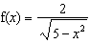 and , evaluate .

13 If and , find .

14 If and , evaluate .

15 If and , find .

16 If and , find .

17 If 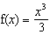 and , find .

18 If and , find .

19 If and , find the value of .

20 If and , determine the value of .

21 A certain drug raises a patient's heart rate, , in beats per minute, according to the function , where x is the bloodstream drug level, in milligrams. The level of the drug in the patient's bloodstream is a function of time, t, in hours, according to the formula . Find the value of , the patient's heart rate in beats per minute, to the nearest whole number.

22 If and , find
a , the inverse of .
b .

23 Given: and
a The inverse of g is a function, but the inverse of f is not a function. Explain why this statement is true.
b Find to the nearest tenth.
1 ANS:
255. 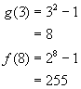

REF: 060322b

2 ANS:
11. 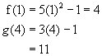.

REF: 010621b

3 ANS:
6. 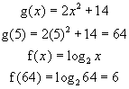

REF: 060725b

4 ANS:
5. . .

REF: 060921b

5 ANS:
10

REF: 011021b

6 ANS:
13

REF: 069608siii

7 ANS:
1

REF: 019710siii

8 ANS:

REF: 069715siii

9 ANS:
9

REF: 089709siii

10 ANS:
7

REF: 089802siii

11 ANS:
49

REF: 089907siii

12 ANS:
1

REF: 010106siii

13 ANS:
24

REF: 060105siii

14 ANS:
7

REF: 080105siii

15 ANS:
3

REF: 010211siii

16 ANS:
25

REF: 060207siii

17 ANS:
3

REF: 080208siii

18 ANS:

REF: 010311siii

19 ANS:
14

REF: 060305siii

20 ANS:
7. . .

REF: 061135a2

21 ANS:
95. .

REF: 060526b

22 ANS:
a 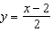
b 1

REF: 089340siii

23 ANS:
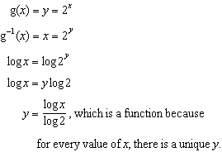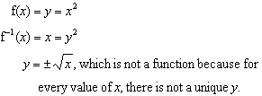. 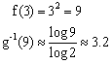

REF: 010332b

