1 If 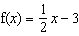 and , what is the value of ?
1) 2) 3.5 3) 3 4) 6

2 If 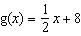 and 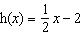, what is the value of ?
1) 0 2) 9 3) 5 4) 4

3 If and , then is equal to
1) 2) 3) 4) 7

4 If and , what is the value of ?
1) 2) 3) 25 4) 129

5 If and , what is the value of ?
1) 2) 16 3) 48 4) 144

6 If and , what is the value of ?
1) 2) 16 3) 80 4) 1,280

7 If and , what is the value of ?
1) 2) 2 3) 8 4) 13

8 If and , what is ?
1) 5 2) 7 3) 4)

9 If and , find .
1) 0 2) 6 3) 24 4) 30

10 If and 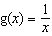, then 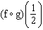 is equal to
1) 2) 3) 4) 4

11 The temperature generated by an electrical circuit is represented by , where m is the number of moving parts. The resistance of the same circuit is represented by , where t is the temperature. What is the resistance in a circuit that has four moving parts?
1) 51 2) 156 3) 174 4) 8,670

12 The accompanying tables define functions f and g.

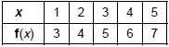

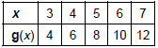

What is ?
1) 6 2) 2 3) 8 4) 4

13 The accompanying graph is a sketch of the function over the interval .

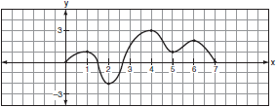

What is the value of ?
1) 1 2) 2 3) 0 4)
1 ANS: 3
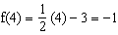.
REF: fall0902a2

2 ANS: 3
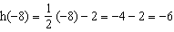. 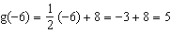
REF: 011403a2

3 ANS: 1
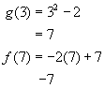
REF: 010501b

4 ANS: 4
REF: 061503a2

5 ANS: 3 REF: 069915siii

6 ANS: 3
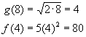
REF: 010207b

7 ANS: 3
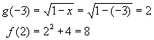
REF: 060806b

8 ANS: 4 REF: 069423siii

9 ANS: 3 REF: 019820siii

10 ANS: 4
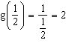.
REF: 011204a2

11 ANS: 3
.
REF: 060605b

12 ANS: 3
f(3) = 5, g(5) = 8
REF: 010812b

13 ANS: 4
,
REF: 080520b

