1 What is the sum of the first 19 terms of the sequence ?
1) | 1188
2) | 1197
3) | 1254
4) | 1292

2 Determine the sum of the first twenty terms of the sequence whose first five terms are 5, 14, 23, 32, 41.

3 An auditorium has 21 rows of seats. The first row has 18 seats, and each succeeding row has two more seats than the previous row. How many seats are in the auditorium?
1) | 540
2) | 567
3) | 760
4) | 798

4 In a theater with 30 rows, the number of seats in a row increases by two with each successive row. The front row has 15 seats. Find the total seating capacity of the theater.
1 ANS: 3
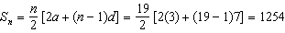

REF: 011202a2

2 ANS:
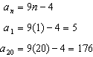. 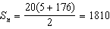

REF: 011328a2

3 ANS: 4
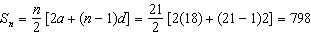

REF: 061103a2

4 ANS:
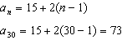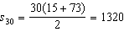

REF: 011732a2

