1 When the expression is rewritten as the product of two binomials, the result is
1)
2)
3)
4)

2 Which expression is equivalent to ?
1)
2)
3)
4)

3 Which expression is equivalent to ?
1)
2)
3)
4)

4 The expression is equivalent to
1)
2)
3)
4)

5 The expression is equivalent to
1)
2)
3)
4)

6 If , then m equals
1)
2)
3) | 3
4) | 6

7 When factored completely, is equivalent to
1)
2)
3)
4)

8 Which expression is equivalent to ?
1)
2)
3)
4)

9 Which expression is not equivalent to ?
1)
2)
3)
4)

10 Which expression is equivalent to ?
1)
2)
3)
4)

11 Factored completely, is equivalent to
1)
2)
3)
4)

12 The completely factored form of is
1)
2)
3)
4)

13 What is the completely factored form of ?
1)
2)
3)
4)

14 The completely factored form of is
1)
2)
3)
4)

15 Which factorization is incorrect?
1)
2)
3)
4)

16 Which expression has been rewritten correctly to form a true statement?
1)
2)
3)
4)

17 Over the set of integers, factor the expression .

18 Over the set of integers, completely factor .

19 Factor the expression completely.

20 Factor completely.

21 Factor the expression completely.

22 Over the set of integers, factor the expression completely.

23 Factor completely over the set of integers:

24 Completely factor the following expression:

25 Rewrite the expression 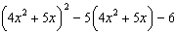 as a product of four linear factors.
1 ANS: 2
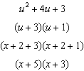

REF: 081901aii

2 ANS: 1
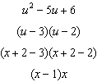

REF: 012301aii

3 ANS: 2
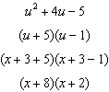

REF: 062401aii

4 ANS: 3
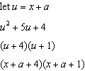

REF: 012006aii

5 ANS: 2
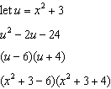

REF: 062310aii

6 ANS: 2 REF: 081904aii

7 ANS: 4

REF: 011703aii

8 ANS: 4
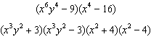

REF: 081814aii

9 ANS: 3 REF: 062302aii

10 ANS: 3

REF: 082423aii

11 ANS: 2
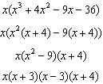

REF: 062407aii

12 ANS: 3
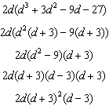

REF: 081615aii

13 ANS: 4
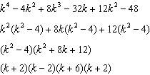

REF: fall1505aii

14 ANS: 2
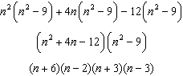

REF: 061911aii

15 ANS: 3

REF: 081605aii

16 ANS: 1
1) let , then 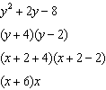

REF: 081715aii

17 ANS:

REF: 081825aii

18 ANS:
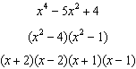

REF: 012331aii

19 ANS:

REF: 082226aii

20 ANS:

REF: 012425aii

21 ANS:
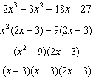

REF: 082325aii

22 ANS:

REF: 061727aii

23 ANS:
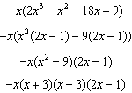

REF: 062228aii

24 ANS:

REF: 011828aii

25 ANS:
The expression is of the form or . Let :
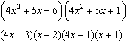

REF: fall1512aii

