1 Tim deposits $300 into a savings account. The annual interest rate is 2.7% and compounds monthly. He uses the equation 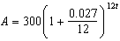 to determine how much money he will have after t years. Which equation is equivalent to Tim's equation?
1) | 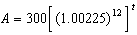
2)
3) | 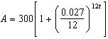
4) | 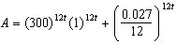

2 Stephanie found that the number of white-winged cross bills in an area can be represented by the formula , where t represents the number of years since 2010. Which equation correctly represents the number of white-winged cross bills in terms of the monthly rate of population growth?
1)
2)
3) | 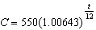
4)

3 A study of the annual population of the red-winged blackbird in Ft. Mill, South Carolina, shows the population, , can be represented by the function , where the t represents the number of years since the study began. In terms of the monthly rate of growth, the population of red-winged blackbirds can be best approximated by the function
1)
2)
3)
4) | 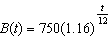

4 A study of the red tailed hawk population in a given area shows the population, , can be represented by the function where t represents the number of years since the study began. In terms of the monthly rate of growth, the population can be best approximated by the function
1)
2) | 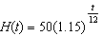
3)
4) | 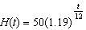

5 A study of black bears in the Adirondacks reveals that their population can be represented by the function , where t is the number of years since the study began. Which function is correctly rewritten to reveal the monthly growth rate of the black bear population?
1)
2) | 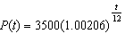
3)
4) | 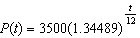

6 The growth of a $500 investment can be modeled by the function , where t represents time in years. In terms of the monthly rate of growth, the value of the investment can be best approximated by
1)
2)
3)
4) | 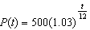

7 Julia deposits $2000 into a savings account that earns 4% interest per year. The exponential function that models this savings account is , where t is the time in years. Which equation correctly represents the amount of money in her savings account in terms of the monthly growth rate?
1)
2)
3)
4)

8 Mia has a student loan that is in deferment, meaning that she does not need to make payments right now. The balance of her loan account during her deferment can be represented by the function , where x is the number of years since the deferment began. If the bank decides to calculate her balance showing a monthly growth rate, an approximately equivalent function would be
1)
2) | 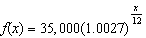
3)
4) | 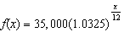

9 A student studying public policy created a model for the population of Detroit, where the population decreased 25% over a decade. He used the model , where P is the population, in thousands, d decades after 2010. Another student, Suzanne, wants to use a model that would predict the population after y years. Suzanne's model is best represented by
1)
2)
3)
4)

10 According to the USGS, an agency within the Department of Interior of the United States, the frog population in the U.S. is decreasing at the rate of 3.79% per year. A student created a model, , to estimate the population in a pond after t years. The student then created a model that would predict the population after d decades. This model is best represented by
1)
2)
3)
4)

11 On average, college seniors graduating in 2012 could compute their growing student loan debt using the function , where t is time in years. Which expression is equivalent to and could be used by students to identify an approximate daily interest rate on their loans?
1) | 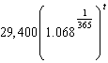
2) | 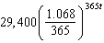
3) | 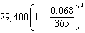
4) | 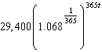

12 To prepare for lacrosse tryouts, Kole is increasing the amount of time he spends at the gym. This week he is spending 150 minutes there and he plans to increase this amount by 2% each week. The amount of time, in minutes, that he plans to spend at the gym t weeks from now is given by the function . In terms of a daily growth rate, the amount of time Kole is planning to spend at the gym can best be modeled by the function
1) | 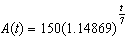
2)
3) | 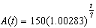
4)

13 The amount of a substance, , that remains after t days can be given by the equation 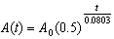, where represents the initial amount of the substance. An equivalent form of this equation is
1)
2)
3)
4)

14 lridium-192 is an isotope of iridium and has a half-life of 73.83 days. If a laboratory experiment begins with 100 grams of Iridium-192, the number of grams, A, of Iridium-192 present after t days would be 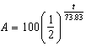. Which equation approximates the amount of Iridium-192 present after t days?
1) | 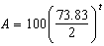
2) | 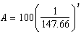
3)
4)

15 Luminescence is the emission of light that is not caused by heat. A luminescent substance decays according to the function below.

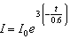

This function can be best approximated by
1) | 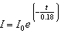
2)
3)
4)

16 Kelly-Ann has $20,000 to invest. She puts half of the money into an account that grows at an annual rate of 0.9% compounded monthly. At the same time, she puts the other half of the money into an account that grows continuously at an annual rate of 0.8%. Which function represents the value of Kelly-Ann's investments after t years?
1)
2)
3)
4)

17 For a given time, x, in seconds, an electric current, y, can be represented by . Which equation is not equivalent?
1)
2) | 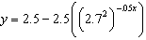
3) | 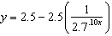
4)

1 ANS: 1
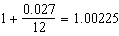

REF: 082403aii

2 ANS: 2

REF: 081808aii

3 ANS: 2
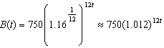 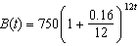 is wrong, because the growth is an annual rate that is not compounded monthly.

REF: spr1504aii

4 ANS: 1
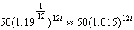

REF: 012424aii

5 ANS: 1
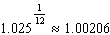

REF: 081924aii

6 ANS: 1
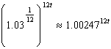

REF: 062224aii

7 ANS: 3
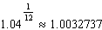

REF: 011906aii

8 ANS: 1
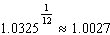

REF: 012323aii

9 ANS: 3
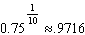

REF: 061713aii

10 ANS: 2

REF: 082311aii

11 ANS: 4
1 year = 365 days

REF: 061823aii

12 ANS: 4
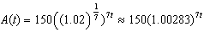

REF: 062415aii

13 ANS: 1
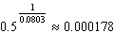

REF: 082224aii

14 ANS: 3
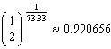

REF: 081710aii

15 ANS: 3
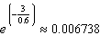

REF: 062315aii

16 ANS: 4
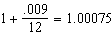

REF: 011918aii

17 ANS: 4 REF: 011808aii

