1 The expression is equivalent to
1)
2)
3)
4)

2 When factored completely, equals
1)
2)
3)
4)

3 When factored completely, the expression is equivalent to
1)
2)
3)
4)

4 When factored completely, the expression is equivalent to
1)
2)
3)
4)

5 Factor completely:

6 Factor completely:

7 Factor:

8 Factor:

9 Factor:

10 Factor:

11 Factor:

12 Factor:

13 Factor:

14 Factor:

15 Factor:

16 Factor:

17 Factor:

18 Factor:

19 Factor:

20 Factor:

21 Factor:

22 Factor:

23 Factor:
1 ANS: 4
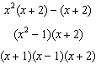
REF: 011426a2

2 ANS: 2
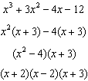
REF: 061214a2

3 ANS: 2
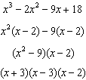
REF: 011511a2

4 ANS: 3
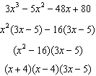
REF: 011317a2

5 ANS:
REF: 011629a2

6 ANS:
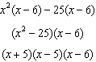
REF: 061532a2

7 ANS:
REF: 039404al

8 ANS:
REF: 099806al

9 ANS:
REF: 069802al

10 ANS:
REF: 060502al

11 ANS:
REF: 069303al

12 ANS:
REF: 019604al

13 ANS:
REF: 010502al

14 ANS:
REF: 099403al

15 ANS:
REF: 090502al

16 ANS:
REF: 010602al

17 ANS:
REF: 019806al

18 ANS:
REF: 030501al

19 ANS:
REF: 010003al

20 ANS:
REF: 090402al

21 ANS:
REF: 099904al

22 ANS:
REF: 089703al

23 ANS:
REF: 039703al

