1 Which ordered pair is in the solution set of the system of linear inequalities graphed below?
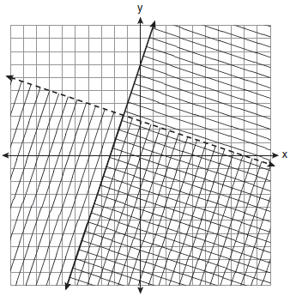
1)
2)
3)
4)

2 Which ordered pair is in the solution set of the system of inequalities shown in the graph below?
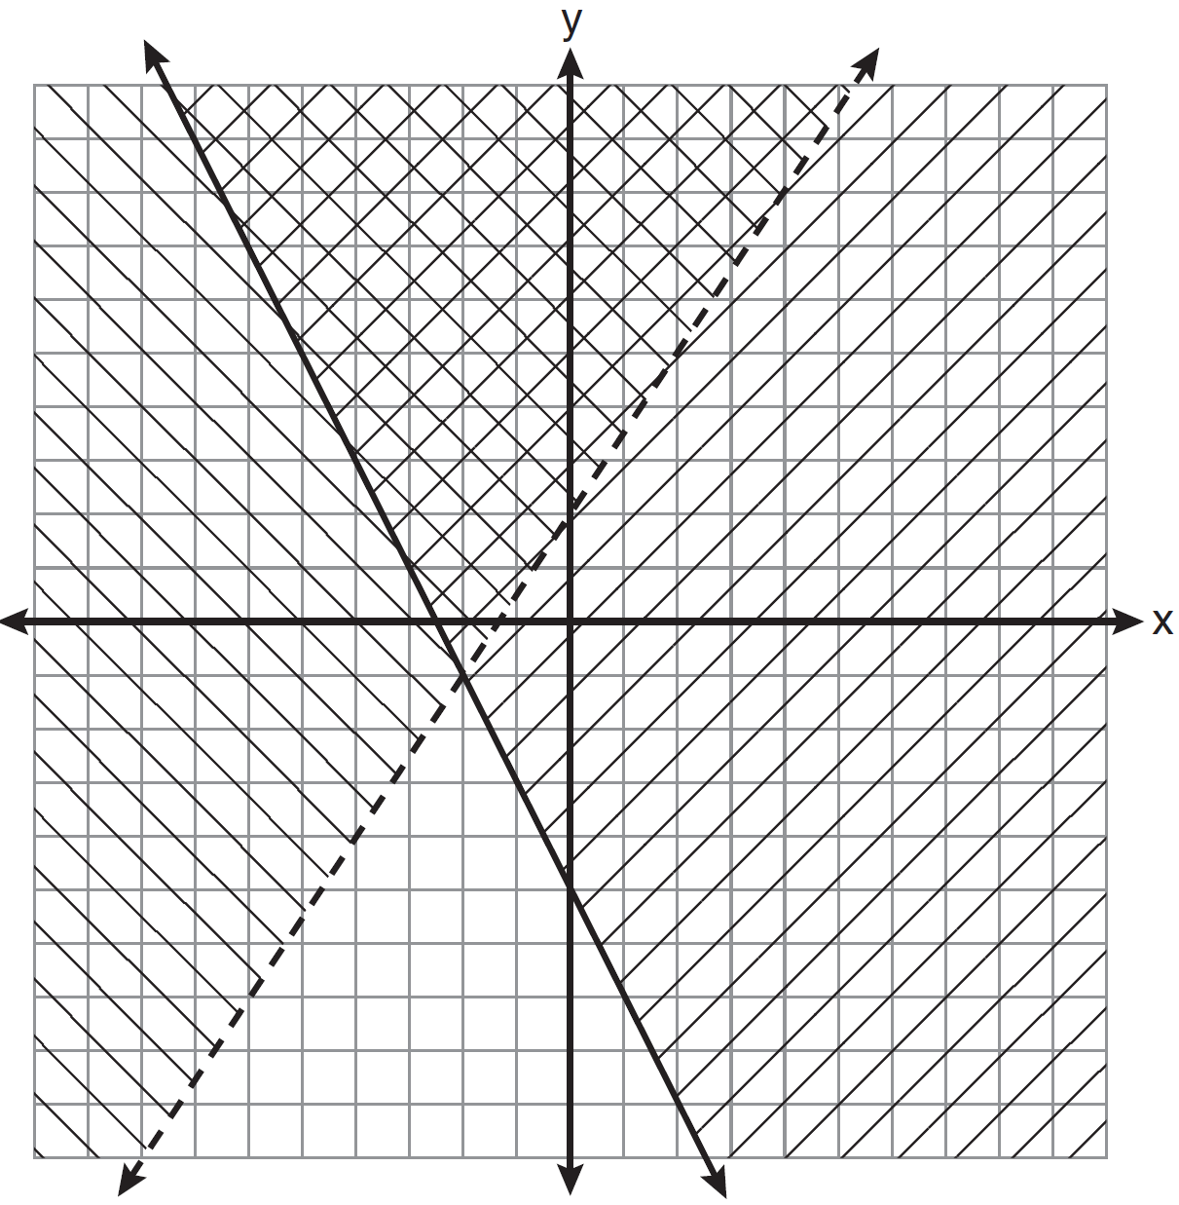
1)
2)
3)
4)

3 A system of inequalities is graphed on the set of axes below.

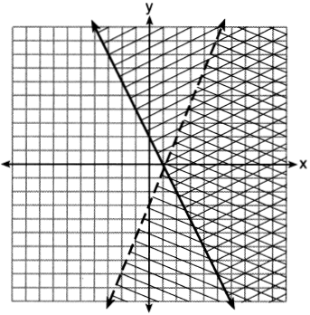

The coordinates of a point in the solution of this system of inequalities are
1)
2)
3)
4) | (3,1)

4 Which point is a solution for the system of inequalities shown on the accompanying graph?

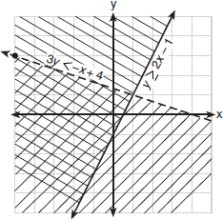
1)
2)
3)
4)

5 Which point is in the solution set of the system of inequalities shown in the accompanying graph?

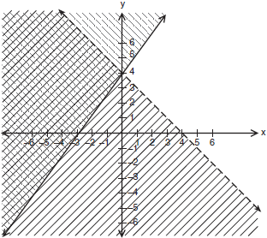
1)
2)
3)
4)

6 Which coordinate point is in the solution set for the system of inequalities shown in the accompanying graph?

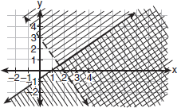
1)
2)
3)
4)

7 Which ordered pair is in the solution set of the system of inequalities shown in the accompanying graph?
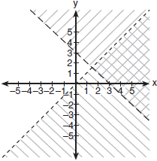
1)
2)
3)
4)

8 Which point is in the solution set of the system of inequalities shown on the accompanying graph?
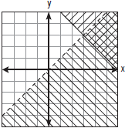
1)
2)
3)
4)

9 Which ordered pair is in the solution set of the following system of inequalities?
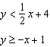
1)
2)
3)
4)

10 Which ordered pair is in the solution set of the following system of linear inequalities?
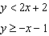
1)
2)
3)
4)

11 Which coordinates represent a point in the solution set of the system of inequalities shown below?
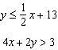
1)
2)
3)
4)

12 Which ordered pair is in the solution set of the system of inequalities and ?
1)
2)
3)
4)

13 Graph and on the axes below.

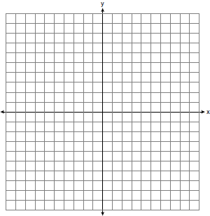

State the coordinates of a point in the solution set.

14 On the set of axes below, solve the following system of inequalities graphically.
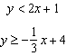
State the coordinates of a point in the solution set.

15 Graph the following system of inequalities on the set of axes shown below and label the solution set S:
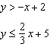

16 On the set of axes below, graph the following system of inequalities and state the coordinates of a point in the solution set.
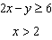
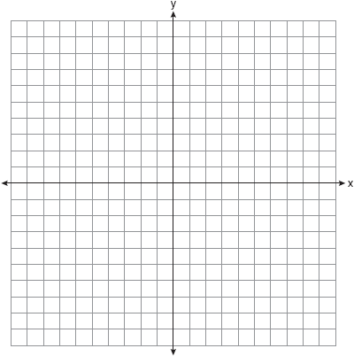

17 Graph the following system of inequalities on the accompanying set of axes and label the solution set S:
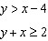
[Only a graphic solution can receive full credit.]

18 Solve the following system of inequalities graphically on the set of axes below.
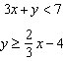
State the coordinates of a point in the solution set.

19 On the set of axes below, graph the following system of inequalities.
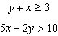
State the coordinates of one point that satisfies , but does not satisfy .
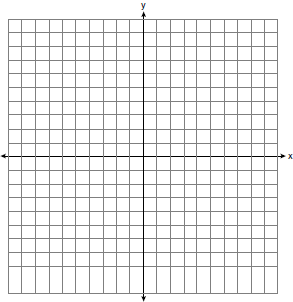

20 On the set of axes below, solve the following system of inequalities graphically. Label the solution set S.
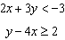

21 On the set of axes below, solve the following system of inequalities graphically.
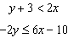
State the coordinates of a point in the solution set.

22 A company manufactures bicycles and skateboards. The company’s daily production of bicycles cannot exceed 10, and its daily production of skateboards must be less than or equal to 12. The combined number of bicycles and skateboards cannot be more than 16. If x is the number of bicycles and y is the number of skateboards, graph on the accompanying set of axes the region that contains the number of bicycles and skateboards the company can manufacture daily.

1 ANS: 1 REF: 061010ia

2 ANS: 2 REF: 081127ia

3 ANS: 4 REF: 061613ia

4 ANS: 1 REF: 010922a

5 ANS: 3 REF: 010528a

6 ANS: 1 REF: 060620a

7 ANS: 4 REF: 080615a

8 ANS: 3 REF: 080822a

9 ANS: 4 REF: 080825ia

10 ANS: 2 REF: 011023ia

11 ANS: 4 REF: 061222ia

12 ANS: 2
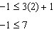. 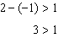

REF: 011323ia

13 ANS:
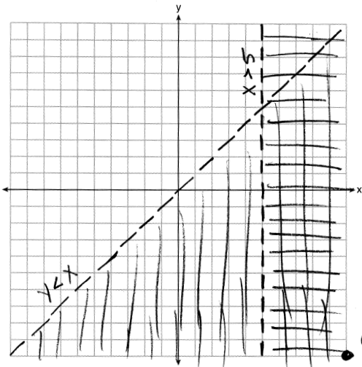

REF: 011536ia

14 ANS:
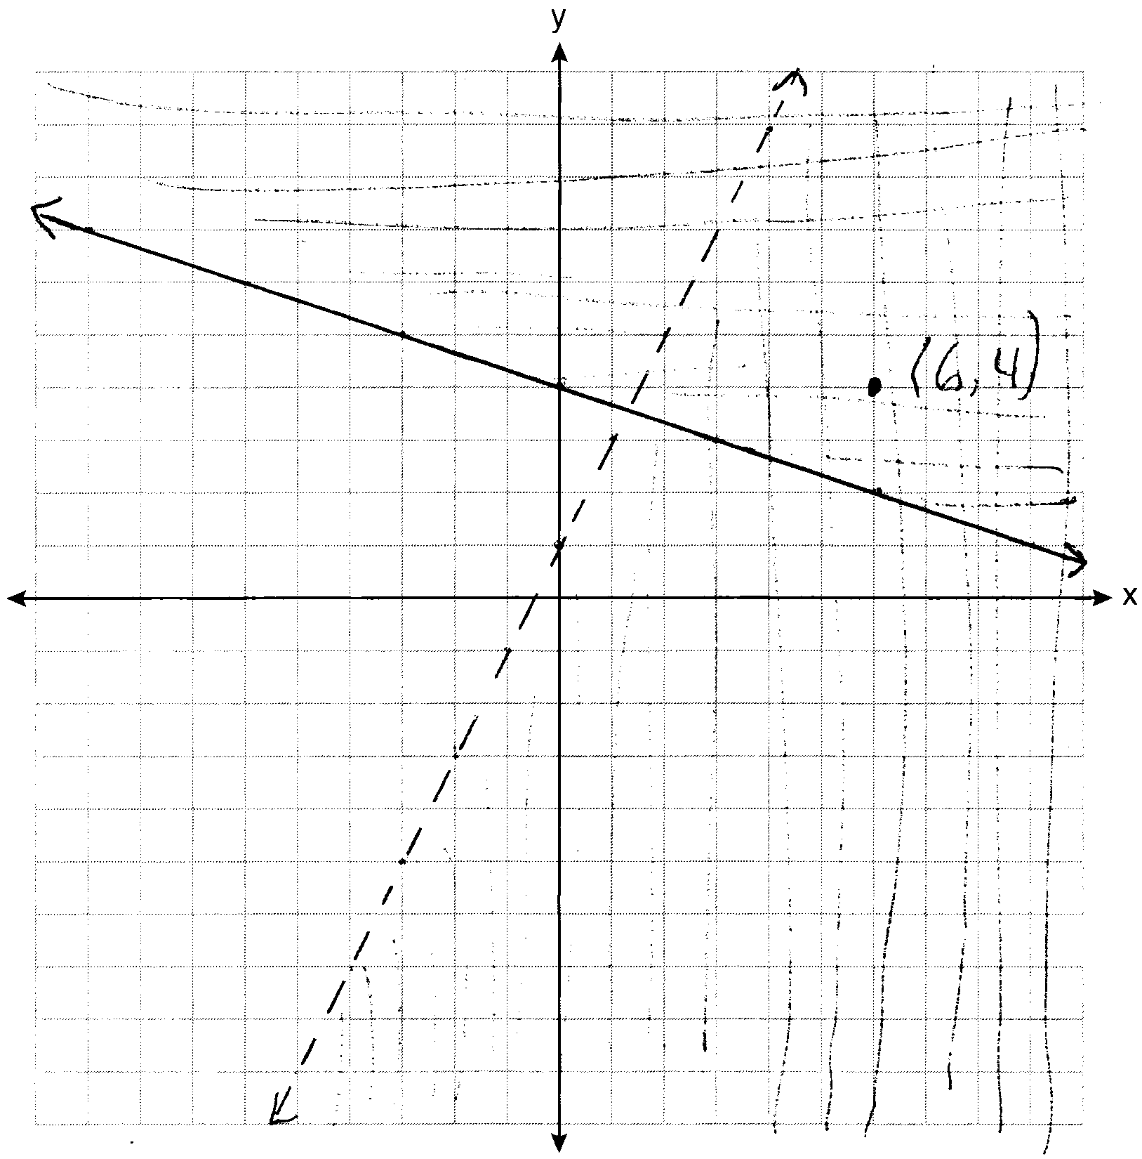

REF: 081037ia

15 ANS:
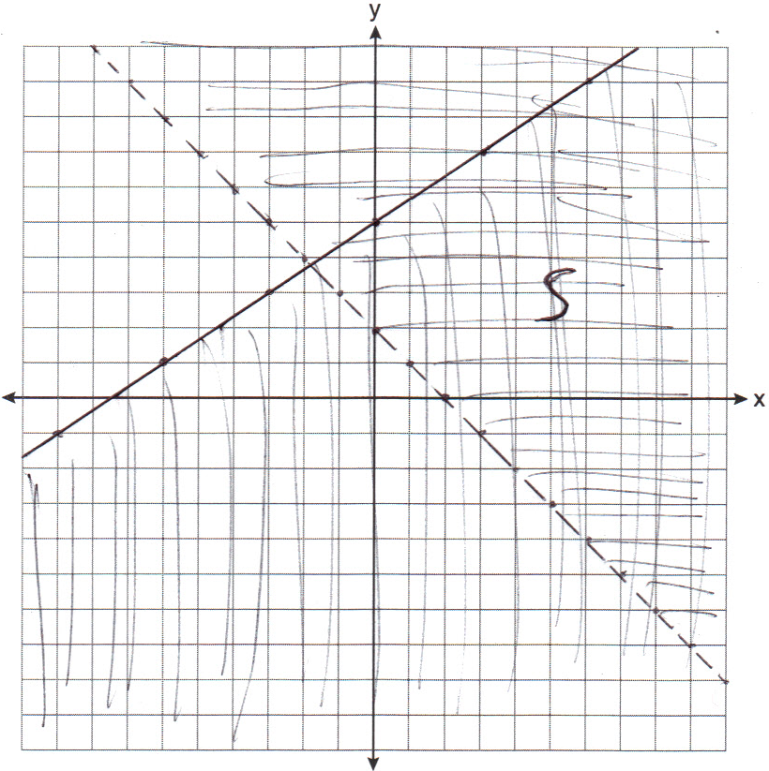

REF: 011139ia

16 ANS:
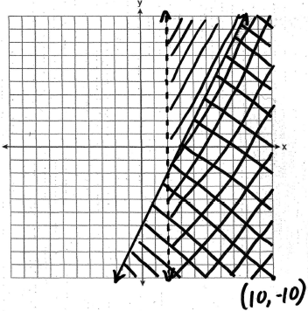

REF: 010938ia

17 ANS:
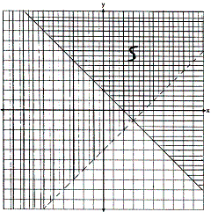

REF: 010738a

18 ANS:
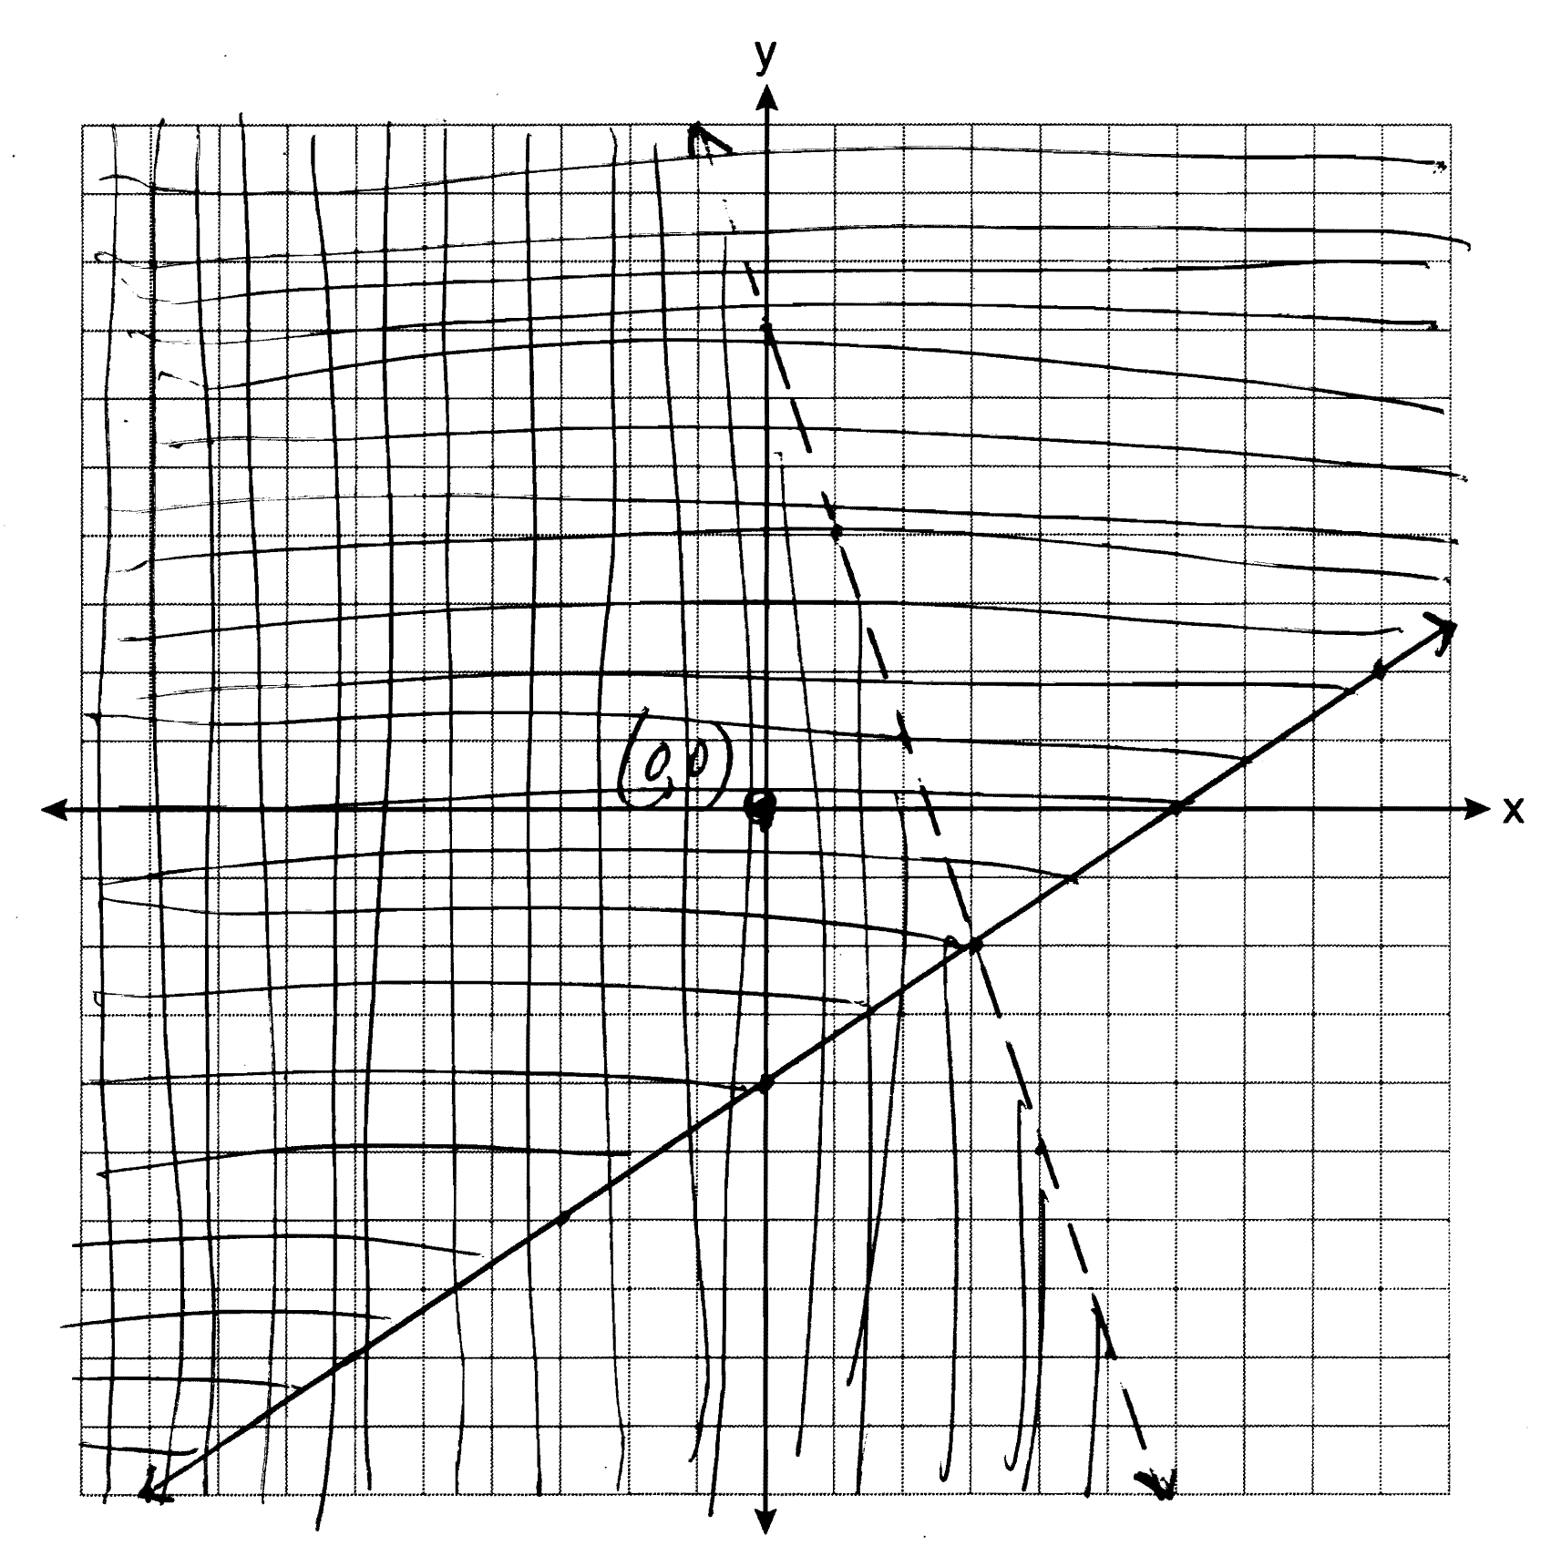

REF: 061139ia

19 ANS:
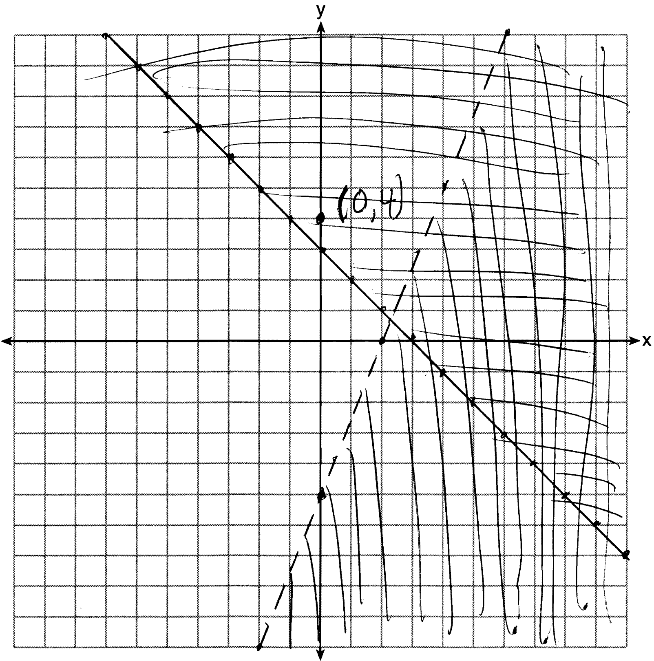

REF: 081239ia

20 ANS:
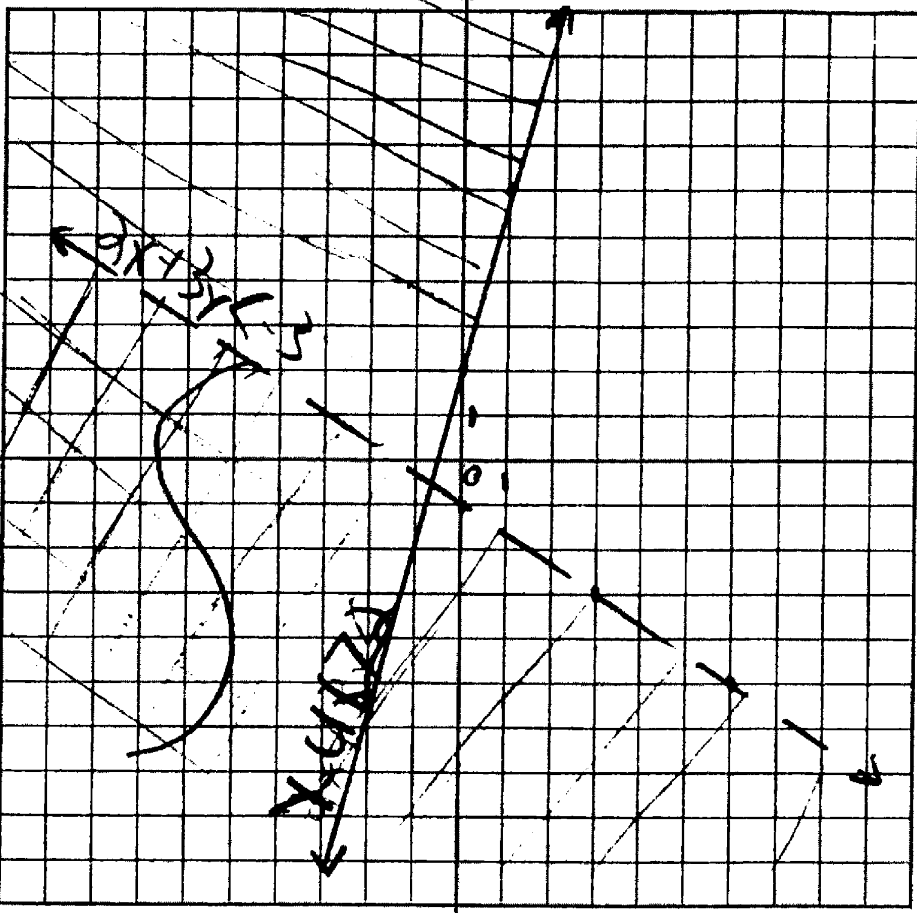

REF: 061438ia

21 ANS:
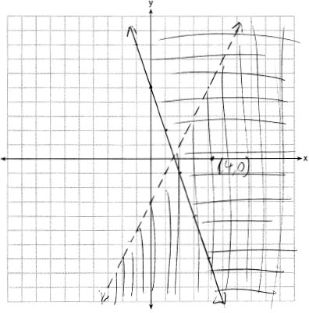

REF: 081437ia

22 ANS:
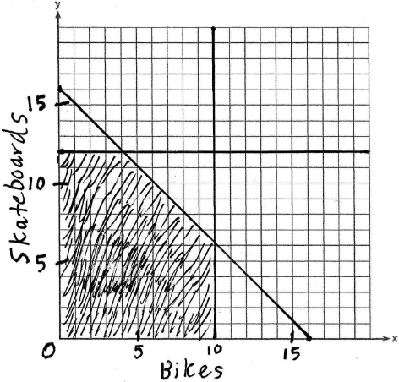

REF: 010234a

