1 Which graph represents the inequality ?
1) | 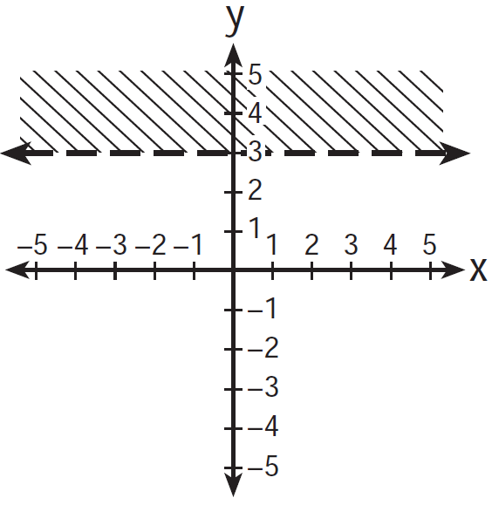
2) | 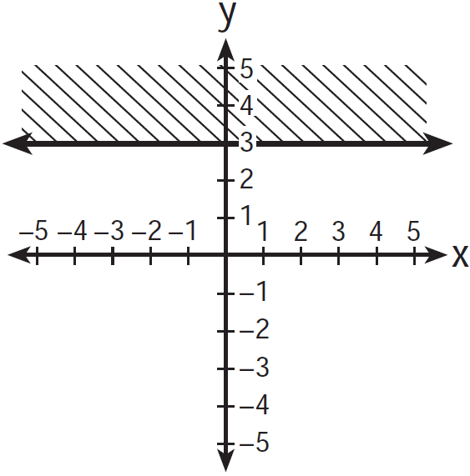
3) | 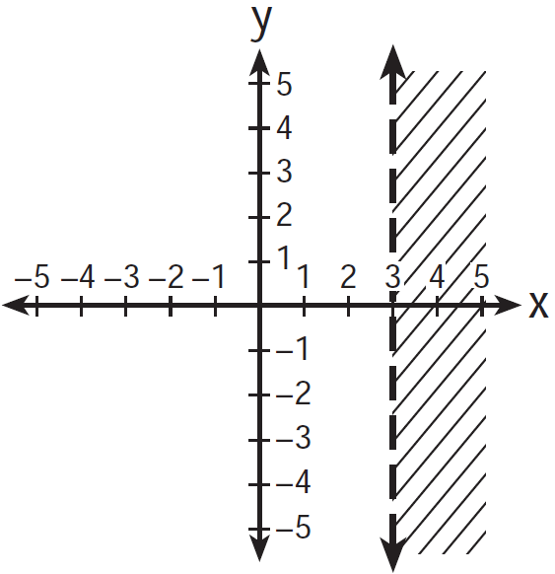
4) | 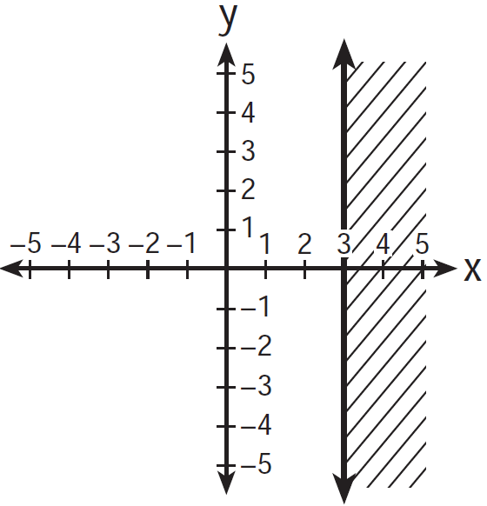

2 Which graph represents the inequality ?
1) | 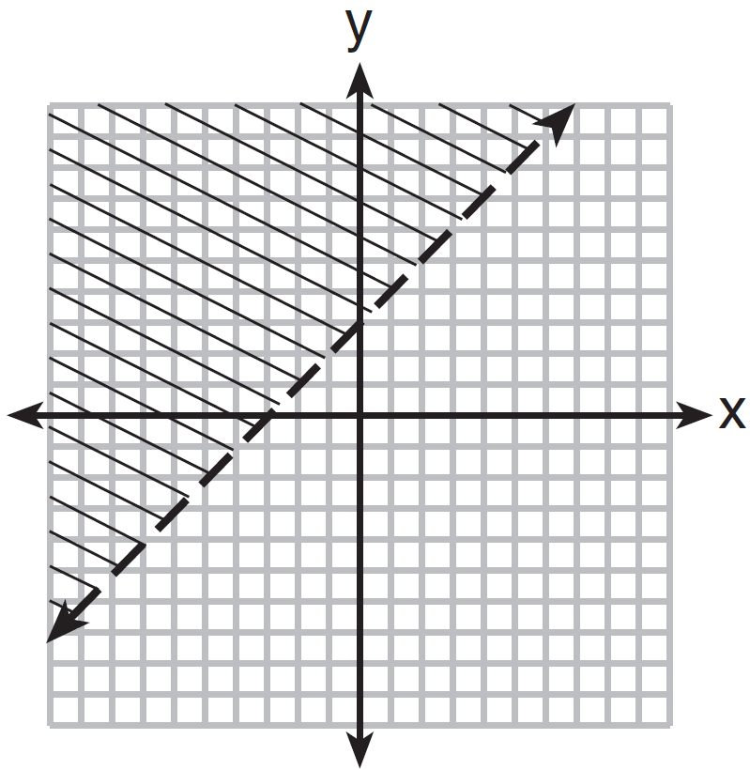
2) | 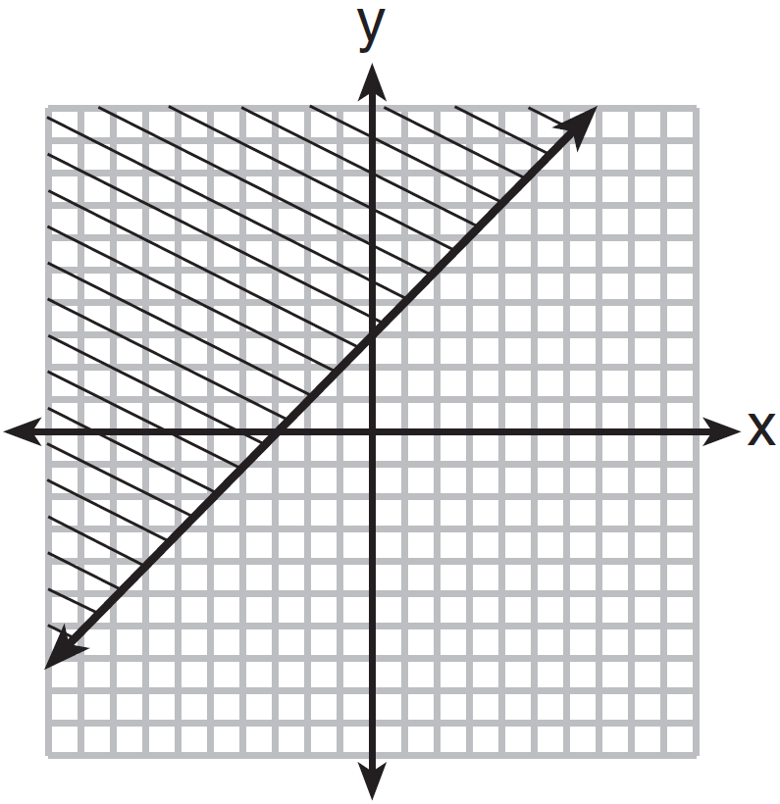
3) | 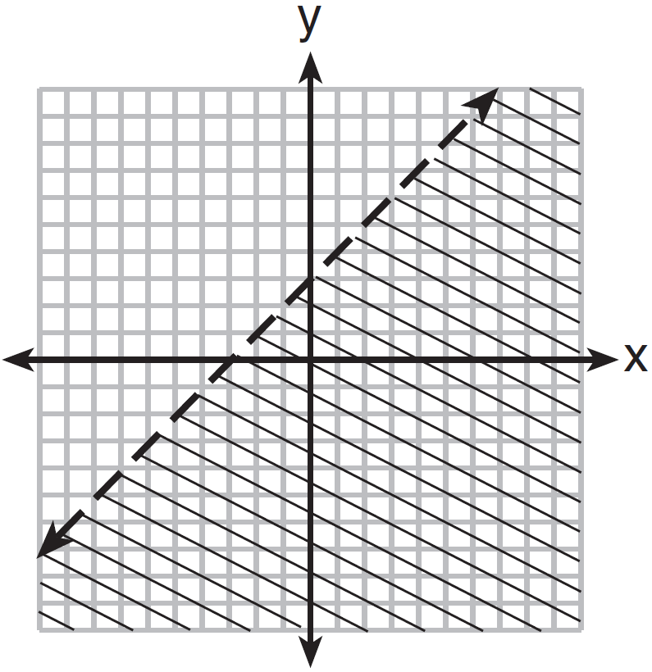
4) | 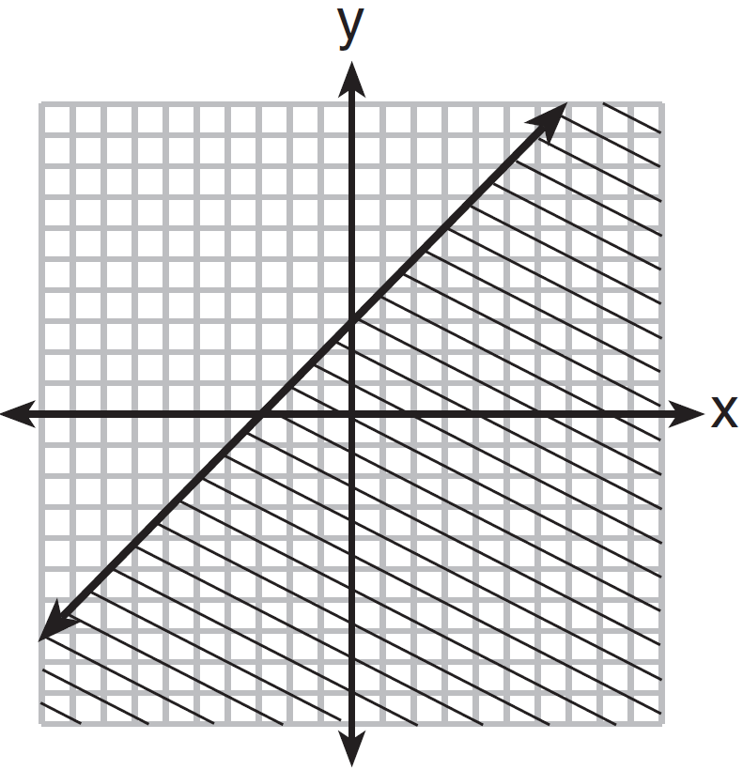

3 Which graph represents the solution of ?
1) | 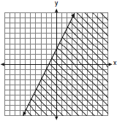
2) | 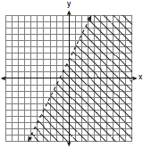
3) | 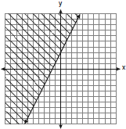
4) | 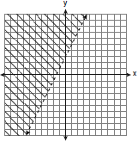

4 Which graph represents the solution of ?
1) | 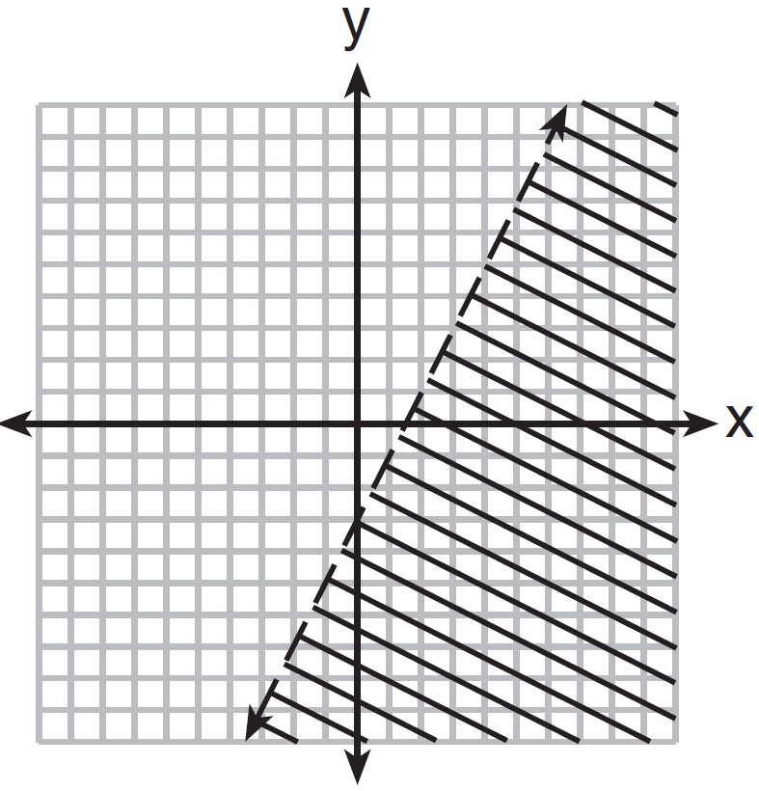
2) | 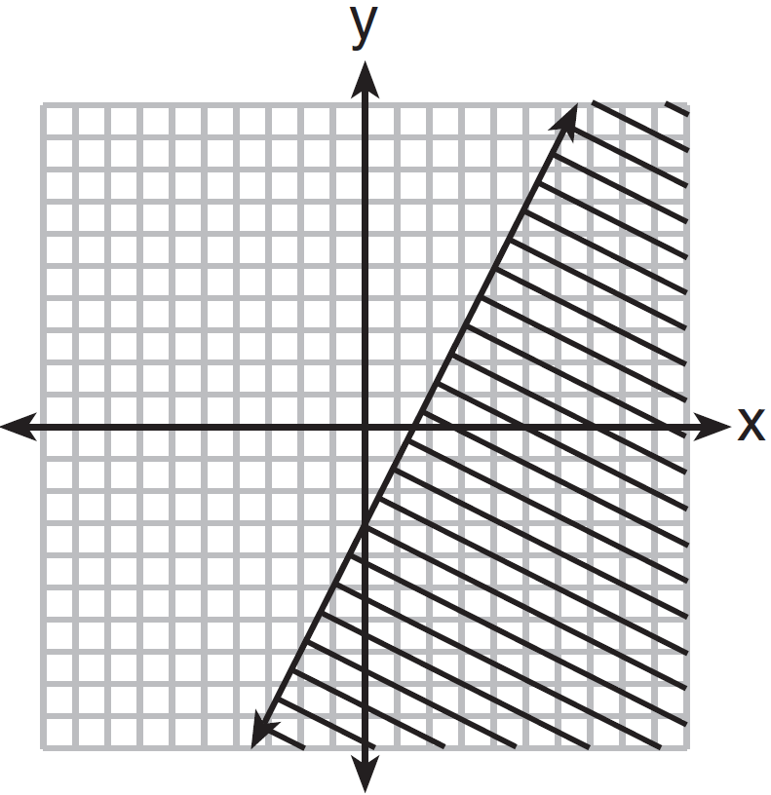
3) | 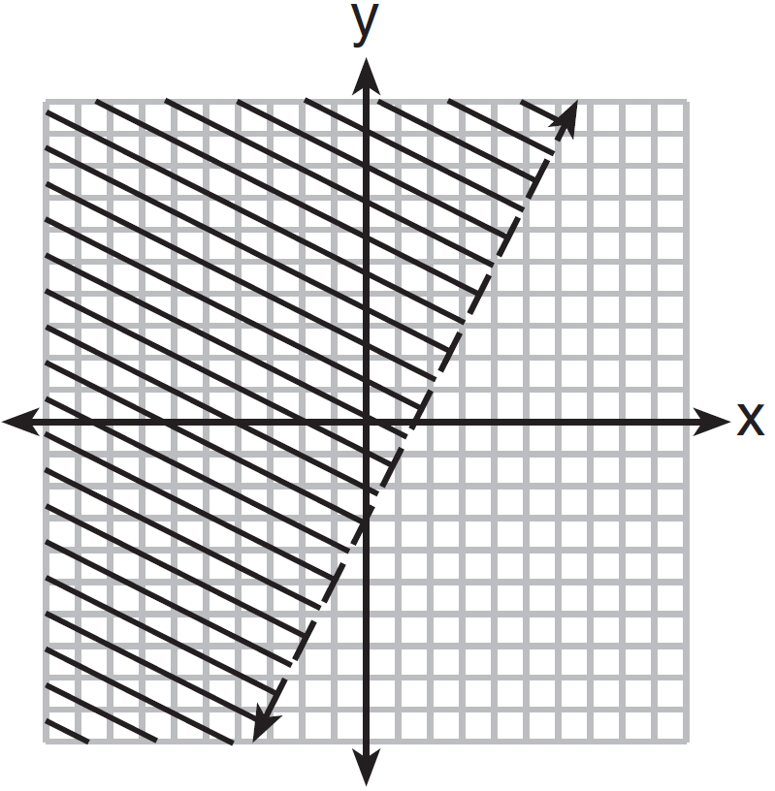
4) | 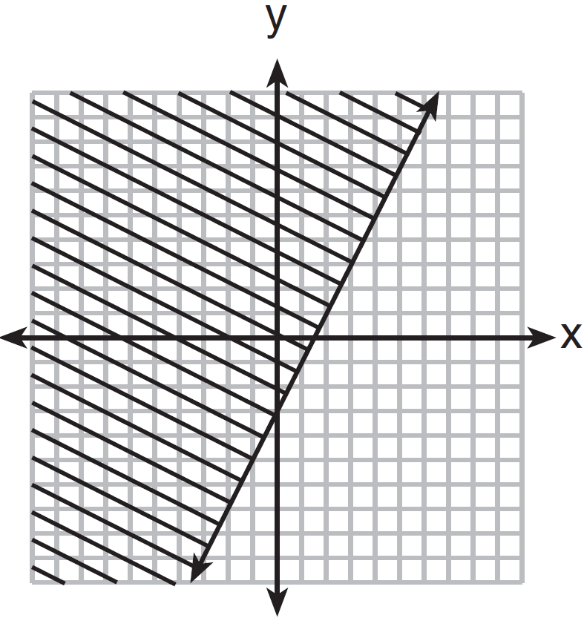

5 In the graph of , which quadrant is completely shaded?
1) | I
2) | II
3) | III
4) | IV

6 Which quadrant will be completely shaded in the graph of the inequality ?
1) | Quadrant I
2) | Quadrant II
3) | Quadrant III
4) | Quadrant IV

7 Which ordered pair is not in the solution set of ?
1)
2)
3)
4)

8 Which inequality is represented by the accompanying graph?

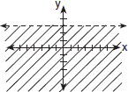
1)
2)
3)
4)

9 Which inequality is represented by the graph below?

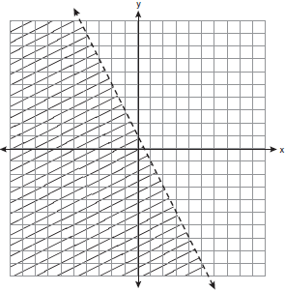
1)
2)
3) | 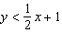
4) | 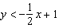

10 The diagram below shows the graph of which inequality?

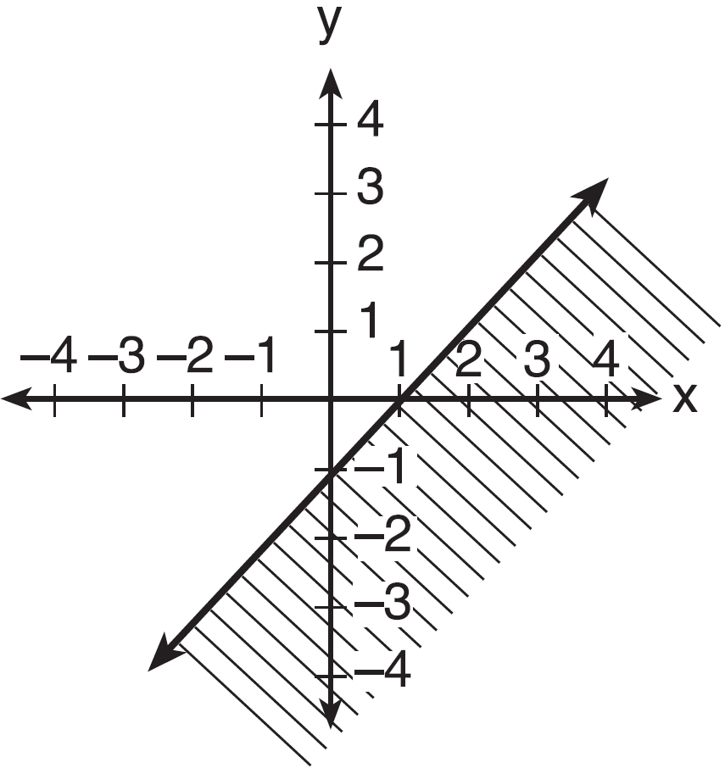
1)
2)
3)
4)

11 Which inequality is shown in the graph below?

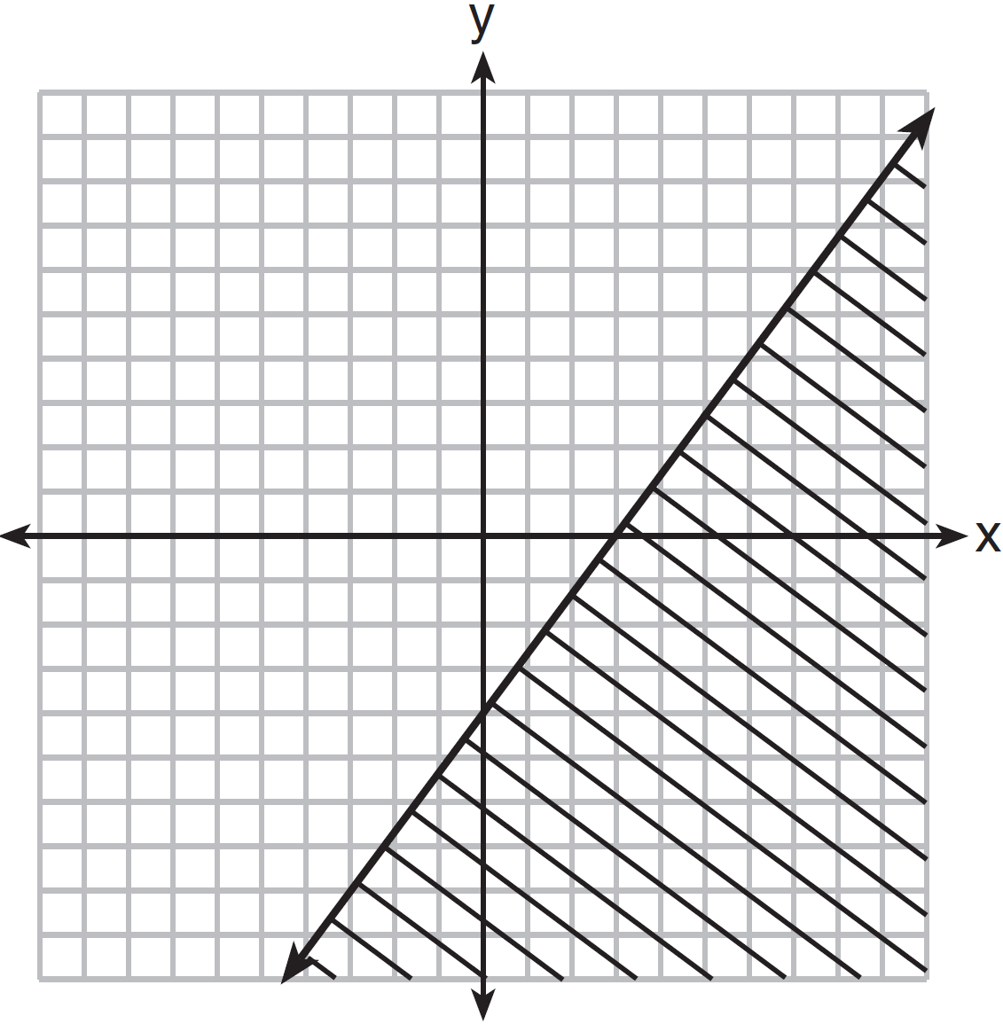
1) | 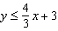
2) | 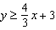
3) | 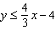
4) | 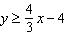

12 Which inequality is shown in the accompanying diagram?

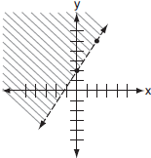
1) | 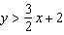
2) | 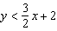
3) | 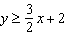
4) | 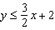

13 Graph the solution set for the inequality on the set of axes below. Determine if the point is in the solution set. Justify your answer.

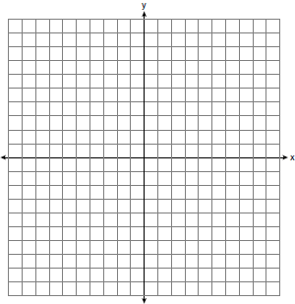
1 ANS: 1 REF: 011210ia

2 ANS: 2 REF: 081314ia

3 ANS: 1 REF: 060920ia

4 ANS: 3

REF: 011422ia

5 ANS: 3 REF: 080220a

6 ANS: 4 REF: 061028ia

7 ANS: 4
is not true.

REF: 080513a

8 ANS: 1 REF: 010629a

9 ANS: 2
The slope of the inequality is .

REF: fall0720ia

10 ANS: 4 REF: 061320ia

11 ANS: 3 REF: 061505ia

12 ANS: 1 REF: 010828a

13 ANS:
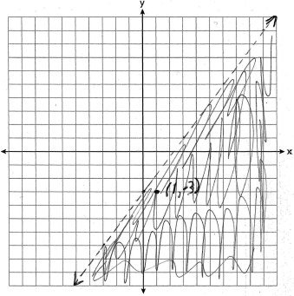 is in the solution set. 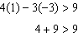

REF: 011038ia

