1 Which inequality is represented by the graph below?

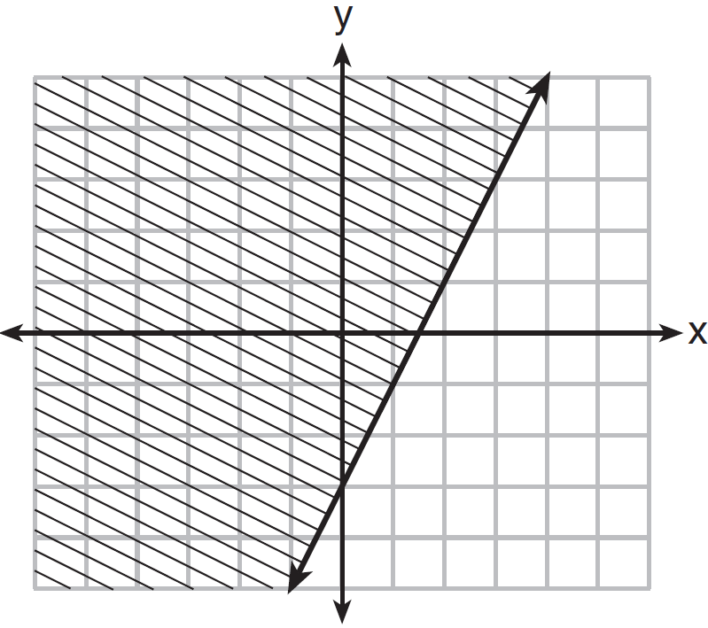
1)
2)
3)
4)

2 Which inequality is represented in the graph below?

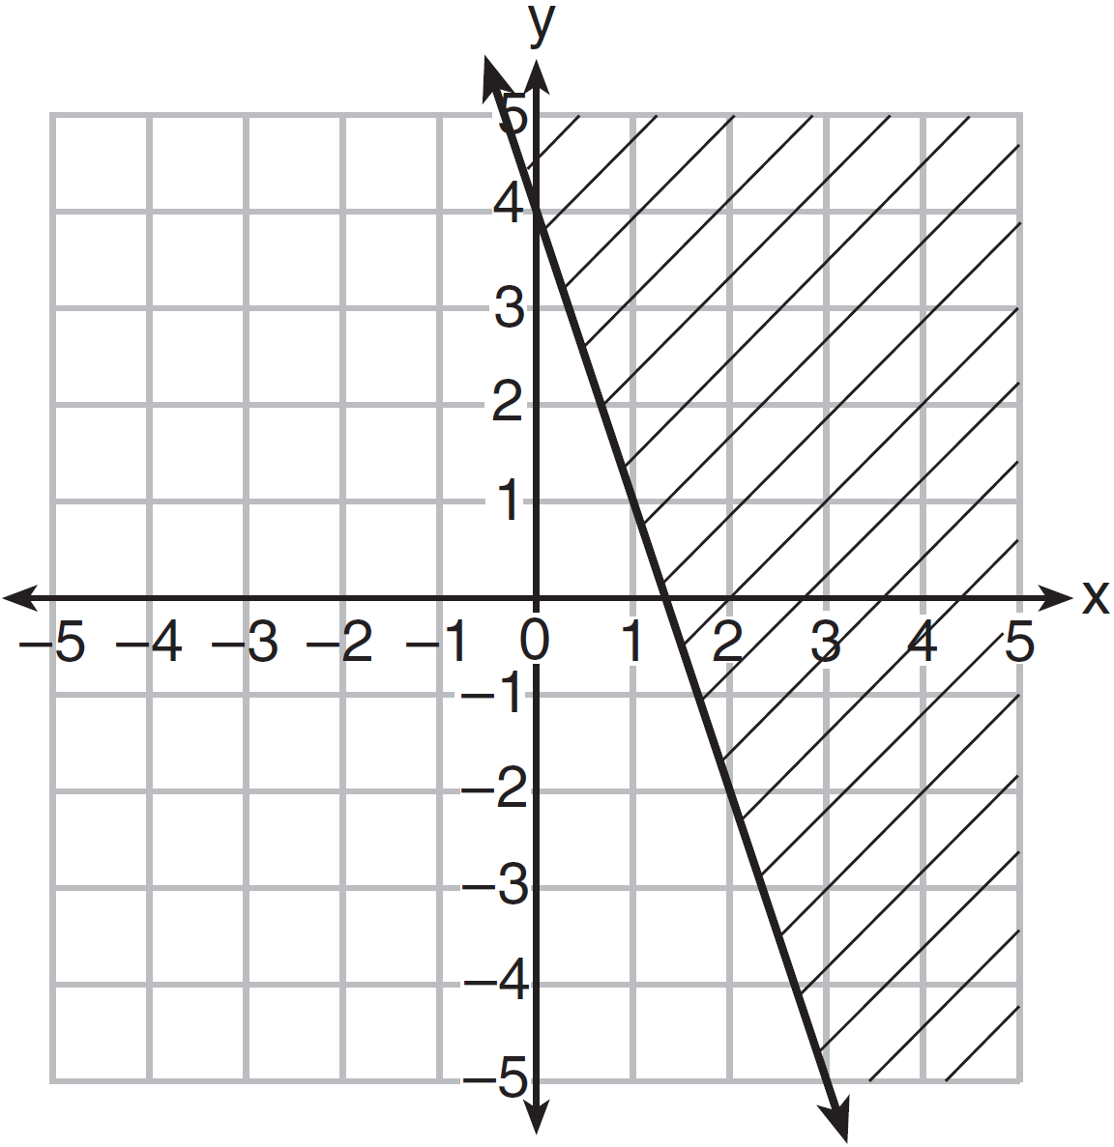
1)
2)
3)
4)

3 Graph the inequality on the set of axes below. State the coordinates of a point in its solution.

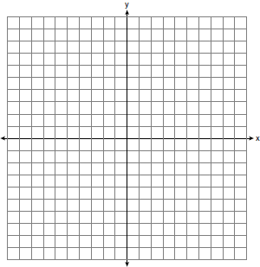

4 On the set of axes below, graph the inequality .

5 Graph the inequality on the set of axes below.

6 Shawn incorrectly graphed the inequality as shown below.

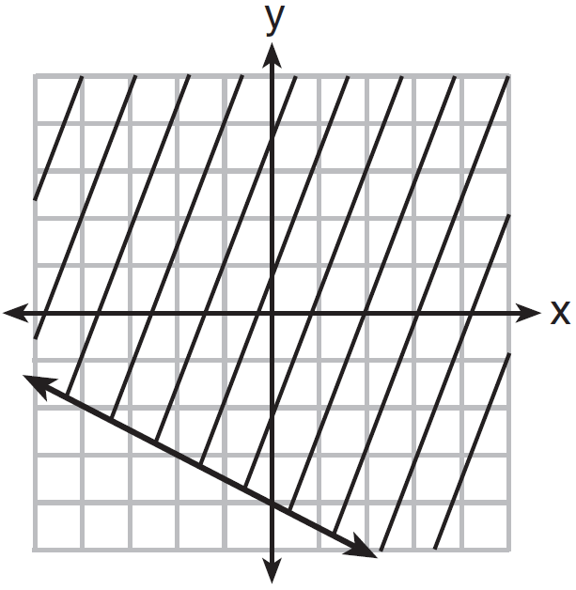

Explain Shawn's mistake. Graph the inequality correctly on the set of axes below.

7 Myranda received a movie gift card for $100 to her local theater. Matinee tickets cost $7.50 each and evening tickets cost $12.50 each. If x represents the number of matinee tickets she could purchase, and y represents the number of evening tickets she could purchase, write an inequality that represents all the possible ways Myranda could spend her gift card on movies at the theater. On the set of axes below, graph this inequality.

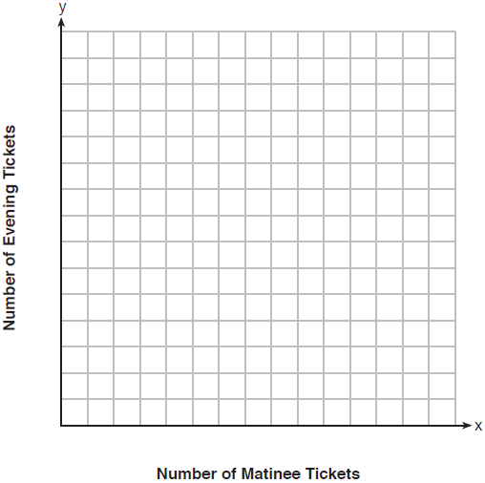

What is the maximum number of matinee tickets Myranda could purchase with her gift card? Explain your answer.
1 ANS: 2 REF: 011605ai

2 ANS: 1 REF: 061505ai

3 ANS:
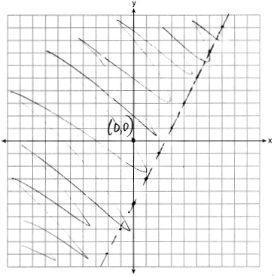

REF: 011729ai

4 ANS:
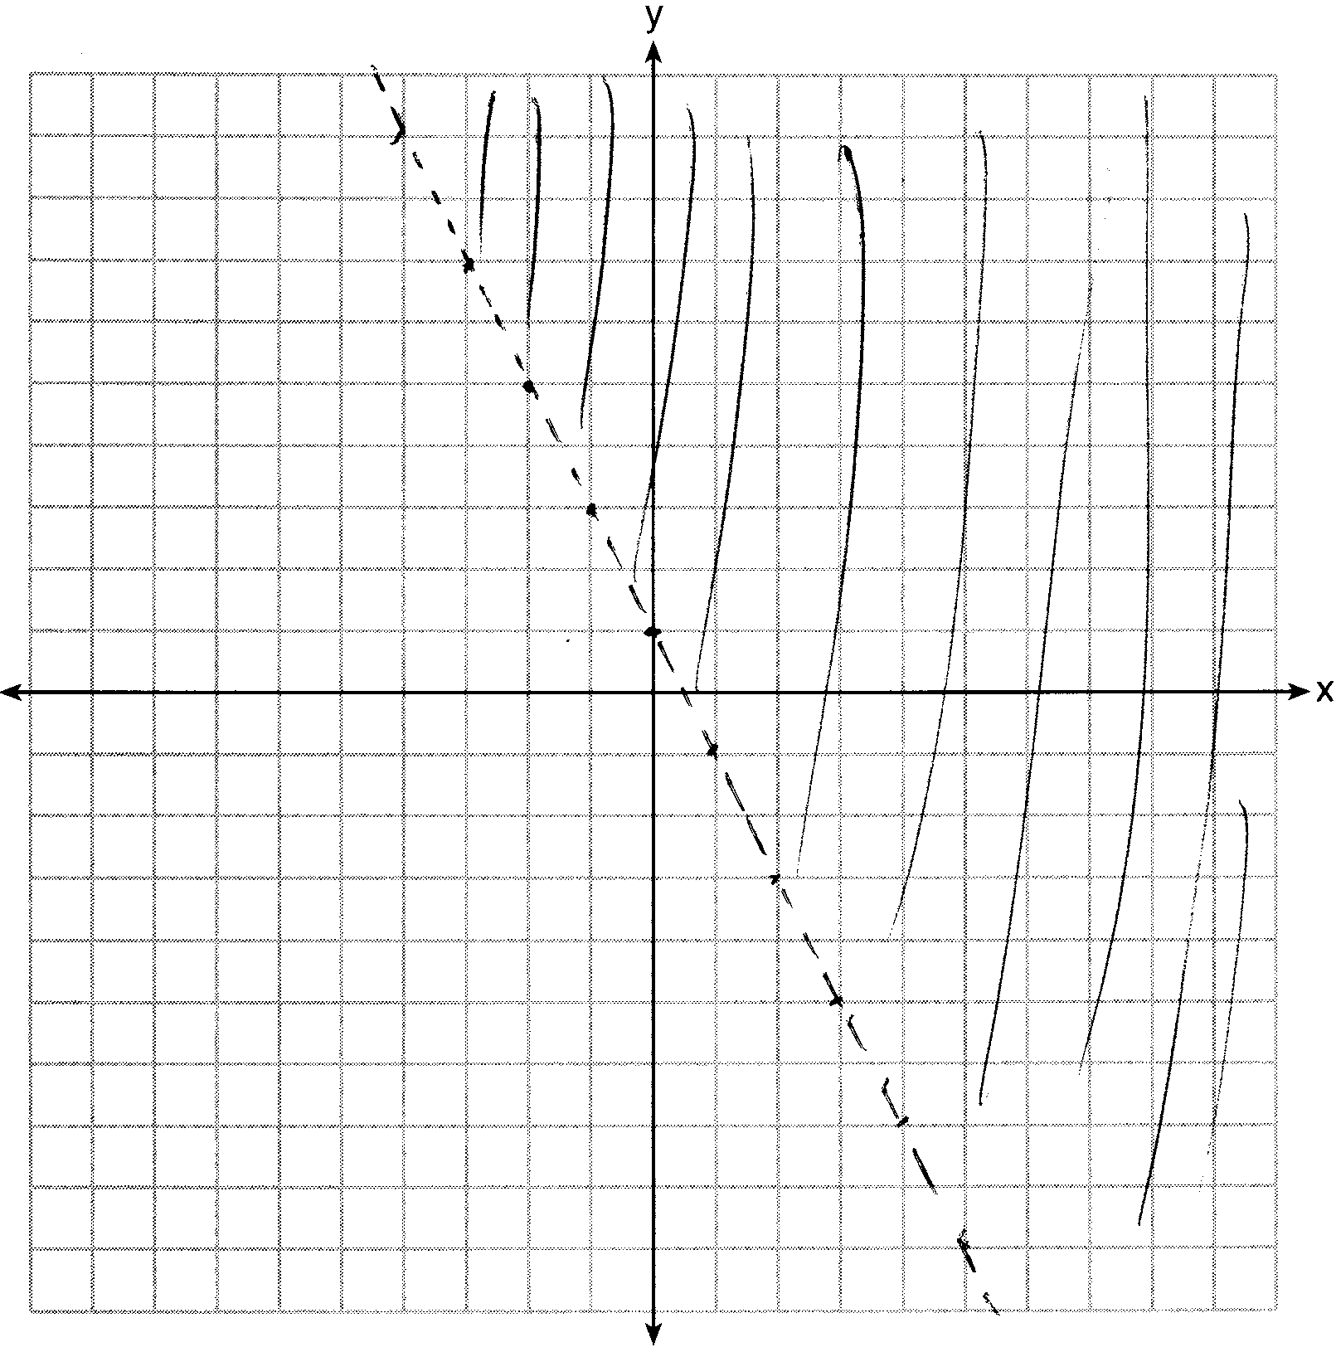

REF: 081526ai

5 ANS:
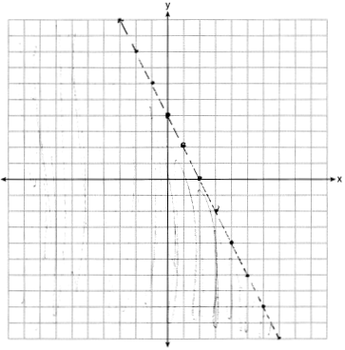

REF: 061730ai

6 ANS:
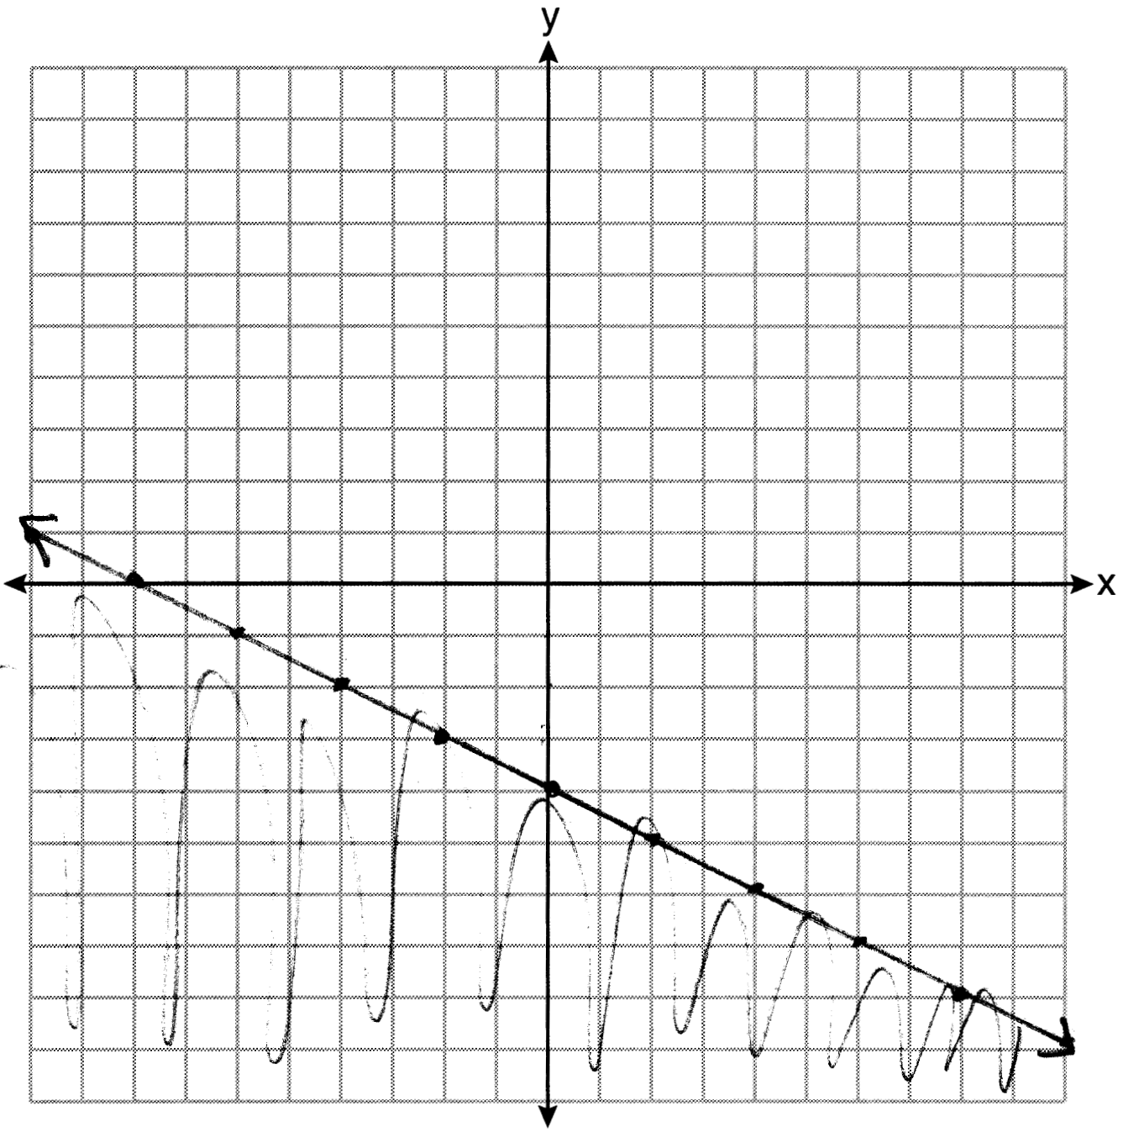

REF: 081634ai

7 ANS:
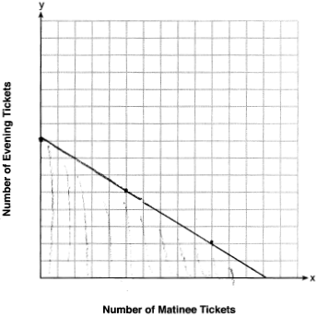13, because and .

REF: 011935ai

