1 Which graph best represents the inequality ?
1) | 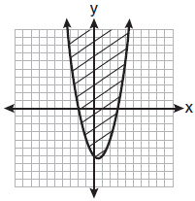
2) | 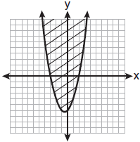
3) | 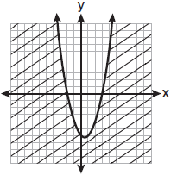
4) | 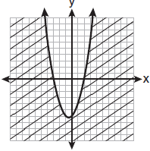

2 When a baseball is hit by a batter, the height of the ball, , at time t, , is determined by the equation . For which interval of time is the height of the ball greater than or equal to 52 feet?

3 The profit a coat manufacturer makes each day is modeled by the equation , where P is the profit and x is the price for each coat sold. For what values of x does the company make a profit? [The use of the grid is optional.]

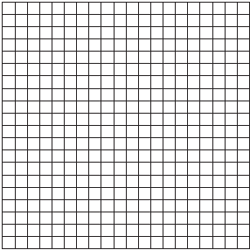

4 The profit, P, for manufacturing a wireless device is given by the equation , where x is the selling price, in dollars, for each wireless device. What range of selling prices allows the manufacturer to make a profit on this wireless device? [The use of the grid is optional.]

5 The height of a projectile is modeled by the equation , where x is time, in seconds, and y is height, in feet. During what interval of time, to the nearest tenth of a second, is the projectile at least 125 feet above ground? [The use of the accompanying grid is optional.]

6 A small rocket is launched from a height of 72 feet. The height of the rocket in feet, h, is represented by the equation , where , in seconds. Graph this equation on the accompanying grid. Use your graph to determine the number of seconds that the rocket will remain at or above 100 feet from the ground. [Only a graphic solution can receive full credit.]

1 ANS: 1
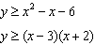
REF: 061017a2

2 ANS:

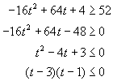  For the product of these binomials to be negative, either:  1) must be negative AND must be positive; or  2) must be positive AND must be negative | CASE 1  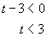 AND 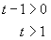  CASE 2  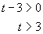 AND 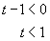  The answer is the first case, The second case is not possible, as t cannot be both greater than 3 and less than 1.

REF: 010231b

3 ANS:
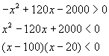  For the product of these binomials to be negative, either:  1. must be negative AND must be positive; or  2. must be positive AND must be negative | CASE 1  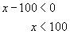 AND 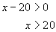  CASE 2  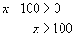 AND 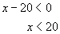  The answer is the first case, The second case is not possible, as x cannot be both greater than 100 and less than 20.
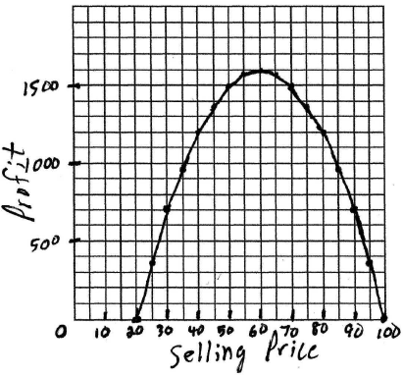
REF: 080424b

4 ANS:
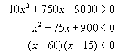  For the product of these binomials to be negative, either:  1. must be negative AND must be positive; or  2. must be positive AND must be negative | CASE 1  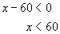 AND 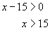  CASE 2  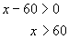 AND 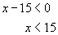  The answer is the first case, The second case is not possible, as x cannot be both greater than 60 and less than 15.
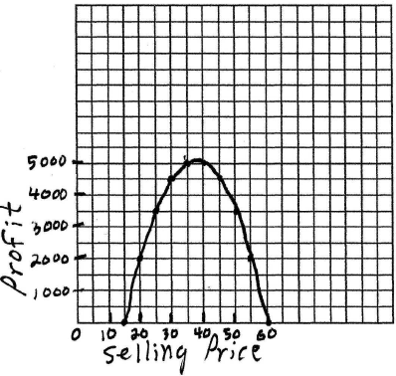
REF: 080531b

5 ANS:
. 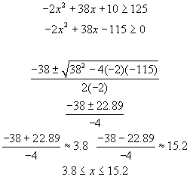. 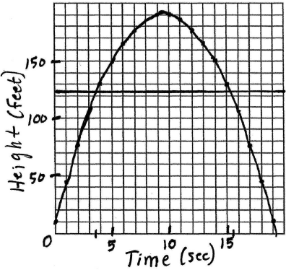
REF: 060532b

6 ANS:
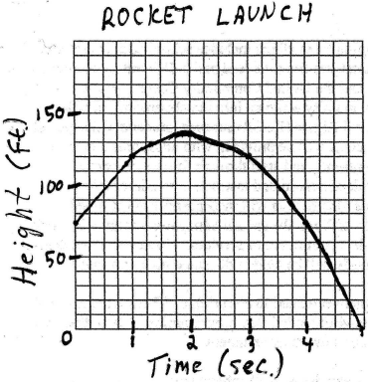 3 REF: 060632b

