1 Which graph represents the solution set of ?
1) | 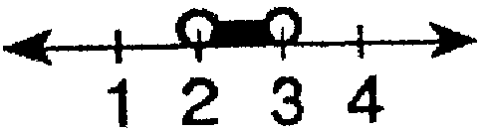
2) | 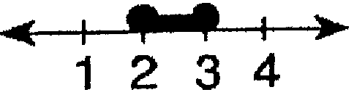
3) | 
4) | 

2 Which graph represents the solution set of ?
1) | 
2) | 
3) | 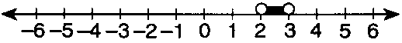
4) | 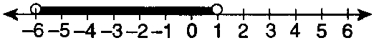

3 Which graph represents the inequality ?
1) | 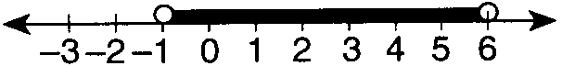
2) | 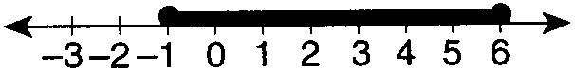
3) | 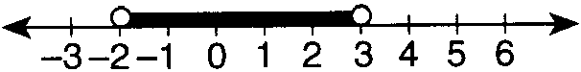
4) | 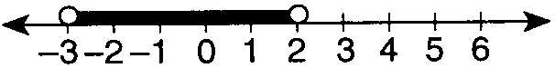

4 Which graph represents the solution set of the inequality ?
1)
2)
3)
4)

5 Which graph represents the solution of the inequality ?
1)
2)
3)
4)

6 Which graph represents the solution of the inequality ?
1) | 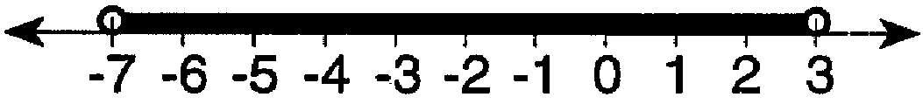
2) | 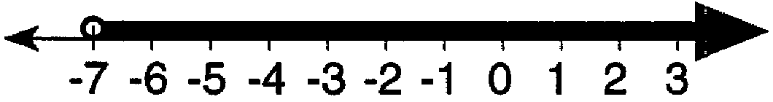
3) | 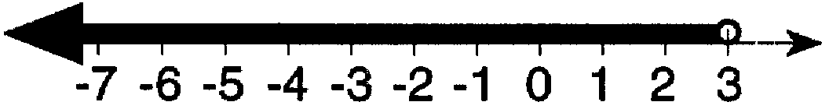
4) | 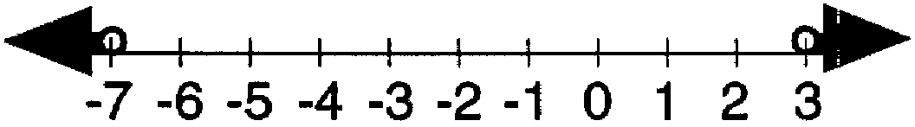

7 What is the solution set for the inequality ?
1) | 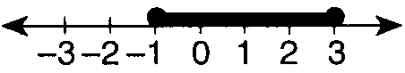
2) | 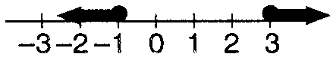
3) | 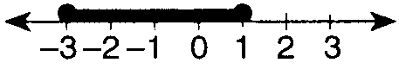
4) | 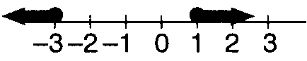

8 Which graph represents the solution set for the inequality ?
1)
2)
3)
4)

9 Which graph represents the solution set of ?
1)
2)
3)
4)

10 Which graph represents the solution set for ?
1)
2)
3)
4)

11 What is the solution set for ?
1) | 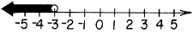
2) | 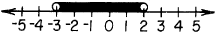
3) | 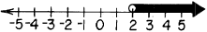
4) | 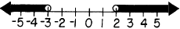

12 Which is the graph of the solution set of the inequality ?
1) | 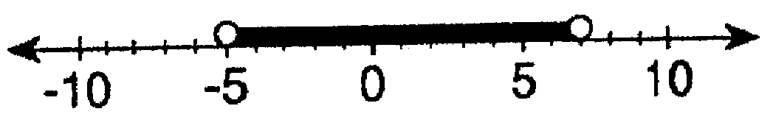
2) | 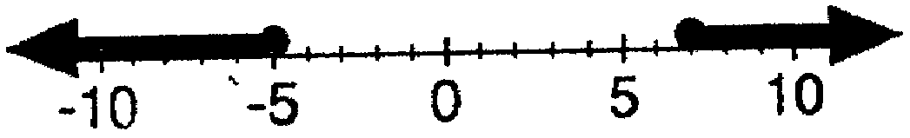
3) | 
4) | 

13 Which graph represents the solution set of ?
1) | 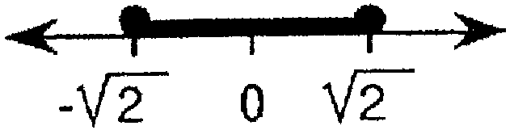
2) | 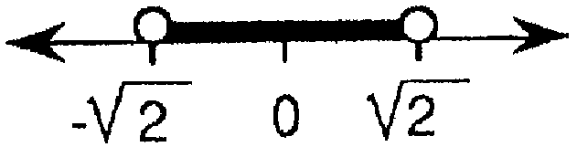
3) | 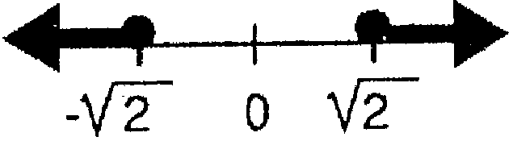
4) | 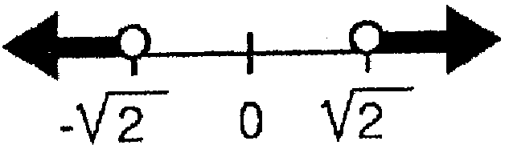

14 Which graph represents the inequality ?
1) | 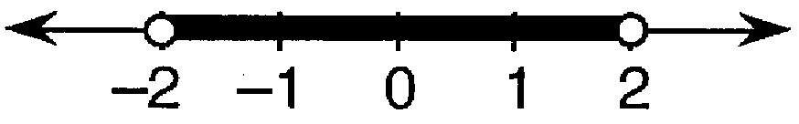
2) | 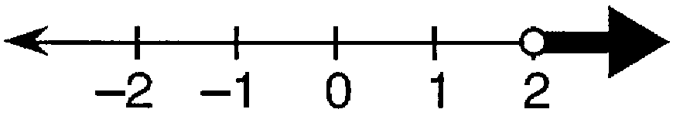
3) | 
4) | 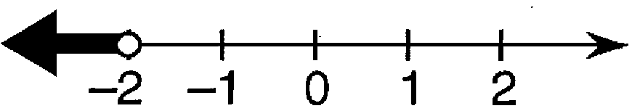

15 The graph below represents the solution set of which inequality?

1)
2)
3)
4)

16 Which inequality is represented by the graph below?

1)
2)
3)
4)

1 ANS: 1 REF: 089526siii

2 ANS: 2 REF: 069826siii

3 ANS: 1 REF: 069918siii

4 ANS: 1
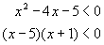  For the product of these binomials to be negative, either:  1. must be negative AND must be positive; or  2. must be positive AND must be negative | CASE 1  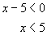 AND 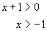  CASE 2  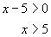 AND 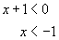  The answer is the first case, The second case is not possible, as x cannot be both greater than 5 and less than -1.

REF: 010509b

5 ANS: 1 REF: 080326siii

6 ANS: 1 REF: 069630siii

7 ANS: 1 REF: 089926siii

8 ANS: 1 REF: 060021siii

9 ANS: 2
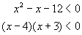  For the product of these binomials to be negative, either:  1. must be negative AND must be positive; or  2. must be positive AND must be negative | CASE 1  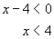 AND 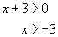  CASE 2  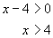 AND 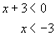  The answer is the first case, The second case is not possible, as x cannot be both greater than 4 and less than -3.

REF: 010318b

10 ANS: 1 REF: 080125siii

11 ANS: 4 REF: 068531siii

12 ANS: 2 REF: 089418siii

13 ANS: 4 REF: 019422siii

14 ANS: 3 REF: 089631siii

15 ANS: 2 REF: 010335siii

16 ANS: 2 REF: 060332siii

