1 Sally’s high school is planning their spring musical. The revenue, R, generated can be determined by the function , where t represents the price of a ticket. The production cost, C, of the musical is represented by the function . What is the highest ticket price, to the nearest dollar, they can charge in order to not lose money on the event?
1)
2)
3)
4)

2 A pelican flying in the air over water drops a crab from a height of 30 feet. The distance the crab is from the water as it falls can be represented by the function , where t is time, in seconds. To catch the crab as it falls, a gull flies along a path represented by the function . Can the gull catch the crab before the crab hits the water? Justify your answer. [The use of the accompanying grid is optional.]



3 The price of a stock, , over a 12-month period decreased and then increased according to the equation , where x equals the number of months. The price of another stock, , increased according to the equation over the same 12-month period. Graph and label both equations on the accompanying grid. State all prices, to the nearest dollar, when both stock values were the same.

1 ANS: 3
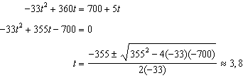

REF: 081606aii

2 ANS:
Yes. 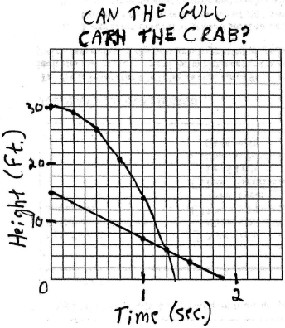. 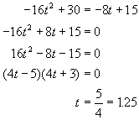. 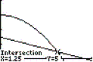
REF: 060228b

3 ANS:
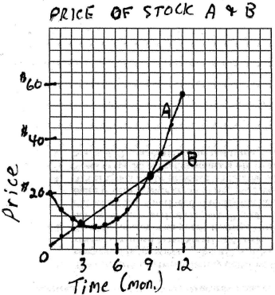 $9, $26. 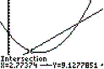. 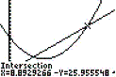
REF: 060328b

