1 Which value, to the nearest tenth, is the smallest solution of if 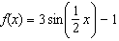 and ?
1)
2)
3)
4) | 1.4

2 A pair of figure skaters graphed part of their routine on a grid. The male skater’s path is represented by the equation 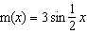, and the female skater’s path is represented by the equation . On the accompanying grid, sketch both paths and state how many times the paths of the skaters intersect between and .



3 The volume of air in an average lung during breathing can be modeled by the graph below.

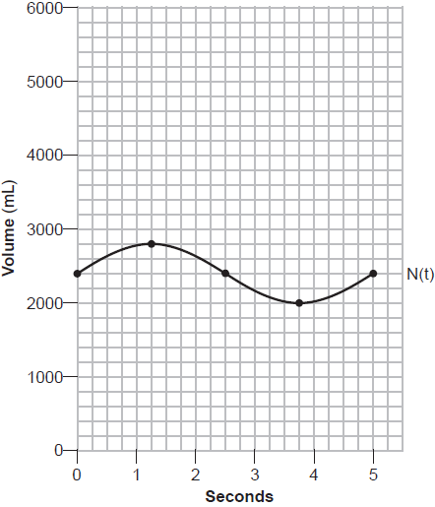

Using the graph, write an equation for , in the form . That same lung, when engaged in exercise, has a volume that can be modeled by , where is volume in mL and t is time in seconds. Graph at least one cycle of on the same grid as . How many times during the 5-second interval will ?
1 ANS: 2
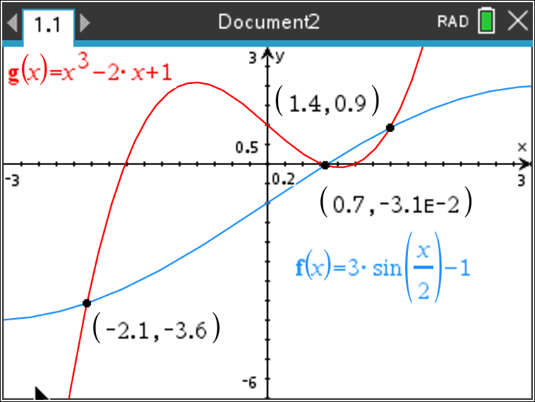

REF: 012021aii

2 ANS:
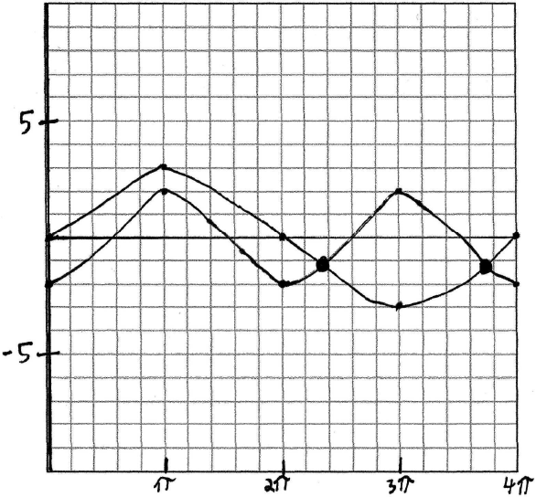 two times. 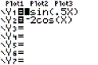 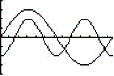

REF: 060329b

3 ANS:
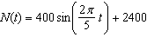. 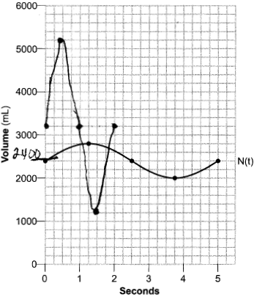 4 times.

REF: 062337aii

