1 The path of a rocket is represented by the equation . The path of a missile designed to intersect the path of the rocket is represented by the equation 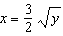. The value of x at the point of intersection is 3. What is the corresponding value of y?
1)
2) | 2
3)
4) | 4

2 The graphs of the equations and intersect in Quadrant I for which values of a?
1)
2)
3)
4)

3 The flight paths of two Thunderbird jets are plotted on a Cartesian coordinate plane, and the equations of the jets' flight paths are represented by and . The best approximation of the intersection of the flight paths is
1)
2)
3)
4)

4 What is the total number of points of intersection of the graphs of the equations and ?
1) | 1
2) | 2
3) | 3
4) | 4

5 Solve the system of equations algebraically for x and y: 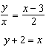

6 Determine algebraically the x-coordinate of all points where the graphs of and intersect.

7 A landscape architect's designs for a town park call for two parabolic-shaped walkways. When the park is mapped on a Cartesian coordinate plane, the pathways intersect at two points. If the equations of the curves of the walkways are and , determine the coordinates of the two points of intersection. [Only an algebraic solution can receive full credit.]

8 On the accompanying grid, sketch the graphs of and over the interval . Identify and state the coordinates of all points of intersection.


9 On the accompanying grid, solve the following system of equations graphically:
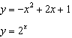



10 A pair of figure skaters graphed part of their routine on a grid. The male skater’s path is represented by the equation 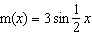, and the female skater’s path is represented by the equation . On the accompanying grid, sketch both paths and state how many times the paths of the skaters intersect between and .

1 ANS: 4
. 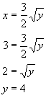

REF: 060205b

2 ANS: 4
The function passes through Quadrant I only if The function intersects the y-axis at and continues through Quadrant I with a positive slope. If the graphs of the equations intersect at (0,1), which is not in Quadrant I. Therefore,

REF: 060519b

3 ANS: 1
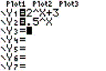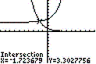

REF: 080705b

4 ANS: 1
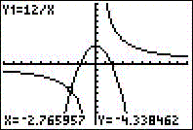

REF: 010704b

5 ANS:
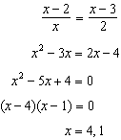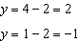

REF: 011737a2

6 ANS:
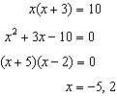

REF: 011431a2

7 ANS:
. 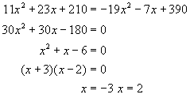 . . 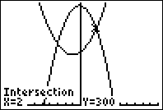

REF: 080831b

8 ANS:
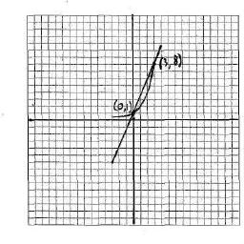

REF: 010628b

9 ANS:
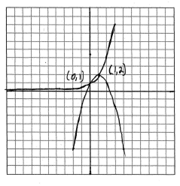

REF: 010527b

10 ANS:
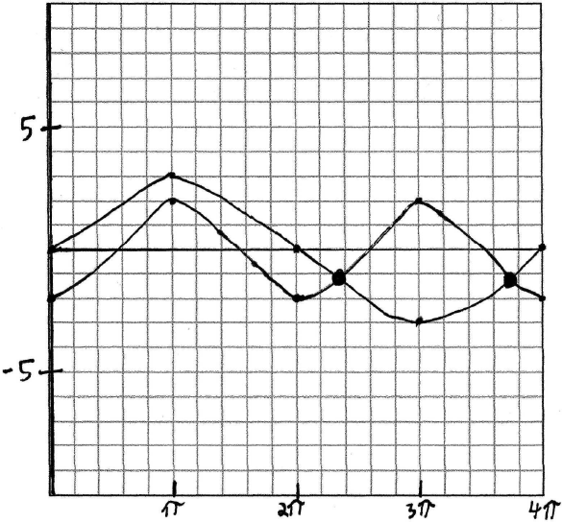 two times. 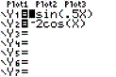 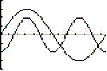

REF: 060329b

