1 Given: 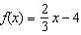 and 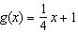
Four statements about this system are written below.
I.
II. When , .
III. The graphs of and intersect at .
IV. The graphs of and intersect at .
Which statement(s) are true?
1) | II, only
2) | IV, only
3) | I and IV
4) | II and III

2 The functions and are graphed below.

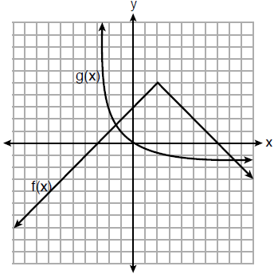

Based on the graph, the solutions to the equation are
1) | the x-intercepts
2) | the y-intercepts
3) | the x-values of the points of intersection
4) | the y-values of the points of intersection

3 The functions and are graphed on the set of axes below.

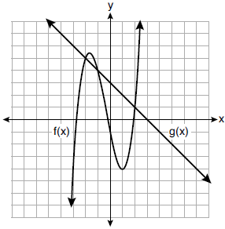

For which value of x is ?
1)
2) | 2
3) | 3
4)

4 Two functions, and , are graphed on the same set of axes. Which statement is true about the solution to the system of equations?
1) | is the solution to the system because it satisfies the equation .
2) | is the solution to the system because it satisfies the equation .
3) | is the solution to the system because it satisfies both equations.
4) | , , and are the solutions to the system of equations because they all satisfy at least one of the equations.

5 The graphs of the functions and are drawn. Which statement about these functions is true?
1) | The solution to is 3.
2) | The solution to is 1.
3) | The graphs intersect when .
4) | The graphs intersect when .

6 If and are graphed on the same coordinate plane, for which value of x is ?
1) | 6
2) | 2
3)
4)

7 Which value of x results in equal outputs for and ?
1)
2) | 2
3)
4) | 4

8 Given the functions 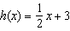 and , which value of x makes ?
1)
2) | 2
3) | 3
4)

9 What is the total number of points of intersection for the graphs of the equations and ?
1) | 1
2) | 2
3) | 3
4) | 0

10 What is one solution of the accompanying system of equations?
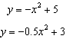
1)
2)
3)
4)

11 Which pair of equations would have as a solution?
1) | and
2) | and
3) | and
4) | and 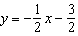

12 The graph below shows two functions, and . State all the values of x for which .

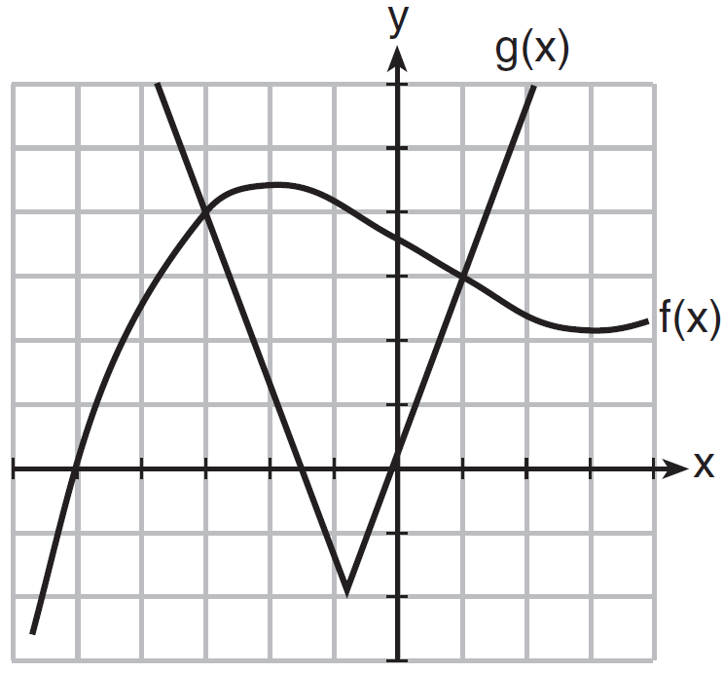

13 Graph and on the grid below. Does ? Use your graph to explain why or why not.



14 Graph and on the set of axes below.

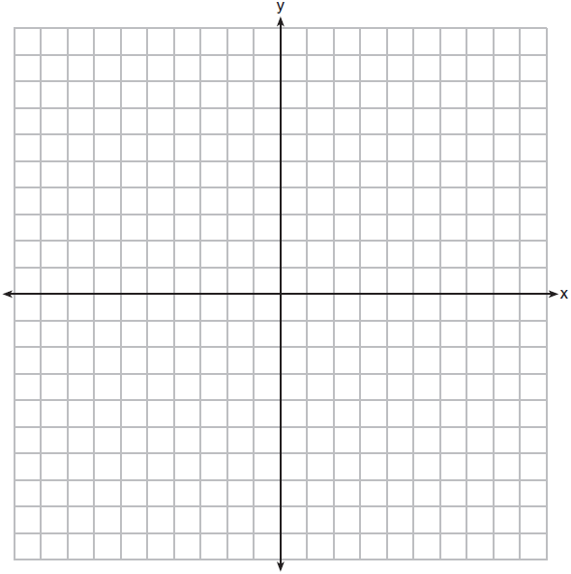

Based on your graph, determine all values of x for which .

15 On the set of axes below, graph and .
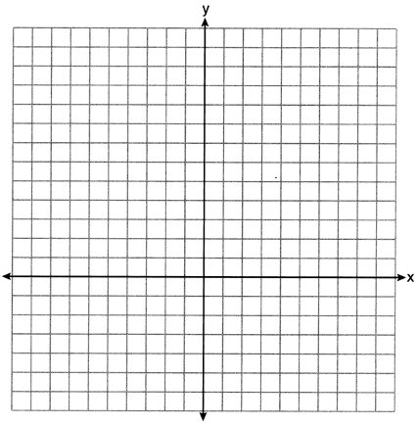
Based on your graph, for how many values of x does ? Explain your reasoning.

16 On the set of axes below, graph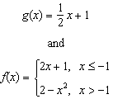

How many values of x satisfy the equation ? Explain your answer, using evidence from your graphs.
1 ANS: 4
I. 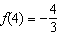 and ; II. and

REF: 062111ai

2 ANS: 3 REF: 081819ai

3 ANS: 3 REF: 081914ai

4 ANS: 3 REF: 011518ai

5 ANS: 2
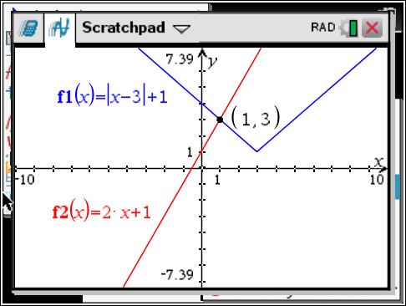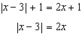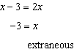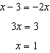

REF: 061622ai

6 ANS: 3
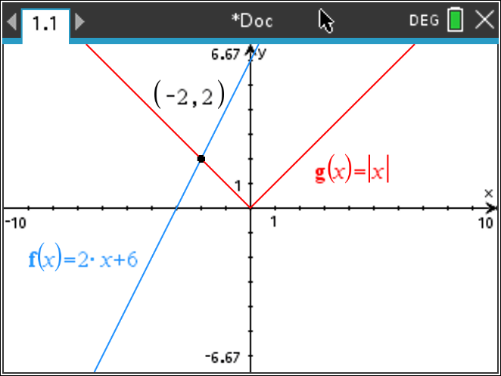

REF: 012417ai

7 ANS: 2
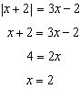

REF: 081702ai

8 ANS: 1
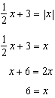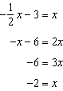

REF: 011617ai

9 ANS: 1
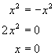. 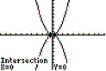 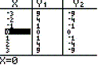

REF: 080611b

10 ANS: 3
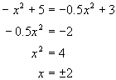

REF: 060706b

11 ANS: 3
,

REF: 011918ai

12 ANS:

REF: 081630ai

13 ANS:
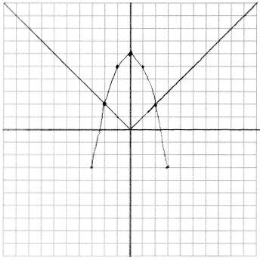 Yes, because the graph of intersects the graph of at .

REF: 011733ai

14 ANS:
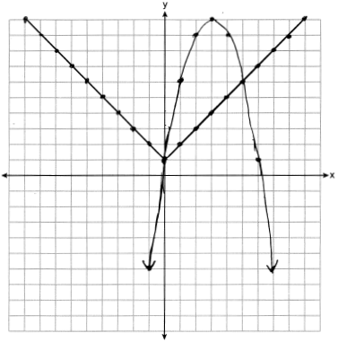

REF: 062333ai

15 ANS:
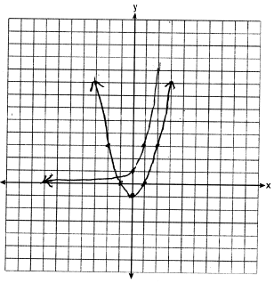 for one value of x because the graphs intersect once.

REF: 062234ai

16 ANS:
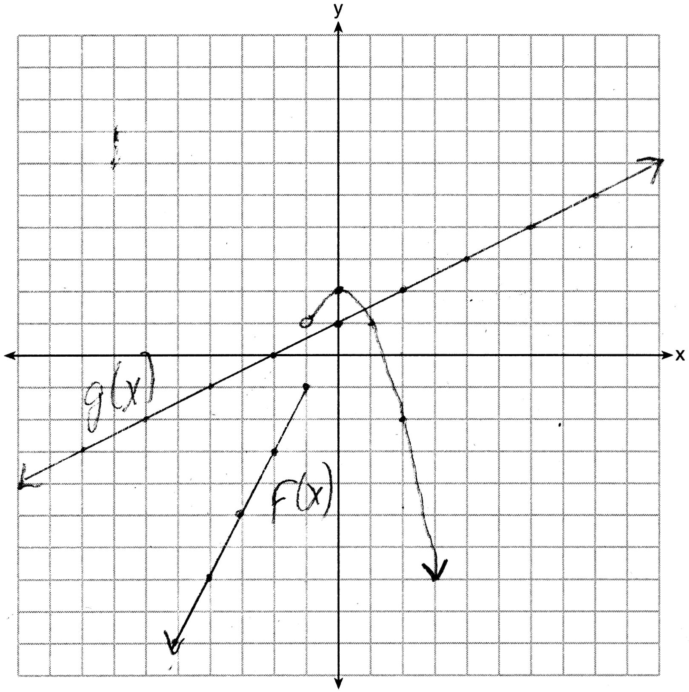 1, because the graphs only intersect once.

REF: 061636ai

