1 Which graph represents the solution set of ?
1) | 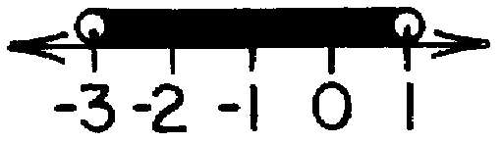
2) | 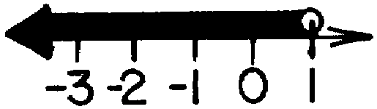
3) | 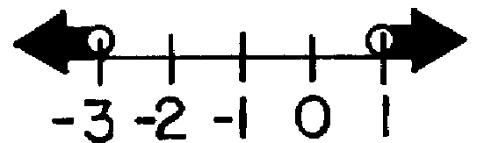
4) | 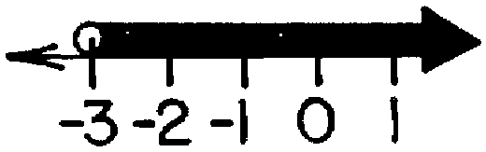

2 Which is the graph of the solution set of ?
1) | 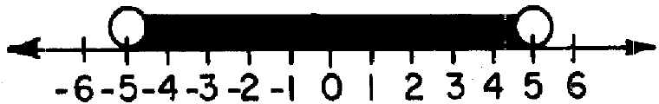
2) | 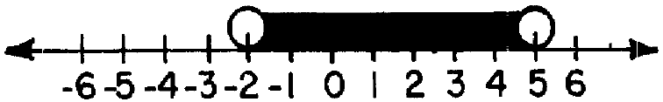
3) | 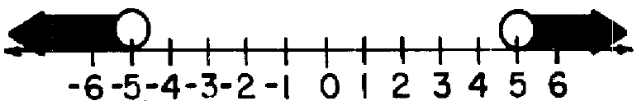
4) | 

3 Which graph represents the solution set of ?
1)
2)
3)
4)

4 Which graph represents the solution set of ?

1)
2) | 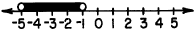
3)
4)

5 Which is the graph of the solution set of ?
1)
2)
3)
4)

6 Which graph represents the solution set of ?
1) | 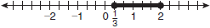
2) | 
3) | 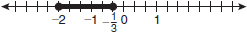
4) | 

7 Which graph represents the solution set for the inequality ?
1)
2)
3)
4)

8 Which graph represents the solution set of ?
1) | 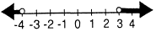
2)
3) | 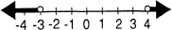
4)

9 What is the graph of the solution set of ?
1) | 
2) | 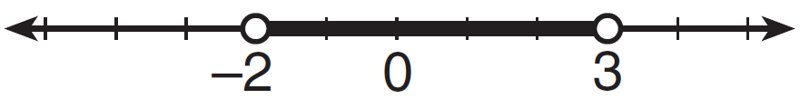
3) | 
4) | 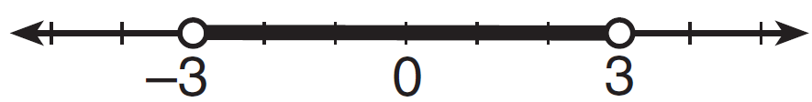

10 Which graph is the solution to the inequality ?
1) | 
2)
3) | 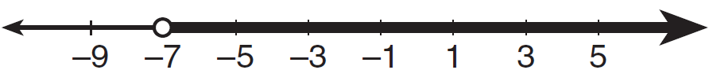
4) | 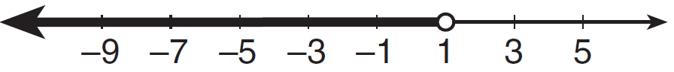

11 Which graph represents the solution set of 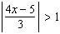?
1)
2)
3)
4)

12 The solution set of which inequality is represented by the accompanying graph?

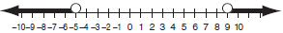
1)
2)
3)
4)

13 Which inequality is represented by the accompanying graph?

1)
2)
3)
4)

14 Which inequality is represented by the accompanying graph?

1)
2)
3)
4)

15 Solve the inequality for x. Graph the solution on the line below.

16 Determine the solution of the inequality . [The use of the grid below is optional.]



1 ANS: 1 REF: 068622siii

2 ANS: 2 REF: 088431siii

3 ANS: 1
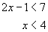 and 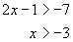

REF: 080303b

4 ANS: 4 REF: 089030siii

5 ANS: 4 REF: 018727siii

6 ANS: 1
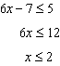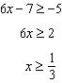

REF: fall0905a2

7 ANS: 2
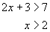 or 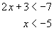

REF: 060505b

8 ANS: 1 REF: 089318siii

9 ANS: 1
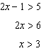. 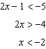

REF: 061307a2

10 ANS: 2
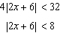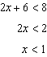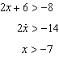

REF: 011612a2

11 ANS: 3
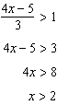 or 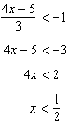

REF: 061209a2

12 ANS: 1
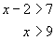 or 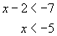

REF: 060617b

13 ANS: 2
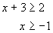 or 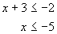

REF: 060707b

14 ANS: 1
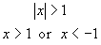

REF: 080806b

15 ANS:
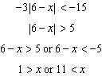.

REF: 061137a2

16 ANS:
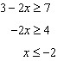 or 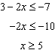

REF: 011334a2

