1 The solution set of the inequality is
1)
2)
3)
4)

2 The solution set of is
1)
2)
3)
4)

3 What is the solution of the inequality ?
1)
2)
3)
4)

4 What is the solution of the inequality ?
1)
2)
3)
4)

5 The solution of is
1)
2)
3)
4)

6 What is the solution of the inequality ?
1)
2)
3)
4)

7 What is the solution set of the inequality ?
1)
2)
3)
4)

8 What is the solution set of the inequality ?
1)
2)
3)
4)

9 Which represents the solution set for x in the inequality ?
1)
2)
3)
4)

10 The solution set of is
1)
2)
3)
4)

11 What is the solution set of ?
1)
2)
3)
4)

12 Which is the solution set for ?
1)
2)
3)
4)

13 What is the solution set of the inequality ?
1) | 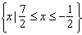
2) | 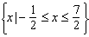
3) | 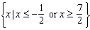
4) | 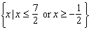

14 Which equation states that the temperature, t, in a room is less than 3° from 68°?
1)
2)
3)
4)

15 The solution set of contains
1) | only negative real numbers
2) | only positive real numbers
3) | both positive and negative real numbers
4) | no real numbers

16 If , then the solution set contains
1) | only negative real numbers
2) | only positive real numbers
3) | both positive and negative real numbers
4) | no real numbers

17 Which value of a does not satisfy the inequality ?
1)
2) | 0
3) | 3
4)

18 The inequality is the solution of
1)
2)
3)
4)

19 What is the solution of the inequality ?

20 Solve algebraically.

21 Solve algebraically for x.

22 Solve algebraically for c: 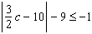

23 Solve algebraically for x:

24 The inequality represents the range of monthly average temperatures, C, in degrees Celsius, for Toledo, Ohio. Solve for C.

25 A depth finder shows that the water in a certain place is 620 feet deep. The difference between d, the actual depth of the water, and the reading is and must be less than or equal to 0.05d. Find the minimum and maximum values of d, to the nearest tenth of a foot.

26 The heights, h, of the students in the chorus at Central Middle School satisfy the inequality 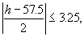 when h is measured in inches. Determine the interval in which these heights lie and express your answer to the nearest tenth of a foot. [Only an algebraic solution can receive full credit.]

1 ANS: 3 REF: 019719siii

2 ANS: 4 REF: 019823siii

3 ANS: 1
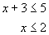 and 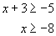
REF: 080203b

4 ANS: 1
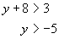 or 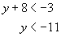
REF: 010610b

5 ANS: 2
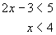 and 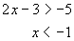
REF: 080509b

6 ANS: 2
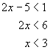 and 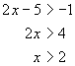
REF: 060907b

7 ANS: 1 REF: 069821siii

8 ANS: 1
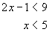 and 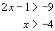
REF: 010710b

9 ANS: 4 REF: 068024siii

10 ANS: 3 REF: 068718siii

11 ANS: 3 REF: 010423siii

12 ANS: 2 REF: 018921siii

13 ANS: 3
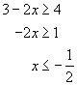 or 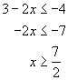
REF: 060318b

14 ANS: 3 REF: 060107b

15 ANS: 1
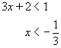 and 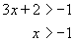
REF: 080102b

16 ANS: 1 REF: 019926siii

17 ANS: 3
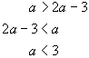 or 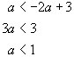
REF: 060808b

18 ANS: 2 REF: 069426siii

19 ANS:
. 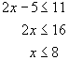 and 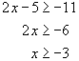
REF: 010925b

20 ANS:
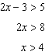 or 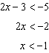
REF: 061430a2

21 ANS:
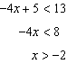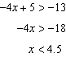
REF: 011432a2

22 ANS:
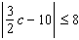 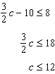 and 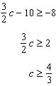
REF: 061637a2

23 ANS:
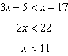 and 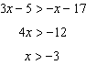
REF: 081538a2

24 ANS:
. 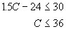 and 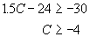
REF: 010326b

25 ANS:
590.5, 652.6. 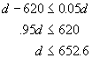 and 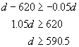
REF: 080427b

26 ANS:
4.3-5.3. 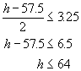 and 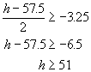. To convert from feet to inches, divide the answers by 12: and
REF: 010531b

