1 What is the solution set of the equation ?
1)
2)
3)
4)

2 What is the solution set of the equation ?
1)
2)
3)
4)

3 What is the solution set for the equation ?
1)
2)
3) | 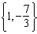
4) | 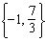

4 What is the solution set of the equation ?
1)
2) | 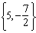
3) | 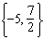
4) | 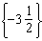

5 What is the solution set for the equation ?
1)
2)
3)
4)

6 What is the solution set of the equation ?
1)
2)
3)
4)

7 The solution set of the equation is
1)
2) | 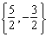
3) | 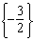
4)

8 What is the solution set of the equation ?
1)
2)
3)
4)

9 The solution set of is
1)
2)
3)
4)

10 What is the solution set of ?
1)
2)
3)
4)

11 What is the solution set for the equation ?
1)
2)
3)
4)

12 What is the solution set for the equation ?
1)
2)
3)
4)

13 What is the solution set of the equation ?
1)
2)
3)
4) | 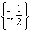

14 What is the solution set of the equation ?
1)
2)
3)
4)

1 ANS: 2 REF: 068923siii

2 ANS: 3 REF: 089717siii

3 ANS: 3 REF: 089417siii

4 ANS: 2 REF: 089518siii

5 ANS: 1 REF: 011005b

6 ANS: 2 REF: 088727siii

7 ANS: 2 REF: 010223siii

8 ANS: 1 REF: 080222siii

9 ANS: 4
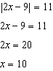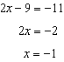

REF: 081614a2

10 ANS: 2
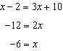 is extraneous. 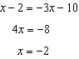

REF: 061513a2

11 ANS: 2 REF: 019624siii

12 ANS: 2 REF: 089923siii

13 ANS: 1
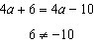. 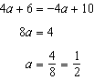. 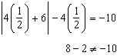

REF: 011106a2

14 ANS: 4
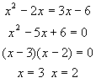. 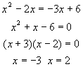. is an extraneous solution since .

REF: 080616b

