1 What is an equation of the line that passes through the point and has a slope of ?
1)
2)
3)
4)

2 What is an equation of the line that passes through the point and has a slope of 2?
1)
2)
3)
4)

3 Which equation represents the line that passes through the point and has a slope of ?
1)
2)
3)
4)

4 What is an equation of the line that passes through the point and has a slope of 3?
1)
2)
3)
4)

5 What is the equation of the line that passes through the point and has a slope of ?
1) | 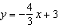
2) | 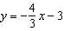
3) | 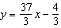
4) | 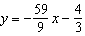

6 If point is on the line whose equation is , what is the value of b?
1) | 1
2) | 2
3) | 3
4) | 0

7 A line having a slope of passes through the point . Write the equation of this line in slope-intercept form.

8 Which equation represents the line that passes through the points and ?
1)
2)
3)
4)

9 What is an equation for the line that passes through the coordinates and ?
1) | 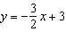
2) | 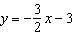
3) | 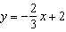
4) | 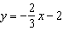

10 Which equation represents the line that passes through the points and ?
1) | 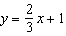
2) | 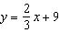
3) | 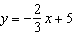
4) | 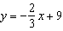

11 Which equation represents the line that passes through the points and ?
1)
2)
3) | 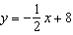
4) | 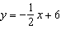

12 What is an equation of the line that passes through the points and ?
1) | 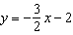
2) | 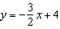
3) | 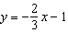
4) | 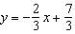

13 What is an equation of the line that passes through and ?
1) | 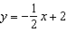
2) | 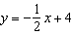
3)
4)

1 ANS: 1
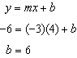
REF: 060922ia

2 ANS: 4
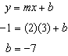
REF: 080927ia

3 ANS: 1
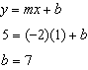
REF: 081108ia

4 ANS: 1
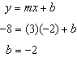
REF: 011406ia

5 ANS: 2
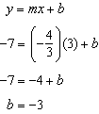
REF: 061419ia

6 ANS: 2
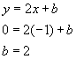
REF: 060521a

7 ANS:
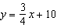. 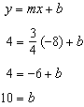
REF: 011134ia

8 ANS: 1
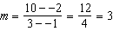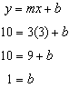
REF: 061515ia

9 ANS: 1
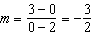. Using the given y-intercept to write the equation of the line .

REF: fall0713ia

10 ANS: 3
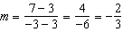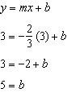
REF: 011013ia

11 ANS: 2
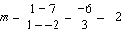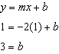
REF: 081404ia

12 ANS: 2
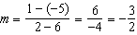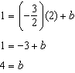
REF: 011510ia

13 ANS: 1
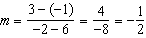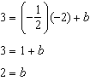
REF: 061606ia

