1 Which linear equation represents a line containing the point ?
1)
2)
3)
4)

2 Which point is on the line ?
1)
2)
3)
4)

3 Which point lies on the line whose equation is ?
1)
2)
3)
4)

4 Which point lies on the graph represented by the equation ?
1)
2)
3)
4)

5 Which set of coordinates is a solution of the equation ?
1)
2)
3)
4)

6 If the point lies on the line represented by the equation , the value of k is
1) | 1
2) | 2
3)
4)

7 Point lies on the line whose equation is . What is the value of k?
1)
2)
3) | 6
4) | 8

8 The graph of the equation passes through point . What is the value of x?
1)
2) | 8
3) | 16
4) | 4

1 ANS: 3
2(1)+3=5
REF: 061007ia

2 ANS: 1
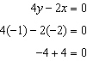
REF: 011021ia

3 ANS: 4
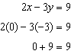
REF: 081016ia

4 ANS: 4
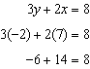
REF: 011218ia

5 ANS: 4
REF: 081217ia

6 ANS: 3
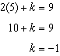
REF: 061304ia

7 ANS: 1
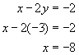
REF: 080628a

8 ANS: 2
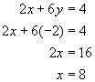
REF: 060721a

