1 What is the total number of points of intersection in the graphs of the equations and ?
1) | 1
2) | 2
3) | 3
4) | 0

2 The graphs of the equations and are drawn on the same set of axes. What is the total number of points of intersection?
1) | 1
2) | 2
3) | 3
4) | 0

3 Which ordered pair is a solution of the system of equations shown below? 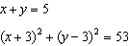
1)
2)
3)
4)

4 What is the total number of points of intersection of the graphs of the equations and ?
1) | 1
2) | 2
3) | 3
4) | 4

5 The equations and are graphed on a set of axes. What is the solution of this system?
1)
2)
3)
4)

6 Solve: 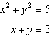

7 Solve: 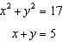

8 Solve: 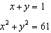

9 Solve the following systems of equations algebraically: 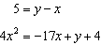

10 On the set of axes provided below, sketch a circle with a radius of 3 and center at and also sketch the graph of the line .

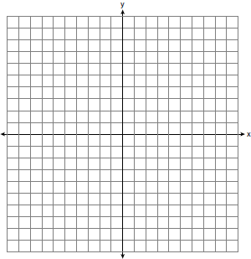

What is the total number of points of intersection of the two graphs?

11 Solve the following system of equations algebraically or graphically: 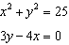
[The use of the accompanying grid is optional.]



12 On the set of axes below, solve the following system of equations graphically and state the coordinates of all points in the solution.
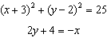

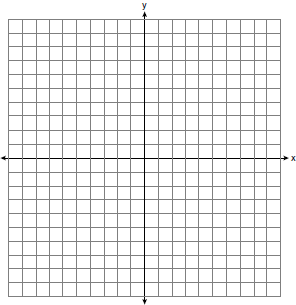

13 The difference between two numbers is 2, and the sum of their squares is 10. Find the numbers.

14 The sum of two numbers is 15, and the sum of their squares is 137. What are the numbers?

15 The difference of two numbers is 2 and the sum of their squares is 100. Find the numbers.

16 The sum of two numbers is 10, and the sum of their squares is 58. Find the numbers.

17 The sum of two numbers is 7 times their difference. The difference of their squares is twice their sum. Find the numbers.

18 Find two numbers such that their difference equals and their squares are equal.

19 The quotient obtained by dividing one of two numbers by the other is .75. The product of the numbers is 300. Find the numbers.

20 A number is composed of two digits the difference of whose squares is 20. If the digits are interchanged the resulting number is 18 less than the original number. Find the number.

21 The distance between two opposite corners of a rectangular field is 17 rods, and its perimeter is 46 rods. Find the length and breadth of the field.

22 The perimeter of a rectangle is 92 feet and its diagonal is 34 feet. Find the area of the rectangle.
1 ANS: 1
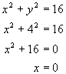. (0,4)
REF: 060119a

2 ANS: 2
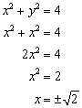.
REF: 010920a

3 ANS: 3
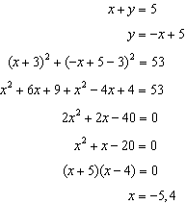. 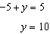
REF: 011302a2 STA: A2.A.3

4 ANS: 2
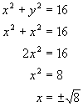. and
REF: 080625a

5 ANS: 3
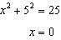
REF: 011312ge STA: G.G.70

6 ANS:
REF: 119409al

7 ANS:
REF: 089605al

8 ANS:
REF: 010015al

9 ANS:
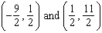. 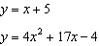. 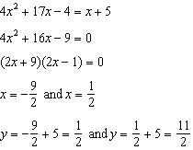
REF: 061139a2 STA: A2.A.3

10 ANS:
a) 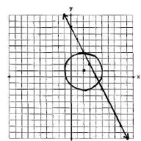; b) 2
REF: 010029a

11 ANS:
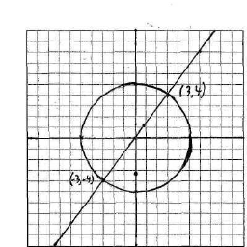. 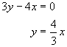. 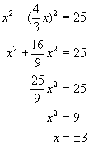. 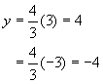
REF: 060439a

12 ANS:
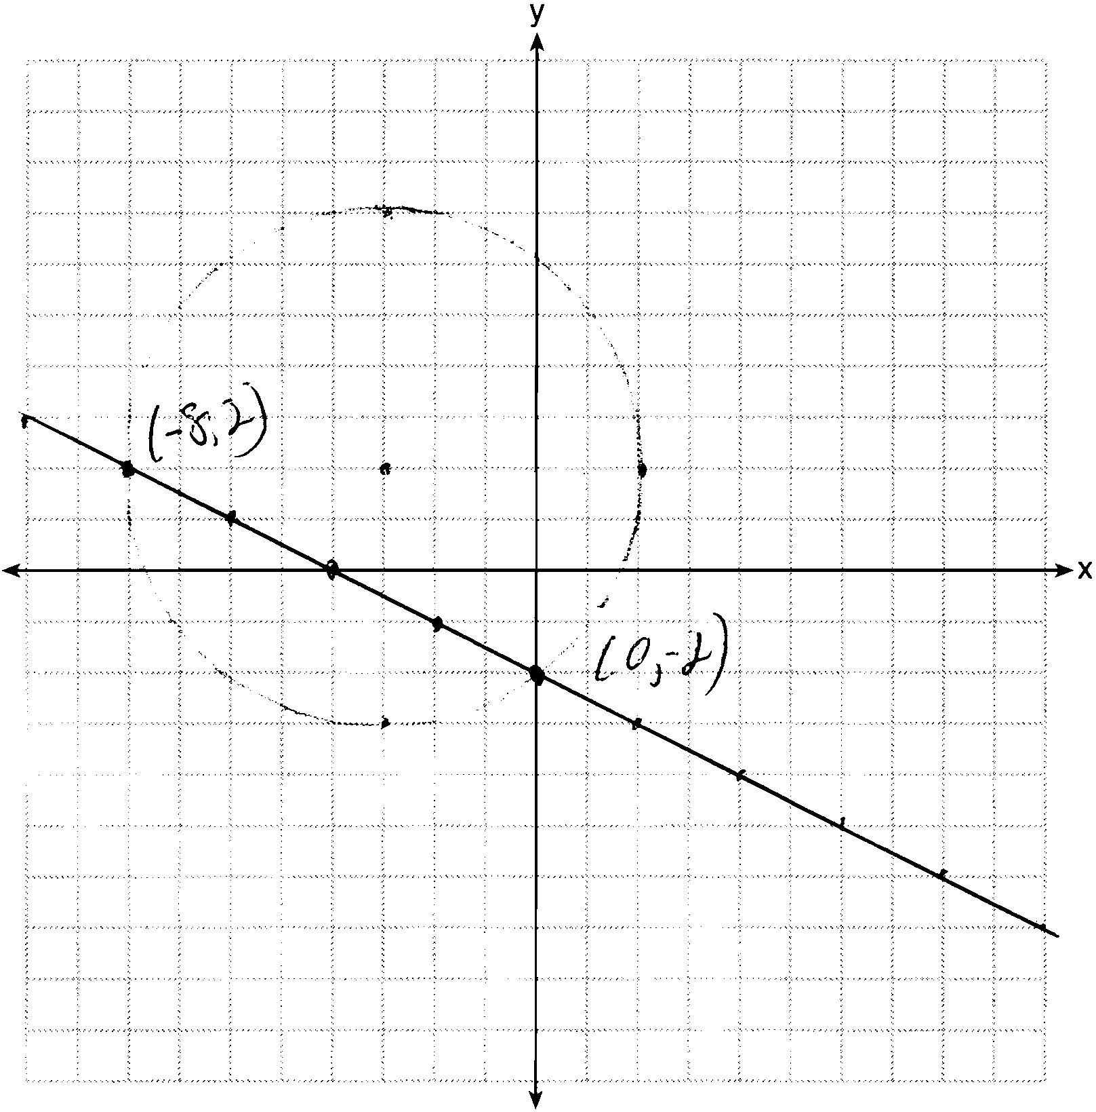
REF: 081237ge STA: G.G.70

13 ANS:
1 and 3
REF: 069305al

14 ANS:
4 and 11
REF: 099510al

15 ANS:
6 and 8
REF: 039811al

16 ANS:
3 and 7
REF: 099812al

17 ANS:
6 and 8
REF: 089311al

18 ANS:
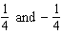
REF: 090508al

19 ANS:
15 and 20
REF: 010509al

20 ANS:
64
REF: 060015al

21 ANS:
15 and 8
REF: 069915al

22 ANS:
480
REF: 030014al

