1 How many real solutions exist for the system of equations below?
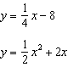
1) | 1
2) | 2
3) | 3
4) | 0

2 Which point is in Quadrant III and is a solution to the system below?
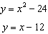
1) | (4, -8)
2)
3)
4) | (-3,-33)

3 The graphs of the equations and are drawn on the same set of axes. One solution of this system is
1)
2)
3)
4)

4 What is the solution set of the following system of equations?
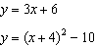
1)
2)
3)
4)

5 What is the solution to the system of equations and where is defined by the function below?

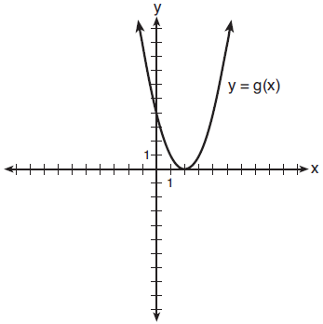
1)
2)
3)
4)

6 The graph of a quadratic function is shown below.

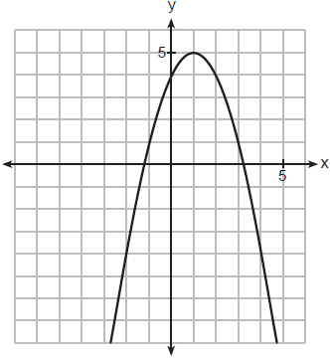

When the graph of is drawn on the same axes, one solution to this system is
1)
2)
3)
4)

7 The graphs of and intersect at approximately
1) | , only
2) | , only
3) | and
4) | and

8 Algebraically determine the values of x that satisfy the system of equations below:
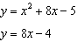

9 Algebraically determine the values of x that satisfy the system of equations below.
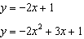

10 Algebraically determine the solution set for the system of equations below.
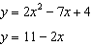

11 Consider the system shown below.
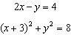
The two solutions of the system can be described as
1) | both imaginary
2) | both irrational
3) | both rational
4) | one rational and one irrational

12 Given and , the point of intersection in Quadrant II is
1)
2)
3)
4)

13 What are the solution(s) to the system of equations shown below?
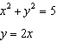
1) | and
2)
3) | and
4) | , only

14 Solve the system of equations algebraically:
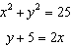

15 Solve the following system of equations algebraically. 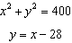

16 Algebraically solve the system:
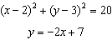

17 Solve the system of equations shown below algebraically:
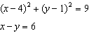

18 Solve the system of equations shown below algebraically.
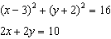

19 Algebraically solve the following system of equations.
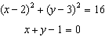
1 ANS: 4
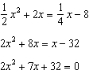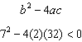

REF: 012310aii

2 ANS: 2
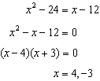

REF: 062404aii

3 ANS: 2
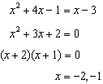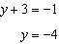

REF: 061801aii

4 ANS: 3
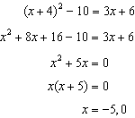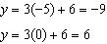

REF: 061903aii

5 ANS: 4
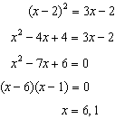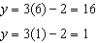

REF: 011705aii

6 ANS: 4
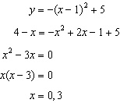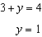

REF: 082305aii

7 ANS: 3
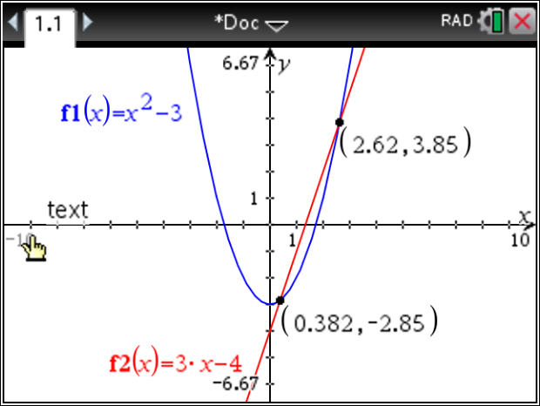

REF: 011810ai

8 ANS:
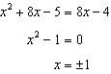

REF: 082326aii

9 ANS:
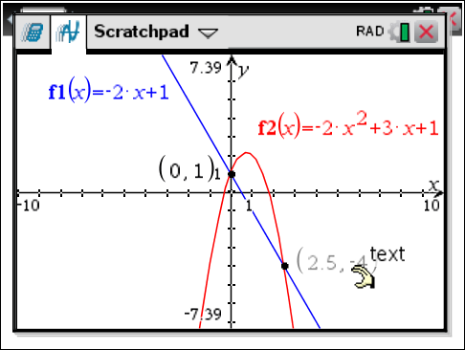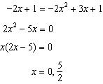

REF: fall1507aii

10 ANS:
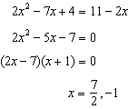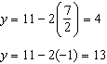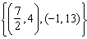

REF: 082232aii

11 ANS: 1
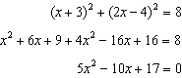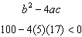

REF: 081719aii

12 ANS: 4
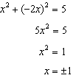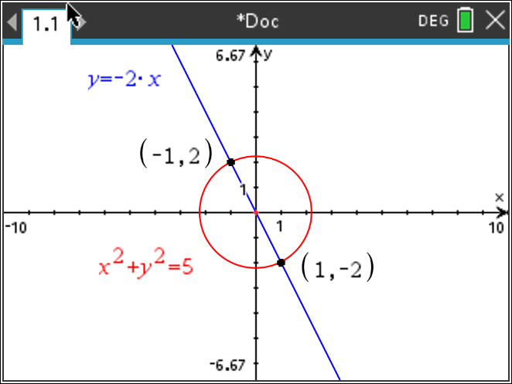

REF: 012407aii

13 ANS: 3
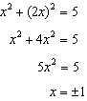

REF: 081916aii

14 ANS:
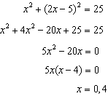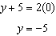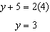

REF: 062236aii

15 ANS:
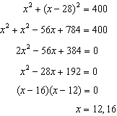

REF: 081831aii

16 ANS:
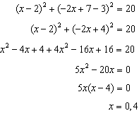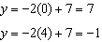

REF: 062335aii

17 ANS:
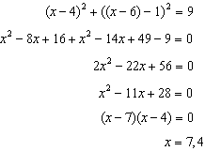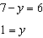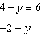

REF: 082436aii

18 ANS:
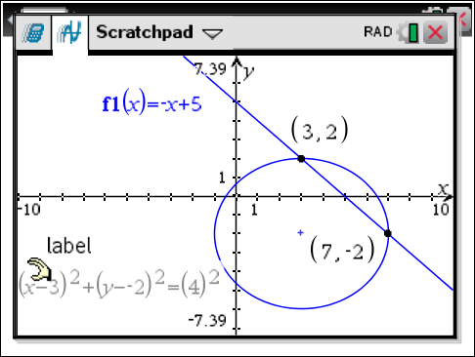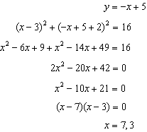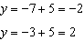

REF: 061633aii

19 ANS:
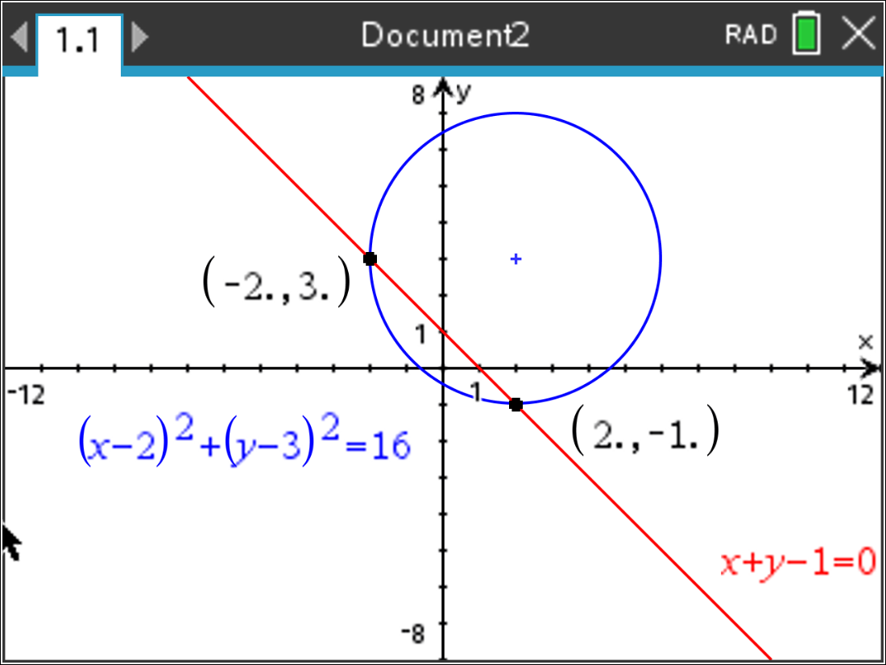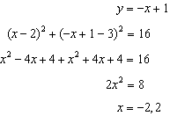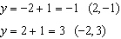

REF: 012035aii

